ML9 Chapter 4 Warm-Up Answers

BLM 4–3 Chapter 4 Warm-Up
Section 4.1
1. 4 2. 3. (–7)⁷ 4. 2
5. 2700 6. 4.32 7. 31 cm
8. 7.95 9. 18.5 mm 10. 12 cm
Section 4.2
1. (–5)²(–5)²(–5)²(–5)² or
(–5)(–5)(–5)(–5) (–5)(–5)(–5)(–5)
2. 77
3. Neither. The heart appears to be doubled in height but not in width.
4. Look for a figure with line lengths of the original length. Example using 0.5-cm grid:
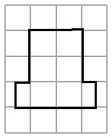
5. Example: Multiply the length 3.8 × 2.4 = 9.1. Draw the new length of 9.12 cm. Multiply the width 1.5 cm × 2.4 = 3.6. Draw the new width
of 3.6 cm.
6. 8 7. 0.5 8. x = 3 9. 230 cm 10. 69 cm
Section 4.3
1. Example: Divide 5 ÷ 2 = 2.5. Redraw the square with side lengths of 2.5 cm.
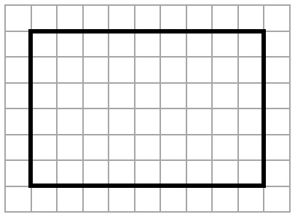
2.

3. 16.4 cm 4. 12.4 km 5. 20
6. a) 156 mm b) 240 cm
7. 52° 8. x = 8; y = 4.5 9. x = 4; y = 9
10. Yes. Example: Each ratio is equal to 1.5.
Section 4.4
1. Reduction 2. 19
3. Example:  ABC is similar to EFG. Similar triangles have corresponding angles equal in measure and corresponding sides proportional in length.
4. AB = DE; AC = DF; BC = EF
5. 3.2 cm 6. 10.2 cm 7. 5.6 cm
8. 25% 9. 17.5 cm 10. 9.5 cm

