Chapter 5 Warm-Up

Section 5.1
1. On grid paper, enlarge this figure so that it is twice as large.
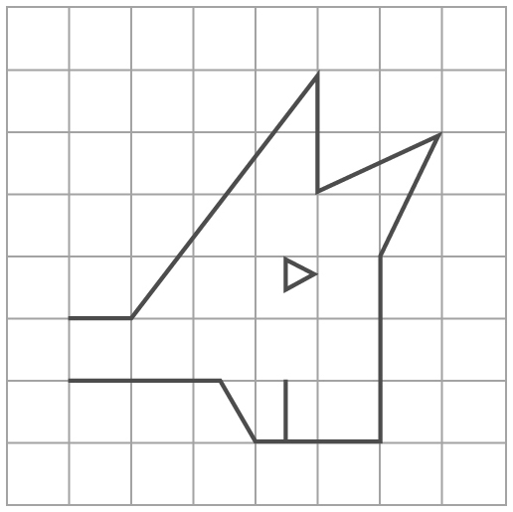

2. A drawing of a turtle measures
8 cm. The scale of the drawing is 1:35. What is the actual length of the turtle in metres?
3. List the corresponding sides and corresponding angles for these two similar triangles.
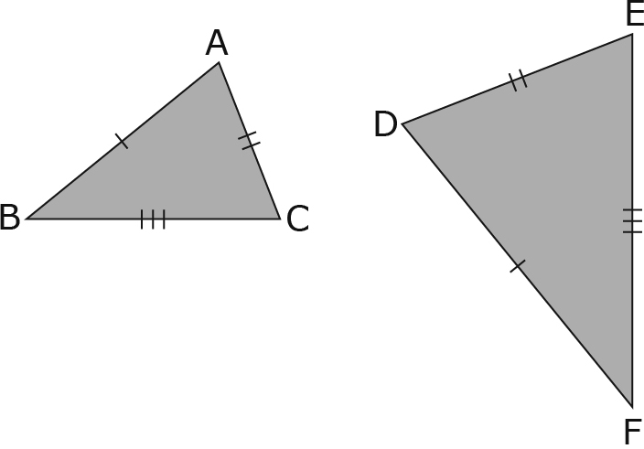

4. Are the triangles similar? Show how you know.
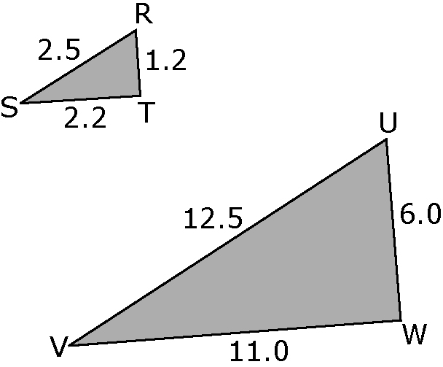

5. Draw two polygons that are of different scale, and are similar. Explain what you did to ensure the two figures were similar.

Mental Math
6. What is the product of 5 and 12?
7. What is the sum of 23 and 18?
8. What is the quotient of –1.8 ÷ 3?
9. What is the difference between 3.5 and –2.7?
10. What is the result when you double 5 and decrease it by 13?

Section 5.2
1. A bicycle is 2.4 m long. A scale diagram of the bicycle measures 6 cm. Was the bicycle enlarged or reduced? By what scale factor?
2. Find the missing length in this diagram, to the nearest tenth.
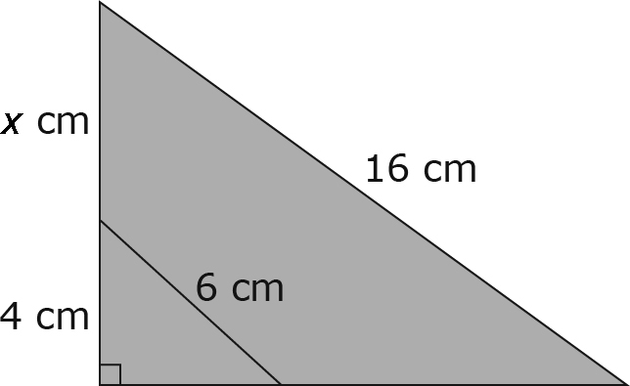

3. What type of polynomial is
3x² – 5x + 7?
4. Write a binomial expression with a degree of two.
5. Let  represent –x²,  represent +x, and  represent –1. Write the polynomial for this diagram.


Mental Math
6. Add:
(–5) + (–8) + 7 + 5 + (–1)
7. Find the sum:
(–4) + 9 + (–5) + (–3) + 11
+ (–2)
8. What is the opposite of 7?
9. Let  represent +1, and represent –1. Find the sum represented by this diagram.
10. What symbol could be used to represent any number?

Section 5.3
1. What is the degree of this polynomial: x + y + 5

2. Let  represent –x, and represent +1. State the polynomial represented by this diagram. What type of polynomial is this?
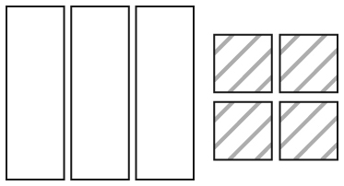
3. Identify the coefficient and the variable in 3m + 5.

4. Using models or a diagram, show that 3x – 5x – 3 – 2 = –2x – 5.
5. Simplify by collecting like terms:
3x² – 5x – 8 – 4x² + 9x – 2

Mental Math
6. 3 – 8 has the same result as
3 + (–8). What is 4 – 15 the same as?
7. (–6) – 4 is equal to (–6) + (–4). Rewrite (–13) – 2 as an addition statement.
8. What is the opposite of –16?
9. What is the opposite of –4x?
10. The sum of two opposites equals zero. State the opposite of 3x – 5.

