ML9 Chapter 5 Warm-Up Answers

BLM 5–3 Chapter 5 Warm-Up
Section 5.1
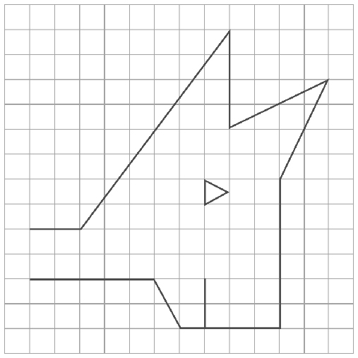
1.

2. 2.8 m
3. AB = DF, DE = AC, BC = FE, ∠A = ∠D,
∠B = ∠ F, ∠C = ∠E
4. Yes, they are similar because
5. Example: I ensured that the ratio for all like sides on the two figures was the same.
6. 60 7. 41 8. –0.6 9. 6.2 10. –3
Section 5.2
1. reduced; 40 2. 10.7 cm 3. a trinomial
4. Example: xn or x² 5. –x² + 3x – 5 6. –2
7. 6 8. –7 9. 7 + (–5) = 2
10. a letter such as x
Section 5.3
1. one
2. –3x + 4, binomial
3. Coefficient is 5; variable is m
4. Striped shapes are positive and white shapes are negative.
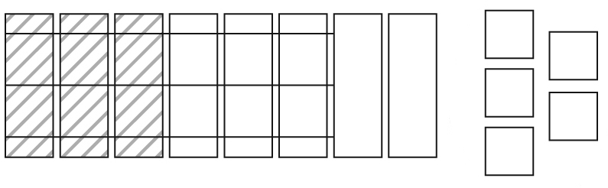
5. –x² + 4x – 10 6. 4 + (–15)
7. (–13) + (–2) 8. +16, or 16
9. +4x, or 4x 10. –3x + 5

