Chapter 6 Warm-Up

Section 6.1
1. What is the difference between a binomial and a trinomial?
2. What is the degree of the monomial 5x²y? Explain how you arrived at your answer.
3. Write an equivalent expression for 3x² – 7x – 3x + 5x² + 8
– 7x² + x – 14.
4. a) Model the addition statement (x² – 2x – 2) + (–2x² +
2x – 5).
b) Write a simplified polynomial that represents the sum.
5. Simplify by combining like terms: (3x + 7) – (–2x – 5) + (8x + 2) – (–x + 6).

Mental Math
6. a) Draw the next two figures.
b) Describe how the number of squares increase for each new figure.
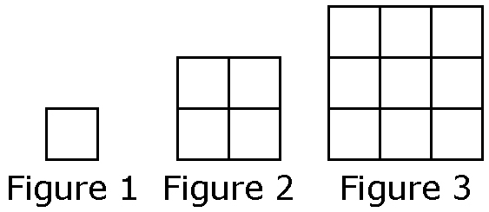
7. Triple 4 and then decrease by 5. What is the result?
8. Evaluate 6n + 5, if n = –3.
9. Double a number and increased by 7 is 15. What is the number?
10. Triple a number decreased by 2 is 34. What is the number?

Section 6.2
1. a) What type of polynomial is
4x² – 5x + 7?
b) What is its opposite?
2. Replace ? with algebra tiles to make a true statement.

3. Create a table of values to represent the relation between the number of happy faces, h, and the row number, r.

4. a) Describe the pattern in #3.
b) What equation represents the pattern?
5. How many happy faces would there be in Row 17? Show your work.

Mental Math
6. Identify the approximate coordinates of each point.
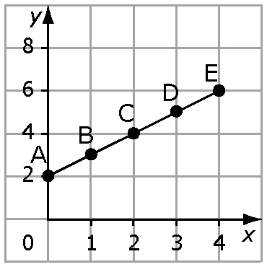
7. Identify the approximate coordinates of B, C, and D.
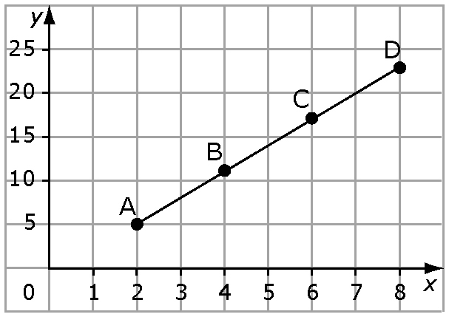

8. This graph shows the travels of a cat over a 6-h span. At 2 p.m., where is the cat?
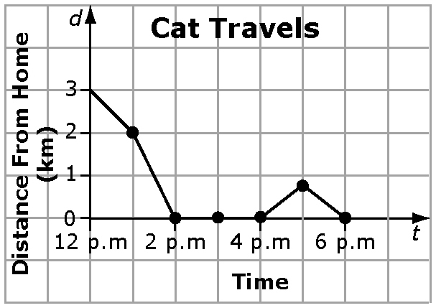
9. How far from home is the cat at noon? at 5 p.m?
10. What pattern do you notice about the value of d when
t = 2, 3, and 4?

Section 6.3
1. a) Holly has $60 in the bank and plans to save $20 per month. What linear equation models the relationship between the amount of money in the bank, m, and the number of months, t, it takes to save money?
b) How long will it take Holly to save $500?
2. Damian is paid $70 per day plus a commission of 10% of sales for selling clothing. Approximately how much must Damian sell to earn $250 in one day?
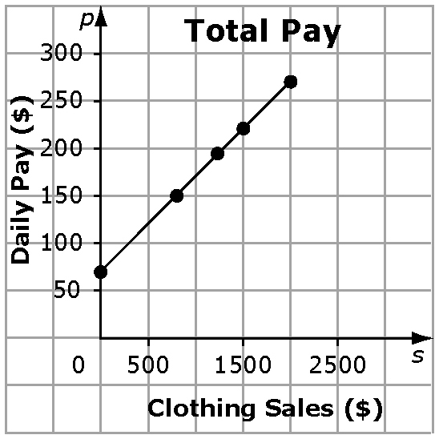
3. Is it reasonable to interpolate or extrapolate values on the graph in #2? Explain.
4. The table shows the student population at a rural school.
2006 | 2007 | 2008 | 2009
80 | 96 | 112 | 128
a) Graph the data.
b) Estimate the value in 2010.

5. Raj missed class and is having difficulty writing the equation for this graph. Write an e-mail to Raj to help him understand why the equation is x = 4.
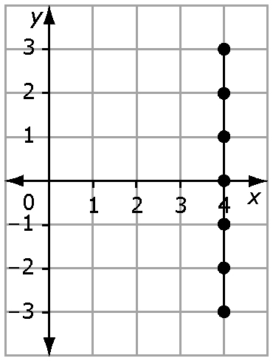

Mental Math
6. Describe the relationship between the x-value and the
y-value for the following points: (2, 10), (3, 15), and (7, 35).
7. Describe the relationship between the x-value and the
y-value for the following points: (8, 1), (6, 3), and (–1, 10).
8. What do you notice about the following points: (3, 8), (7, 8), and (–2, 8)?
9. Create a table of values for
y = 2x + 3.
10. Create a table of values for
y = –3x + 6.

