ML9 Chapter 6 Warm-Up Answers

BLM 6–3 Chapter 6 Warm-Up
Section 6.1
1. Example: A trinomial has one more term than a binomial.
2. 3. Example: Add the exponents of the powers 2 + 1.
3. x² – 9x – 6
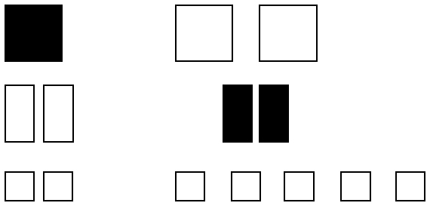
4. a)

b) –x² – 7
5. 14x + 8
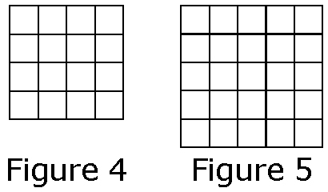
6. a)

b) Example: Add 3, add 5, add 7, add 9.
7. 7 8. –13 9. 4 10. 12

Section 6.2
1. a) Trinomial b) –4+ 5x – 7

2.

3.
Row Number, r | Number of Happy Faces, h
1 | 2
2 | 5
3 | 8
4. a) Examples:
• Each row has three more happy faces than the previous one.
• Multiplying the row number by 3 and then subtracting 1 gives the number of happy faces in that row.
b) h = 3r – 1
5. h = 3(17) – 1 = 50; 50 happy faces
6. A(0, 2); B(1, 3); C(2, 4); D(3, 5); E(4, 6)
7. Y-values are approximate for B to D. Example: B(4, 11); C(6, 17); D(8, 23)
8. At home
9. 3 km; approximately 0.75 km
10. Example: The value of d stays the same.

Section 6.3
1. a) p = + 70 b) 22 months
2. Example: Approximately $1900
3. Example: Yes, it makes sense to have values for sales between and beyond given sales values.
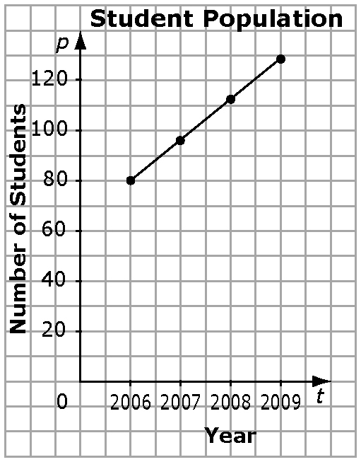
4.

5. Example: For each y-coordinate, the corresponding x-value is 4.
6. Example: Each y-value is five times the corresponding x-value. Or, each x-value is
the corresponding y-value.
7. Example: Each x-value and corresponding
y-value add to 9.
8. Example: Each y-value is 8.
9. Example:
x | y
0 | 3
1 | 5
2 | 7
3 | 9
10. Example:
x | y
0 | 6
1 | 3
2 | 0
3 | –3

