ML9 Chapter 7 Warm-Up Answers

BLM 7–3 Chapter 7 Warm-Up
Section 7.1
1. y = 2x + 1, where y is the number of lines and x is the figure number.
y = 2(100) + 1. There would be 201 lines in the hundredth figure.
2.
x | y
–4 | 11
–2 | 7
0 | 3
2 | –1
3 | –3
y = –2x + 3
3. Example: Approximately 3.3 kg
4.
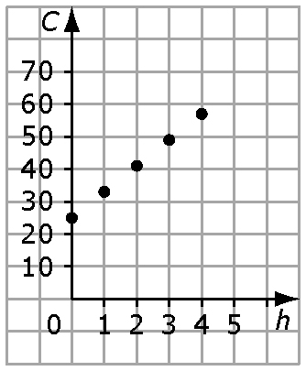
C = 8h + 25, where C is how much you charge, in dollars, and h is the number of hours
5. No. Example: The graph shows y = 10x.
6. 9 7. 8. 6 9. 3⁷ 10. 6³
Section 7.2
1. C = 20 + 0.58n, where C is the total rental charge and n is the number of kilometres
2. The graph should have a y-intercept of 6 and increase from left to right.
3. Shaded tiles are positive, and white tiles are negative.
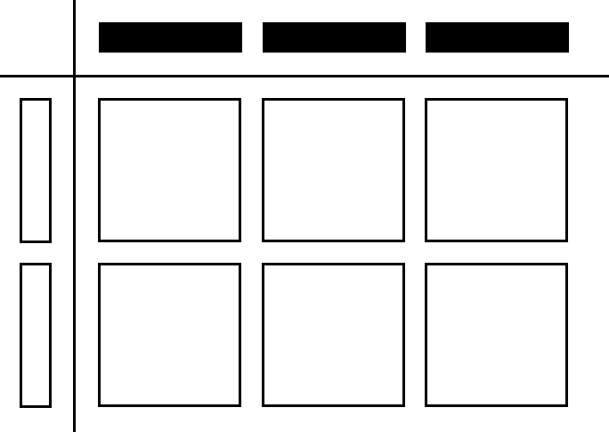
4. –21xy 5. –4y 6. 7. 8.4
8. 6x – 15 9. –2x – 10 10. 4(2x + 3)
Section 7.3
1. 3.15xy 2. 9x 3. –x(–x – 3)
4. –6x² – 15xy + 6x 5. –2.1x² + 1.8x
6. 3x + 4 7. –4x + 6y 8. –6y 9. 6 10. –0.8x

