Chapter 8 Warm-Up

Section 8.1
1. Determine the area of the figure.
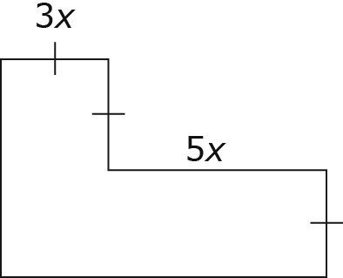
2. Solve:
3. Divide by 5x.
4. Expand –3x(2x – 5y + 7)
5. What is 8x² – 24x divided by 4x?

Section 8.2
1. The area of a rectangle is 15xy. If the length is 5y, what is the width?
2. Write a simplified expression for the area of this figure.
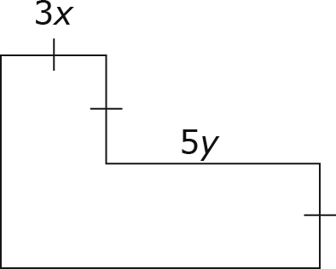
3. Solve for x:
4. Solve for m: –3.77 =–1.3m
5. Solve for y:

Mental Math
6. Evaluate:
7. Evaluate:
8. Calculate: (–0.2) + (–3.4) ÷ (17)
9. If the length of a rectangle is
5.2 cm long and the width is
4.8 cm long, what is the area?
10. You commit to saving 15% every time you are paid. You make $230 in one week. How much should you transfer to your savings account each week?

Mental Math
6. What is ?
7. What is the sum of and ?
8. Evaluate: 2.8(–3.7 – 2.5)
9. What is the result if you subtract 4.95 from 18.95, then divide the difference by –0.5?
10. A small pizza costs $8.50. Extra toppings cost $0.50 each. How much does a small pizza cost if you want three extra toppings?

Section 8.3
1. Solve for n:
2. A roll of dimes is worth $5. Write and solve an equation to determine the number of dimes in a roll.
3. Solve for x:
4. Solve for x:
5. Solve for x: 2.5 – 0.2x = –3.9

Section 8.4
1. a) Write an equation that is represented by this model.
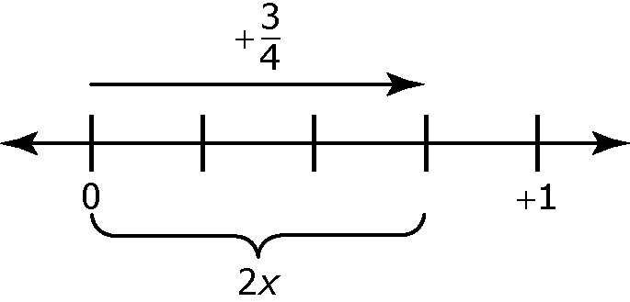
b) Solve your equation.
2. Solve, expressing your answer to the nearest hundredth:
3. Solve:
4. Solve: 1.5(x – 3.2) = 5.7
5. Concert tickets are for sale online. There is a handling fee of $3.50 added to the cost of every ticket. If you buy seven tickets and the total comes to $385, what is the cost of one ticket before the handling fee is added?

Mental Math
6. Evaluate:
7. Find the product of 3 and 2x – 5.
8. Expand:
9. A number that has been increased by 5 is then multiplied by 3. The result is 24. What is the number?
10. Double the sum of 2 and another number is –18. What is the other number?

Mental Math
6. Collect like terms:
3x – 7 – 5x – 9
7. Evaluate:
8. Write an expression that is the opposite of the one represented.


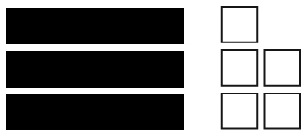

9. Expand:
10. Expand: –0.25(7x – 4)

