ML9 Chapter 9 Warm-Up Answers

BLM 9–3 Chapter 9 Warm-Up
Section 9.1
1. n = –4.1
2. x = –3.5
3. x = 2.2
4. x = –
5. x = 3
6. Yes. Example: 3 is left of 8 on a number line.
7. No, –5 is further to the right than –8.
Example:
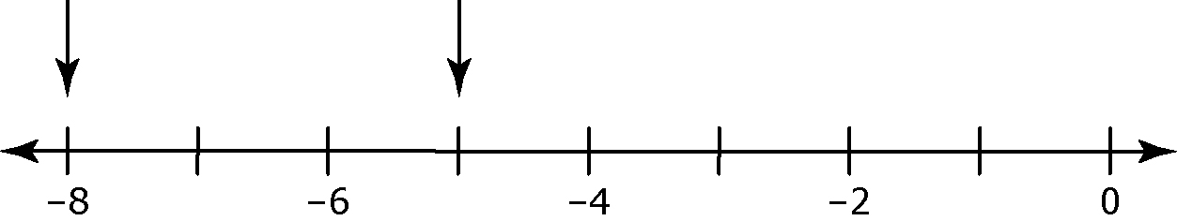

8. Integers that are larger than –17.
9. 40 and all the integers less than 40.
10. All numbers less than 8.
Section 9.2
1. x = –1.1
2. No. The solution is .
3. 40 ≥ x or x ≤ 40

4.

5. Example: All numbers greater than –5 and less than or equal to 7.
6. x = –3
7. x = 9
8. x = –53.56
9. y = –12
10. x = –8
Section 9.3
1. All numbers equal to or greater than 8; x > 8 or 8 < x

2.

3. All numbers less than or equal to 6.1
4. It reverses.

5. a) x > 6 b) Example:

6. x = –10
7. x = 20
8. x = 8
9. x = –6
10. x = 2

