Modelling Equations
You can model an equation using concrete materials, such as algebra tiles.
In the figures below, shaded tiles are positive and white tiles are negative.

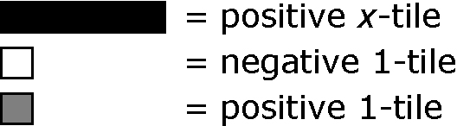

1. Model each equation using algebra tiles or diagrams.  a) 2x = 8  b) 4r – 2 = 10  c) 5p + 1 = 11 | 2. Write the equation modelled by the algebra tiles.    a)  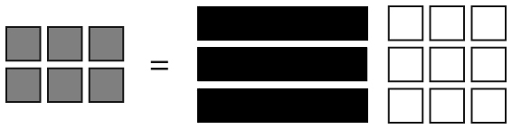  b)

Solving an Equation

Two ways of solving an equation are:
• perform the opposite operation on both • model the equation and then
sides of the equal sign balance it
Solve 3x – 5 = 4.
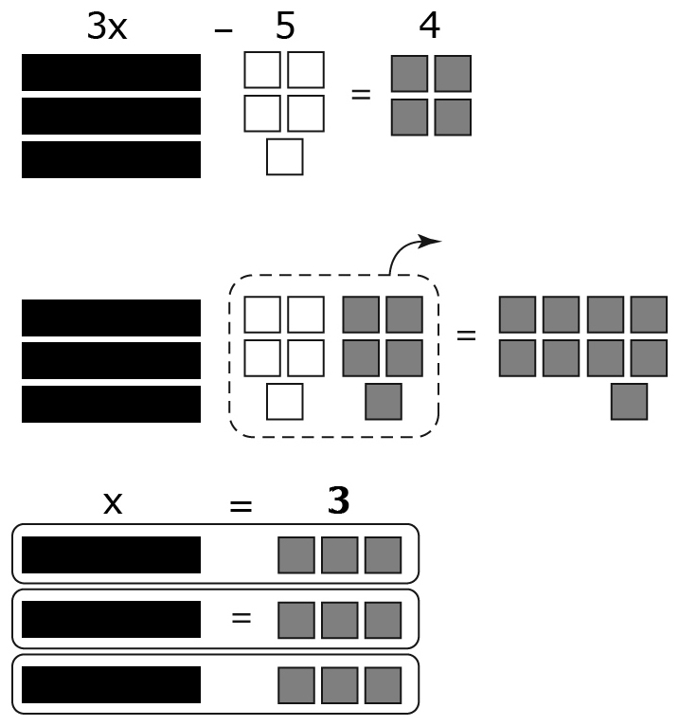
3x – 5 = 4
3x – 5 + 5 = 4 + 5
3x = 9
=
x = 3

3. Solve each equation modelled by algebra tiles.
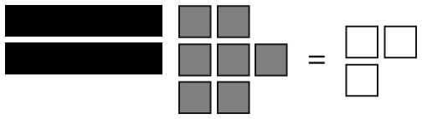
a)

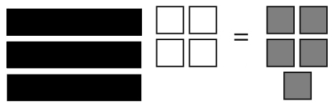
b)

4. Solve each equation.
a) 3r = –12
b) = 3
c) 3p – 2 = –14
d) 12 – 2x = –4

Checking an Equation

You can check your solution to an equation by substituting your
answer back into the equation. Both sides should have the same value.
Check if x = 5 is the solution to 4x + 3 = 23.
Left Side = 4x + 3 Right Side = 23
= 4(5) + 3
= 20 + 3
= 23
Left Side = Right Side
The solution, x = 5, is correct.

5. Show whether x = –4 is a solution to each equation.
a) 5x + 7 = –13
b) 12 – 5x = 8
6. Solve and check.
a) x – 2 = 5
b) 3t + 4 = 10
c) 2g – 7 = –11

