Use Symbols to Describe Relationships

Mathematicians use symbols for operations and to show relationships between quantities. For example,
× represents multiplication  ÷ represents division  < represents is less than | > represents is greater than  = represents is equal to  ≠ represents is not equal to

1. Translate each word
statement into symbols.
a) 5 is greater than 2.
b) 7 is less than 20.
c) 5 multiplied by 3.
d) 9 is equal to .

2. Write each mathematical statement in words.
a) 4 < 8
b) 8 > 2
c) 14 ÷ 2
d) 4 ≠

Use Between

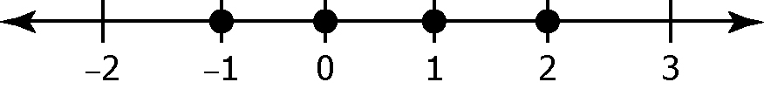
The term between can be used to
describe a physical relationship or
location. For example, Paul is between Sue and Shasta in line. Similarly, between can be used in mathematics. For example, all of the integers between –2 and 3 are –1, 0, 1 and 2
Note that between does not include –2 and 3.

3. List all of the whole numbers satisfying each condition. Use the number line to help you.
a) between 6 and 3 b) between –2 and 2
c) between 4.6 and 7.1 d) less than 4
Use Inequality Symbols
An inequality expresses a relationship
between numbers or quantities. Two
inequality symbols are < and >.
The inequality 5 < 6 means 5 is less than 6. This same information can be shown as 6 > 5, which means 6 is greater than 5.

4. Write two expressions showing the relationship between the given numbers. Use both the less than, <, and greater than, >, symbols.
a) 1 and 7
b) 4 and –1
c) 3 and 3.5
d) 0 and 1
5. List the whole numbers that satisfy each statement.
a) x < 4
b) between 4 and 8
c) t > 11
d) a < 15

Solve Equalities

When you solve an equation, you need to find all values for the unknown that make a true statement.

Solve: 2x – 1 = 7.
Solution:  2x – 1 + 1 = 7 + 1  2x = 8  x = 4 | Check:  2(4) – 1 = 7  8 – 1 = 7  7 = 7

6. Solve each equation. Then, verify your answer.
a) x + 4 = 6 b) –2x + 1 = 9

c) –5x – 3 = −8 d) 3x – 5 = 4

