ML9 Chapter 10 Get Ready Answers

BLM 10–2 Chapter 10 Get Ready
1. a) 2 cm b) 1.5 cm
2. a) Examples: ~6 cm, ~4.5 cm
b) 2 × 3.14 = 6.28 cm, 1.5 × 3.14 = 4.71 cm
3. a) Example: any estimate between 20° and 30°
b) Example: any estimate between 45° and 55°
c) Example: any estimate between 100° and 110°
4. a) 25° b) 48° c) 105°
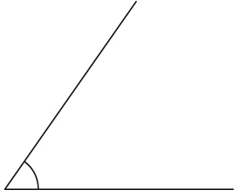
5. Example:

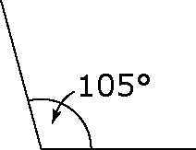
6.

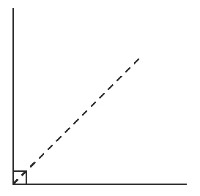
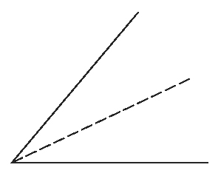
7. a) b)

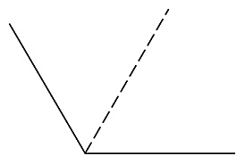
c)

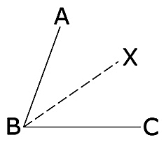
8.

Example: The measure of ∠ABX is 35°, which is of 70°.

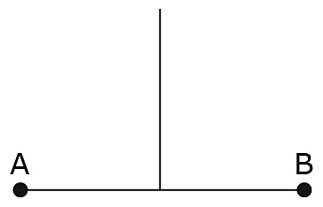
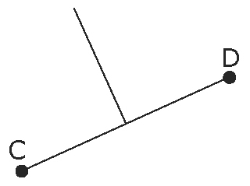
9. a) b)

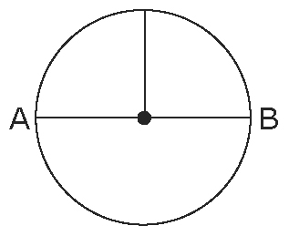
10.

