ML9 Chapter 5 Get Ready Answers

BLM 5–2 Chapter 5 Get Ready
1. a) (+5) + (–2) = +3
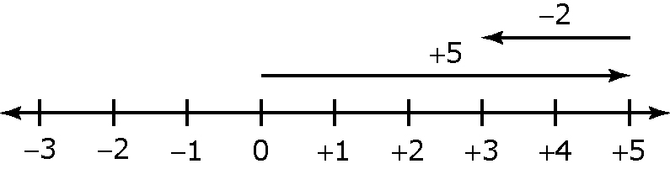
b) (–3) + (+7) = +4
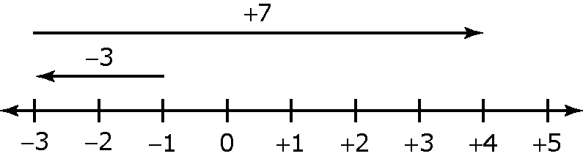
c) (+1) + (+4) = +5
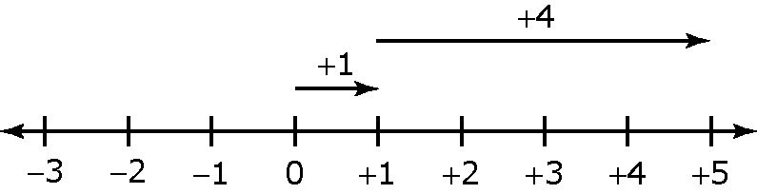
d) (–3) + (–2) = –5
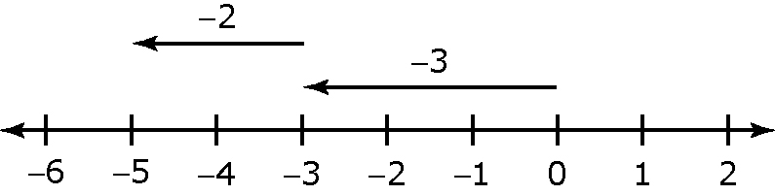
2. a) (–2) + (+5) = +3
b) (–1) + (–2) = –3
3. a) +5 or 5 b) –4 c) –13 d) +2 or 2
4. a) (+3) – (–1) = (+3) + (+1) = +4 or 4
b) (–3) – (+2) = (–3) + (–2) = –5
c) 5 – (+2) = 5 + (–2) = +3 or 3
d) 2 – (–8) = 2 + (+8) = +10 or 10
5.
 | Numerical  Coefficient | Variable | Constant
a) | 2 | x | –7
b) | –3 | b | +5 or 5
c) | 1 | t | –4
d) | –6 | r | +3 or 3
6. a) s – 5, where s is Sarah’s age
b) 2l – 3, where l is the length
c) p + 14, where p is the perimeter of the triangle
d) n or , where n is the number of tickets they expected to sell.
7. a) p + p + p + p or 4p is the perimeter of a square with sides of length p
b) length of rectangle is 8 more than its width, or length is increased by 8 over its width, or length is 8 larger than the width.

