ML9 Chapter 8 Get Ready Answers

BLM 8–2 Chapter 8 Get Ready
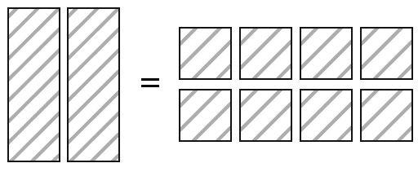
1. a)

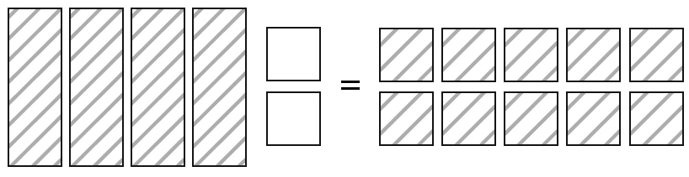
b)

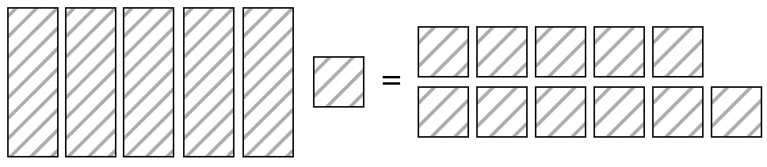
c)

2. a) 2x − 6 = 6 b) 6 = 3x − 9
3. a) 2x + 7 = –3, so x = –5 b) 3x – 4 = 5,
so x = 3
4. a) r = –4 b) s = 6 c) p=–4 d) x = 8
5. a) 5(–4) + 7 = –13, so x = –4 is the solution
b) 12 – 5(4) = –8, so x = –4 is not the solution
6. a) x = 7; Check: 7 – 2 = 5
b) t = 2; Check: 3(2) + 4 = 10
c) g = –2; Check: 2(–2) – 7 = –11

