Chapter 10 Gifted and Enrichment
1. Based on the diagram below, determine the length of DE.  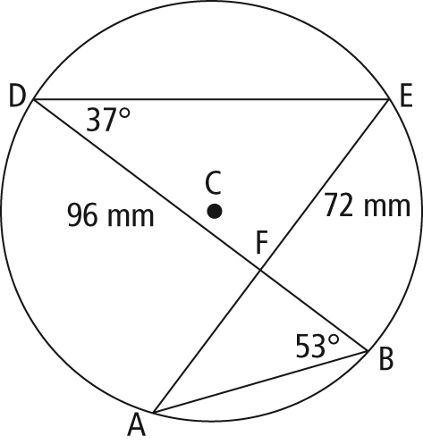 | 2. In the diagram below, determine the measure of ∠EAD.  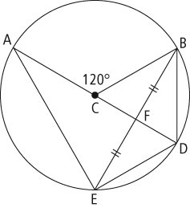
3. A round dining table has a centre, H, and a diameter of 1.4 m. The table is pushed into a corner of a dining room, as shown. Determine the distance between the corner of the wall, C, and the edge of the table. Express your answer to the nearest millimetre. State any assumptions.

