Chapter 1 Gifted and Enrichment Answers

1.
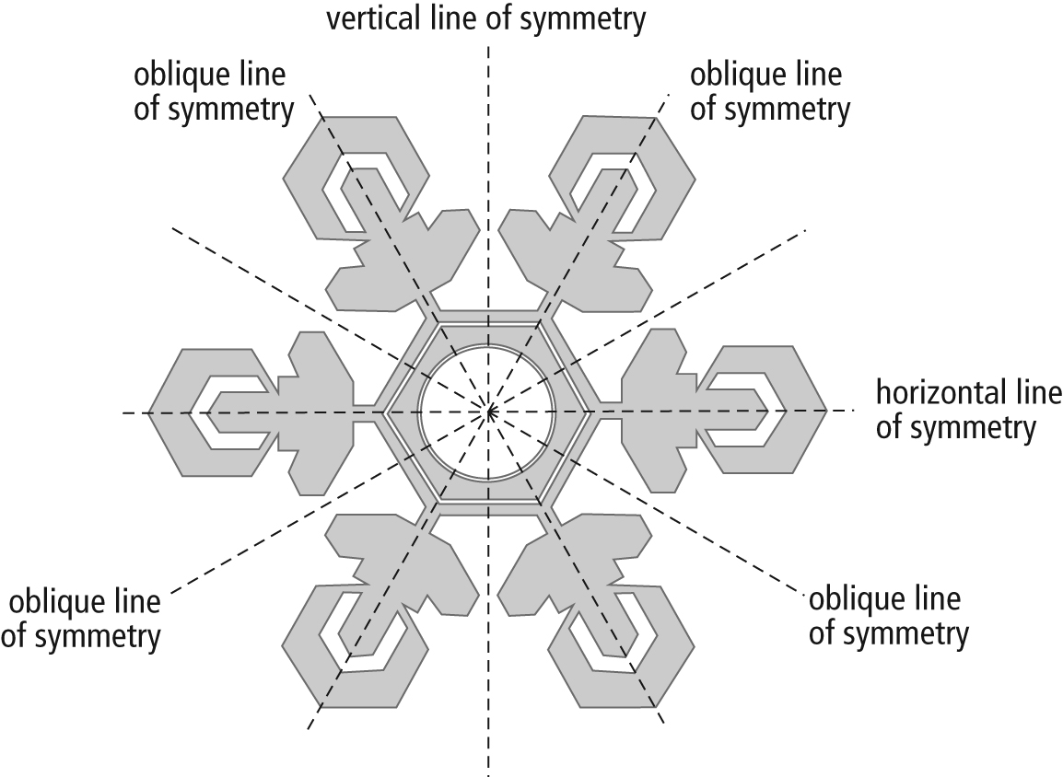

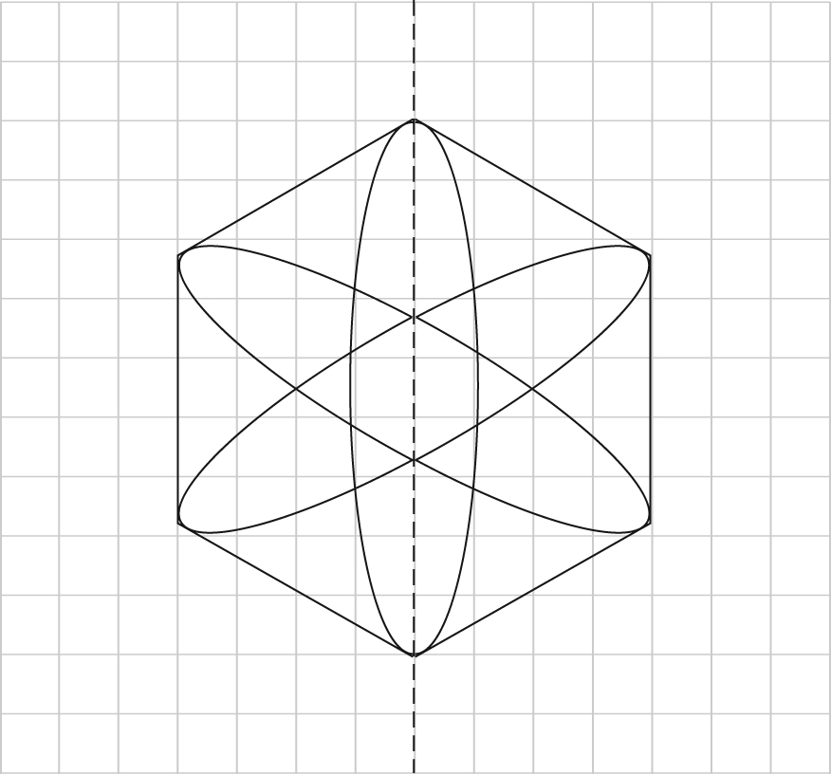
2.

3. Roof: 2 × 4.0 × 7.0 = 56.0
Windows: 10 × 0.8 × 0.6 = 4.8
Doors: 2 × 2.05 × 0.82 ≈ 3.4
Walls: (2 × 2.5 × 7.0) + (2 × 2.5 × 4.8)
+ (2 × 0.5 × 4.8 × 3.2) – 4.8 – 3.4 = 66.2
The surface area of the roof is 56.0 m², of the doors is 3.4 m², of the windows is 4.8 m², and of the walls is 66.2 m².
4. a)
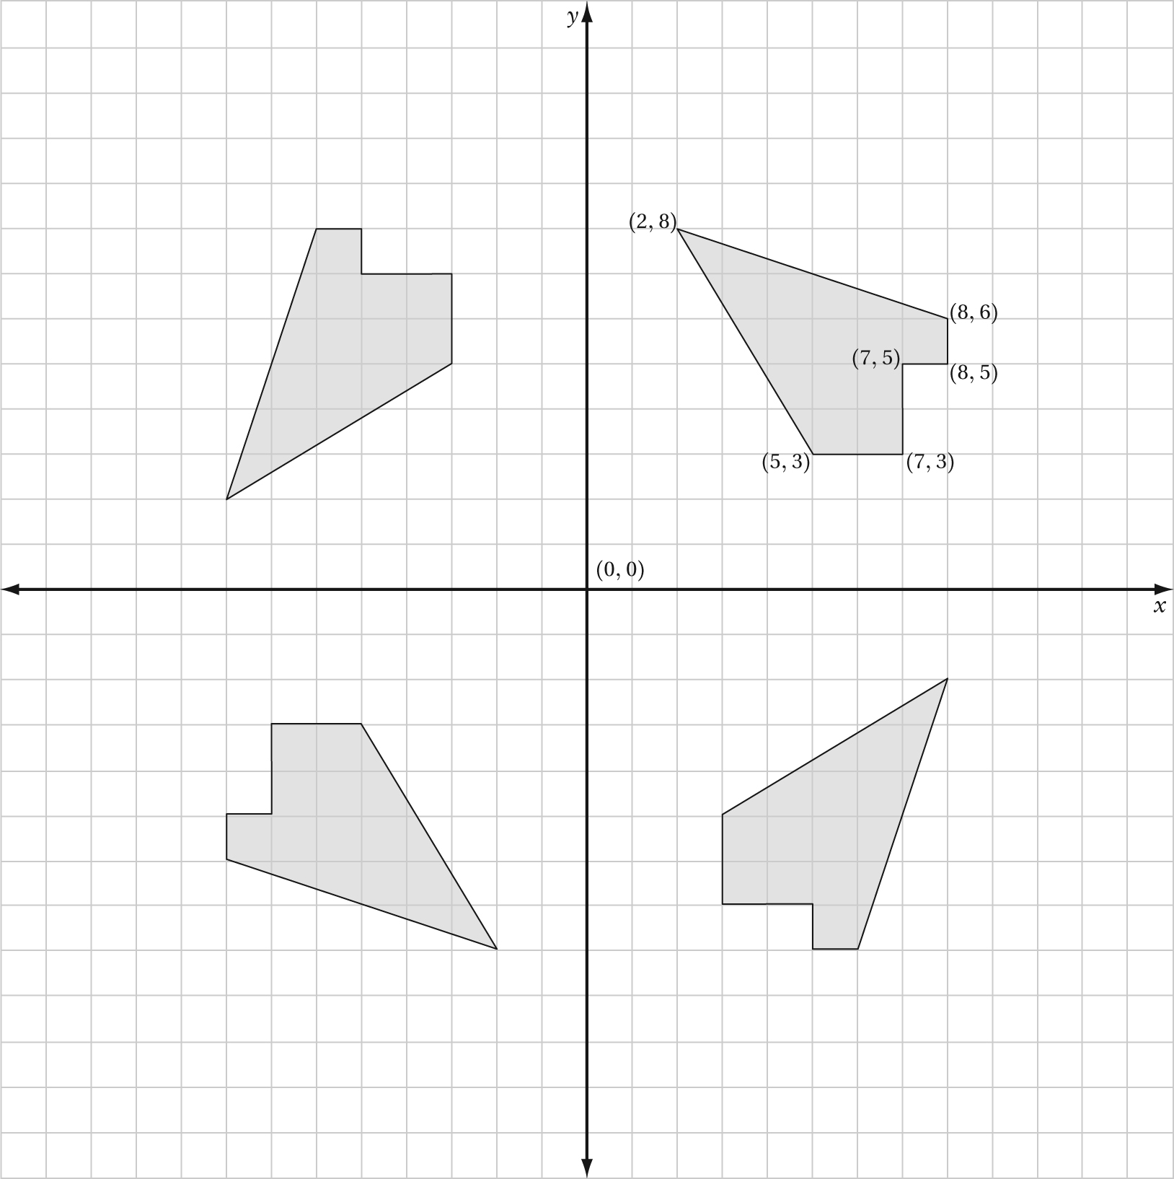
b) Example: The design shows rotation symmetry around the origin.
5. Outer cylindrical surface: 2π7(50) ≈ 2199.11
Inner cylindrical surface: 2π3(50) ≈ 942.48
Ends: 2π7² – 2π3² ≈ 251.33
Coated surface area: 2199.11 + 942.48
+ 251.33 ≈ 3392.9
The surface area of the tube that needs to be coated is 3392.9 cm².

