Chapter 1 Gifted and Enrichment
1. Draw all lines of symmetry for the figure. Label each line with the type of symmetry.  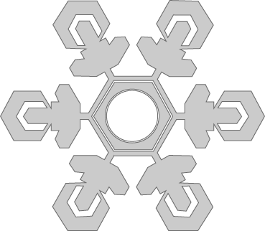 | 2. The dashed line represents a line of symmetry for the figure. Draw a complete version of the figure.  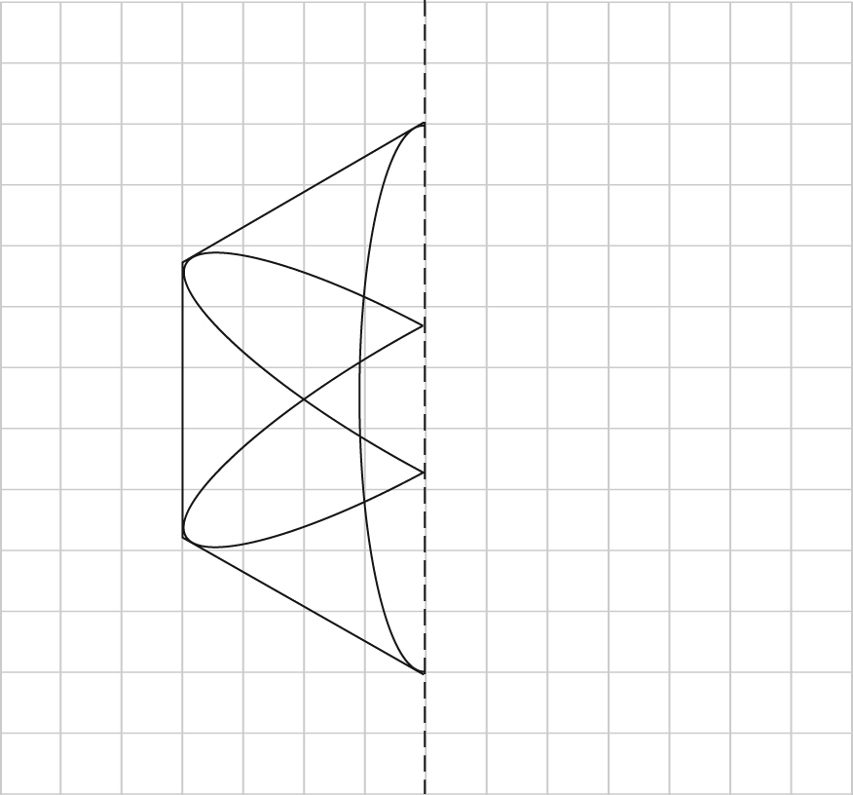
3. The surface area of walls, roofs, doors, and windows all affect the amount of heat loss from a house. Calculate the surface area for the doors, windows, walls, and roof for the house below. Express each answer to the nearest tenth of a square metre.

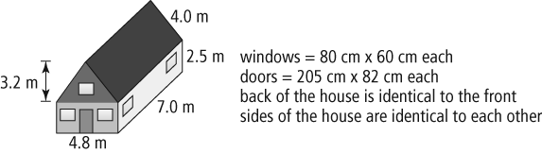

Chapter 1 Gifted and Enrichment continued

4. a) Draw each step in the completed rotation if the centre of rotation is the origin and the angle of rotation is 90°.

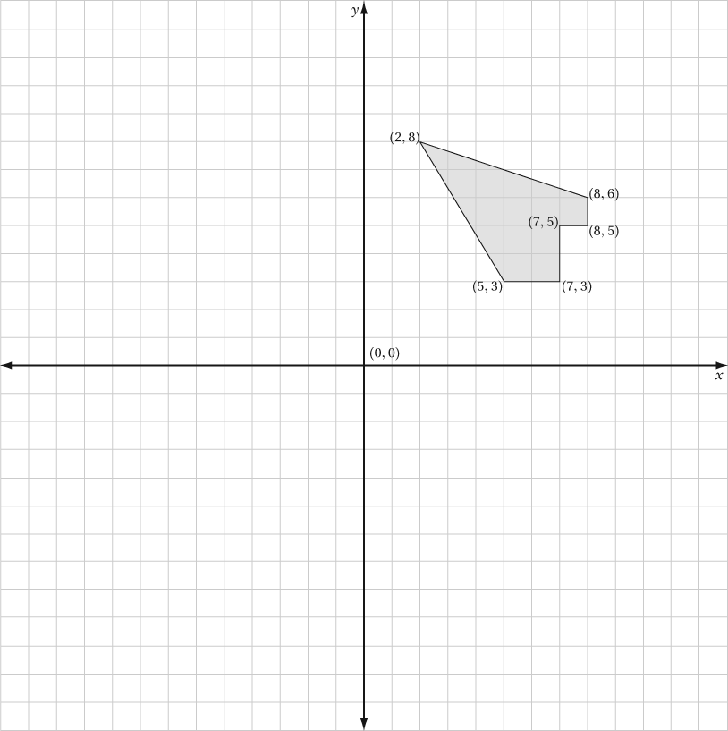

b) What type of symmetry does your new design have? Explain.

5. The surface area of a metal tube must be coated with lubricant. The exterior diameter of the tube is 14 cm, the thickness of the tube wall is 4 cm, and the length of the tube is 50 cm. Determine the total surface area that must be coated, to the nearest tenth of a square centimetre.

