Chapter 4 Gifted and Enrichment Answers

1. The enlargement has the measurements shown on the labels in the diagram below.
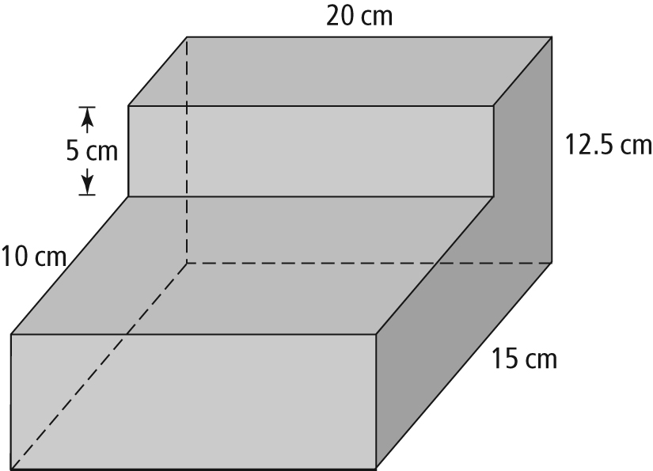

2. Scale inside diameter: 1.2 – 2(0.3) = 0.6
0.6 × 5 = 3
The actual inside diameter of the pipe is 3 cm.
3. For a scale of 2:1, the legs of Triangle B are
2 × 29, or 58 mm long. Use the Pythagorean relationship.
c² = 58² + 58²
c² = 6728
c ≈ 82
The length of the hypotenuse of Triangle B is approximately 82 mm.
4. Example: From measuring the sample diagram, I estimated the scale factor of the image to be approximately 0.2.
• The height of the image is approximately
2.2 cm. The speaker must therefore be about 11 cm high.
• The width of the image is 1.9 cm. The speaker must be about 9.5 cm wide.
• If I place the speakers with the height on the 27.7 dimension, a maximum of two will fit.
• If I place the speakers with the width on the 38.8 dimension, a maximum of four will fit.

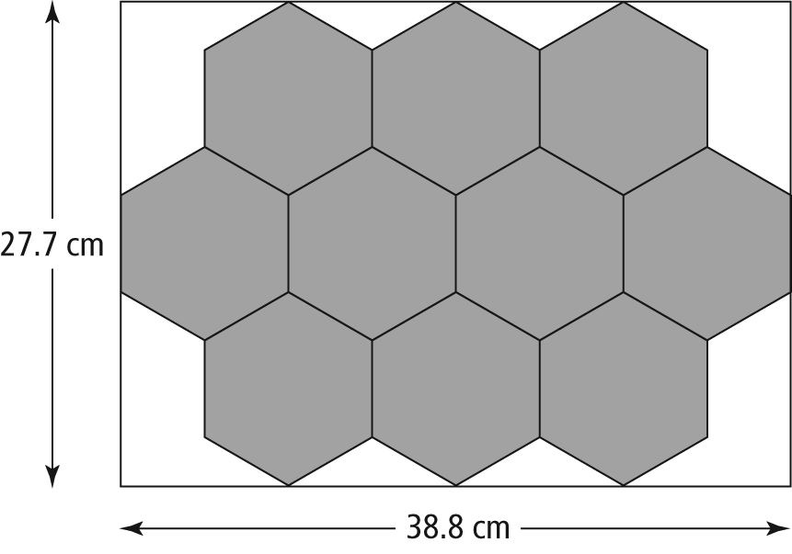
Jake will be able to fit 10 speakers into the speaker casing.

