Chapter 4 Gifted and Enrichment
1. Examine the object below. Using a ruler, create an enlargement of the object, using a scale factor of 2.5.  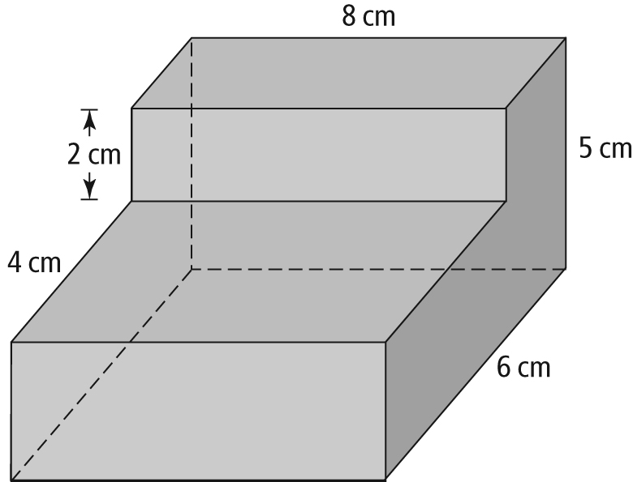 | 2. The scale diagram below shows a cross-section of a pipe. The scale used to create the diagram is 1:5. What is the inside diameter of the actual pipe?  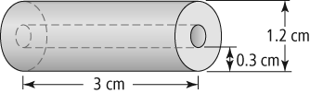
3. Triangle B is drawn from Triangle A using a scale of 2:1. If the two legs of Triangle A are 29 mm long, what is the approximate length of the hypotenuse of Triangle B?

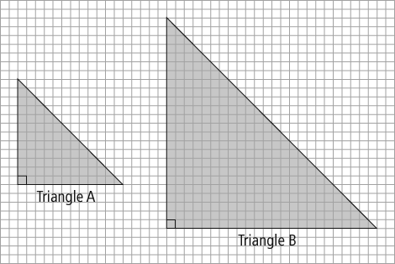

4. Jake has designed hexagonal speakers for his car stereo. To achieve the best sound, he wants to fit as many speakers as possible into the speaker casing. The casing is 27.7 cm by 38.8 cm. Each speaker has sides that are 5.5 cm long. How many speakers can Jake fit into the casing? Draw a scale diagram to show your thinking. What assumption did you make?

