Chapter 6 Gifted and Enrichment
1. If the area of the first iteration of the Sierpinski triangle fractal is 1 unit², what is the area of the smallest triangle in the fifth iteration?
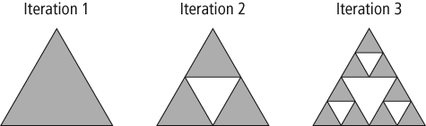

2. In a table tennis tournament, a player who wins a match plays against another winning player in the next round. A player who loses a match is eliminated. A tournament takes 8 rounds to find the winning player.
a) Write an equation that can be used to calculate how many players can enter the tournament.
b) How many players can enter the tournament?

3. For safety reasons, divers need to be aware of the pressure as they dive. At a depth of 3 m, the pressure is approximately 130 kPa (kilopascals) and at
8 m it is approximately 180 kPa. At what depth is the pressure 2.5 times that of the pressure at 0 m? Explain your reasoning.

4. Joseph is considering two different payment plans for his gym membership. Plan A charges a flat fee of $45.00 each month. Plan B charges a flat fee of $25.00 each month plus $2.50 per visit.
a) Write a linear equation to represent each plan.
b) Graph the two linear relations.
c) Use the graph to help you identify when the two plans would have the same monthly cost.
d) If Joseph planned to visit the gym 10 times per month, which plan would cost less?

