Chapter 7 Gifted and Enrichment Answers

1. a) (5x)³ – 3x(3x)(5x) = 125x³ – 45x³
= 80x³
The volume of the shape is 80x³.
b) The surface area is made up of six faces, two of which are missing a square, plus the four rectangles on the inside of the hole.
6(5x)² – 2(3x)² + 4(3x)(5x)
= 150x² – 18x² + 60x²
= 192x²
The surface area of the shape is 192x².
2. Use algebra tiles to model the division statement .
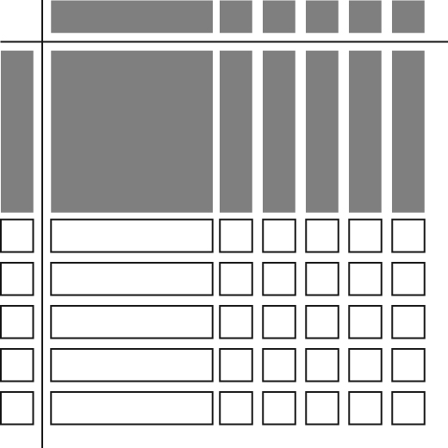
The missing dimension is x + 5.
3. a) w = 4x + 3
A = (4x + 3)(12x + 14)
A = 48x² + 56x + 36x + 42
A = 48x² + 92x + 42
An expression for the area of the field is 48x² + 92x + 42.
b) A = 48(6)² + 92(6) + 42
A = 1728 +552 + 42
A = 2322
The area of the field is 2322 m².
c) Example: A = (4x + 3)(12x + 14)
A = [4(6) + 3][12(6) + 14]
A = (24 + 3)(72 + 14)
A = (27)(86)
A = 2322
The area of the field is 2322 m².
4. The radius of circle is .
Area of circle =
=
Area of rectangle = x(3x)
= 3x²
The ratio of the area of the rectangle to the area of the circle is .

