Chapter 7 Gifted and Enrichment
1. A square hole is cut all the way through a cube.  a) Find the volume of the shape that remains.  b) Find the surface area of the shape.  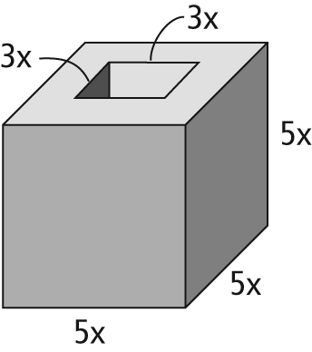 | 2. Determine the missing dimension of the rectangle.  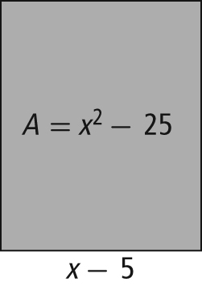
3. A field is (4x + 3) m wide. It is 5 m longer than triple the width.
a) What is an expression for the area of the field?
b) If x = 6, what is the area of the field?
c) Use another method to answer b).

4. A circle is inscribed in a rectangle that is three times as long as it is wide. What is the ratio of their areas?

