Using Translations

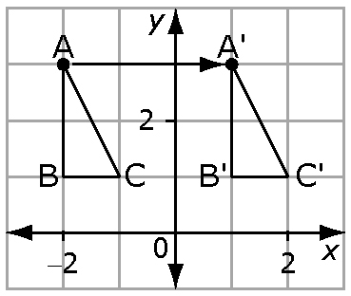
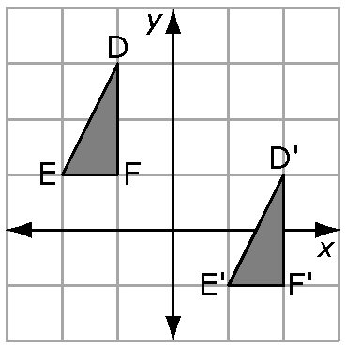
Transformations include translations, reflections, and rotations. A translation is a slide along a straight line. The slide can be horizontal, vertical, or oblique.

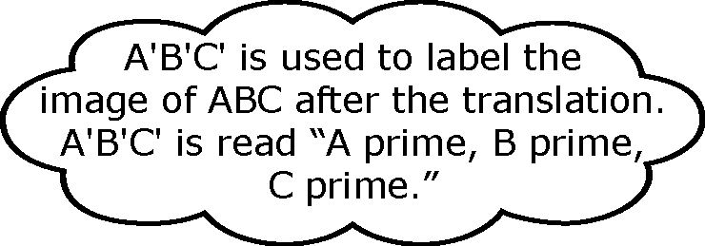

This is a translation This is a translation
3 units horizontally 3 units horizontally
to the right. to the right and 2
units vertically down.

1. Describe each translation.  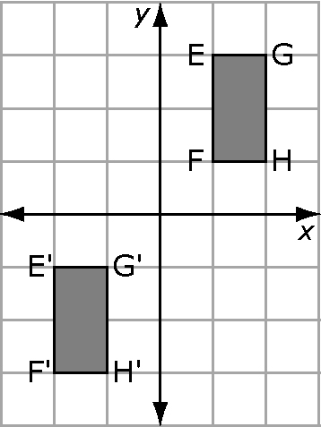  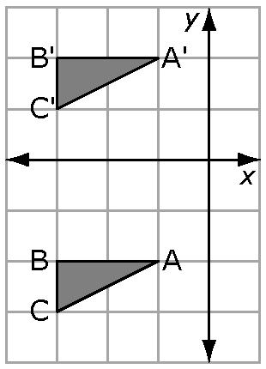  a) b) | 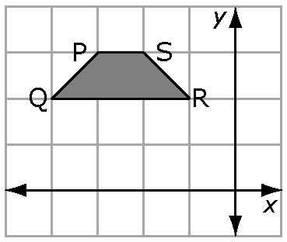  2. Use the diagram to help  answer the questions.  a) If figure PQRS is  translated 6 units  horizontally to the  right, what are the  coordinates of P'?  b) If figure PQRS is translated so that P'=(3, 2) and Q'=(2, 1), describe the translation.
Drawing Reflections

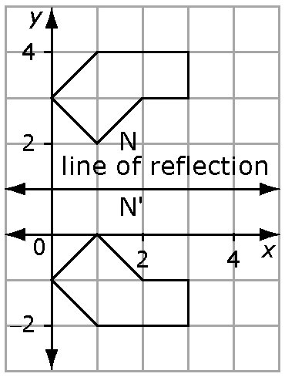
A reflection is a mirror image in a line of reflection. A point
and its reflection are the same distance from the line of
reflection.

The line of reflection is a horizontal line at y = 1.
Both N and N' are 1 unit from the line of reflection.

3. Draw the reflection image for each figure.
C = × d
C ≈ 3 × 10
‪ C ≈ 30
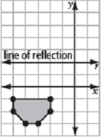  a) | 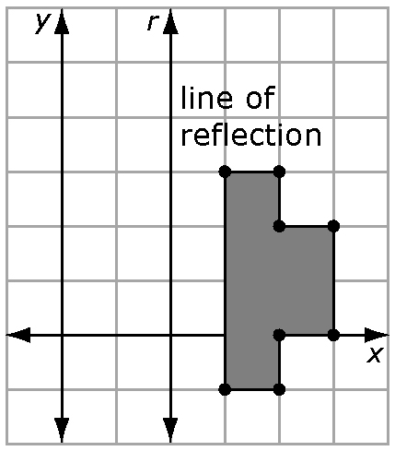  b)
Drawing Rotations

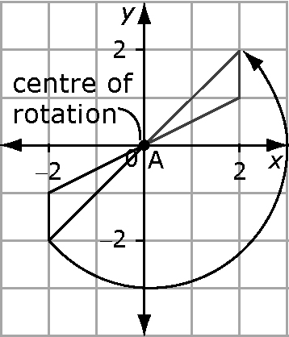
A rotation is a turn about a point or centre of rotation.
The rotation can be clockwise or counter-clockwise.

The centre of rotation is at A.
The rotation is 180° counter-clockwise about A.

4. Figure DEFG is rotated 90° about its centre of rotation, A.

a) Draw the rotation image D'E'F'G'.
b) What are the coordinates of D', E', F', and G'?
c) Describe the rotation if it had been in a counter-clockwise direction.
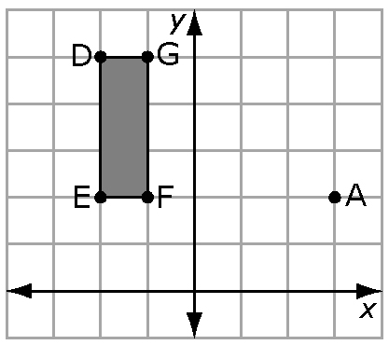

Using Surface Area

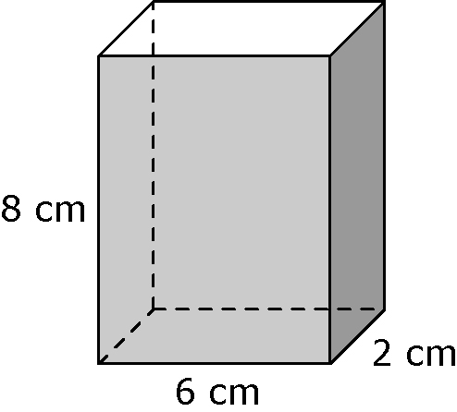
Surface area is the sum of the areas of all the
faces of a 3-D object.
A right rectangular prism has six faces. Three of its faces
are different sizes.
Front and back have the same area: A = 6 × 8 = 48
Top and bottom have the same area: A = 6 × 2 = 12
Two ends have the same area: A = 2 × 8 = 16
Total surface area = 2(48 + 12 + 16) = 152
The surface area is 152 cm².

5. Calculate the surface area of each right rectangular prism.  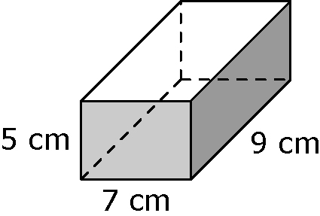  a)  b) The dimensions are 3 m by 4 m by 6 m. | 6. How many faces does each solid have?  a) right triangular prism  b) cylinder

