Chapter 10 BLM Answers

BLM 10–2 Chapter 10 Get Ready
1. a) 2 cm b) 1.5 cm
2. a) Examples: ~6 cm, ~4.5 cm
b) 2 × 3.14 = 6.28 cm, 1.5 × 3.14 = 4.71 cm
3. a) Example: any estimate between 20° and 30°
b) Example: any estimate between 45° and 55°
c) Example: any estimate between 100° and 110°
4. a) 25° b) 48° c) 105°
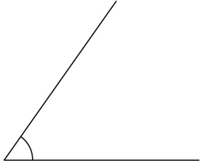
5. Example:

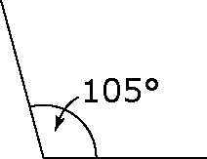
6.

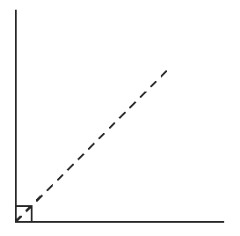
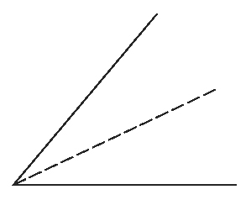
7. a) b)

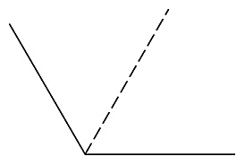
c)

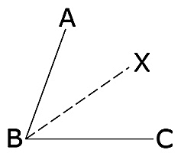
8.

Example: The measure of ∠ABX is 35°, which is of 70°.

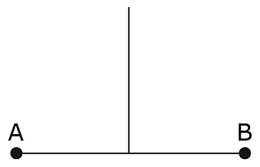
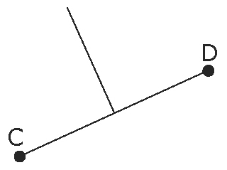
9. a) b)

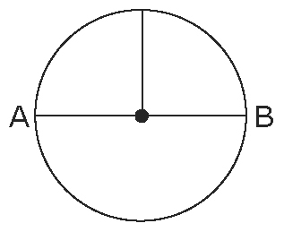
10.

BLM 10–3 Chapter 10 Warm-Up
Section 10.1
1. Incorrect. The circle at –1 should be an open circle.
2. 18 < x < 25 3. x > 2
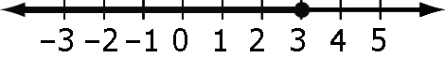
4.

5. x > –5.5 6. 115° 7. 100° 8. 67°
9. 235° 10. A0 = B0 = C0
Section 10.2
1. The inequality reverses. 2. > x
3. ∠DCB and ∠DEB are inscribed angles. They both lie on the same arc so they are both equal to each other.
4. 135°
5. Example:
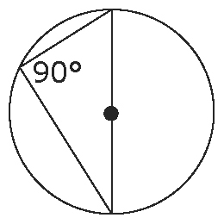
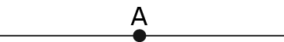
7.

8. 13 cm 9. 3 cm
10. Example: wall and floor
Section 10.3
1. x = 48°; y = 48° 2. x = 35°; y = 45°
3. x = 150°; y = 30° 4. CD = 10 cm
5. Example: HJ ⊥ CF
6. 11.3 cm 7. 15 cm 8. x = 66°
9. ∠ABC = ∠BCA = ∠BAC = 60°
∠CAD = 30°; ∠ACD = 120°; ∠CDA = 30°
10. ∠D = 95°; ∠E = 30°; ∠F = 55°
BLM 10–4 Chapter 10 Problems of the Week
1. a) Example: Each hour is approximately
or 130º.
b) Example: The length of the day is 12 h.
c) Example: The string is the radius, the spike is the centre, the shadow is a radius, the distance covered each hour is an arc, and central angles are produced by marking the shadow at each hour.
2. 0.5 m 3. 307.30 cm²
4. a) Example: All angle measures are the same.
b) Example: ∠AXB is twice any other angle for the circle.

BLM 10–5 Section 10.1 Extra Practice
1. a) ∠ABC = ∠AEC = ∠ADC = 59°. Example: An inscribed angle is half the measure of a central angle subtended by the same arc.
b) ∠ABC = 61°, ∠AEC = 122°. Example: Inscribed angles subtended by the same arc of a circle are equal. A central angle is twice the measure of an inscribed angle subtended by the same arc.
2. a) BC = 5 units b) BC = 5 units
3. 11.3 m
4. a) m = 40°, n = 100°, x = 40°, y = 40°
b) m = 22.5°, n = 27.5°, x = 80°
BLM 10–7 Section 10.2 Extra Practice
1. Example: Segment CX is a perpendicular bisector of AB. Segment CY is a perpendicular bisector of DE. Therefore, C is the centre of the circle.
2. CD = 5.7 units. Example: Segment CD bisects AB. If a bisector of a chord in a circle passes through the centre, then the bisector is perpendicular to the chord. ∠CDA = ∠CDB = 90°. AD = BD = 4 units. CE is a radius of the circle. Use the Pythagorean relationship.
3. CB = 6.4 units, ED = 1.4 units, EF = 12.8 units
4. CF = 12 units, CB = 12 units, BD = 8 units,
CD = 8.9 units, DE = 3.1 units
5. Tipi ring = 6.9 m. Pole = 6.7 m.
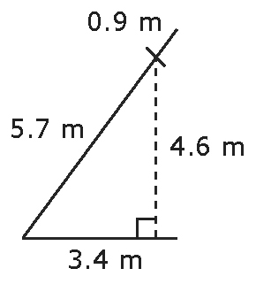
Example: Example:
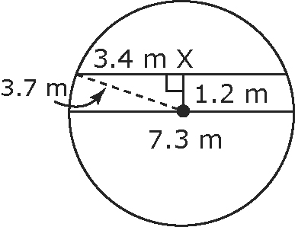

BLM 10–10 Section 10.3 Extra Practice
1. a) Isosceles triangle. Example: RCT is an isosceles triangle because RC and TC are congruent radii.
b) ∠TRC = 30°
c) PN = 8 cm. Example:

2. a) ∠OEF = 17° b) AX = 8 cm
c) DA = 4.9 cm
3. a) BE = 12 km
b) Sarah, by 1 km. Example: DE = 13 km (Pythagorean relationship)
Jorge = 13 km + 6 km = 19 km
Sarah = 6 km + 6 km + 6 km = 18 km
4. Chord tangent = 20 cm. Example:
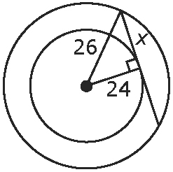
5. The centres are 6.8 m apart.
BLM 10–13 Chapter 10 Test
1. A 2. B 3. A 4. C
5. 43° 6. 43° 7. 42°
8. a) 90° b) or 3.9 c) 25°
9. a) 26 cm b) 16 cm
10. 2.6 m

