Chapter 11 Warm-Up

Section 11.1

1. Point A is the centre of the circle. Find the measures of x and y.
2. Point X is the centre of the circle. AC is the diameter. The radius is 6 cm. Determine each side length of ABC, to the nearest tenth.
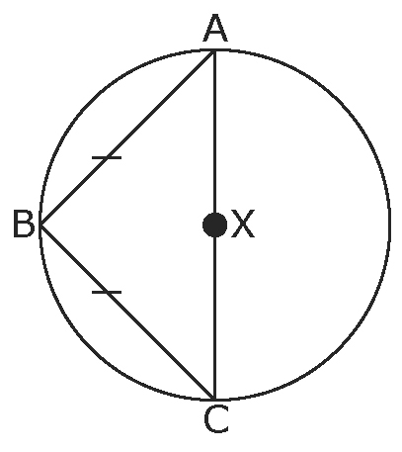
3. Point X is the centre of the
circle. AB is the diameter. Determine ∠y.
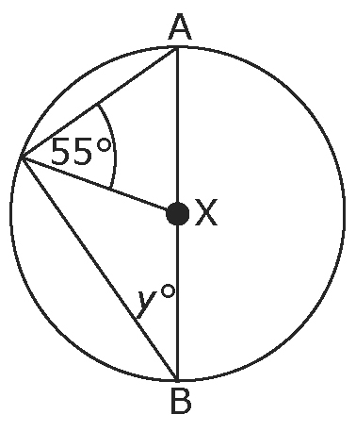
4. Point X is the centre of the circle. AC is the diameter. BC is tangent to the circle. Determine the length of AX, to the nearest tenth.
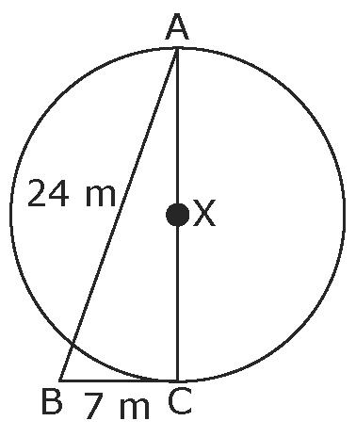

5. Draw a circle. Then, draw a line tangent to the circle.
Mental Math
6. The graph shows categories of books the Wong family signed out from the library. Approximately how many books did the Wong family sign out?

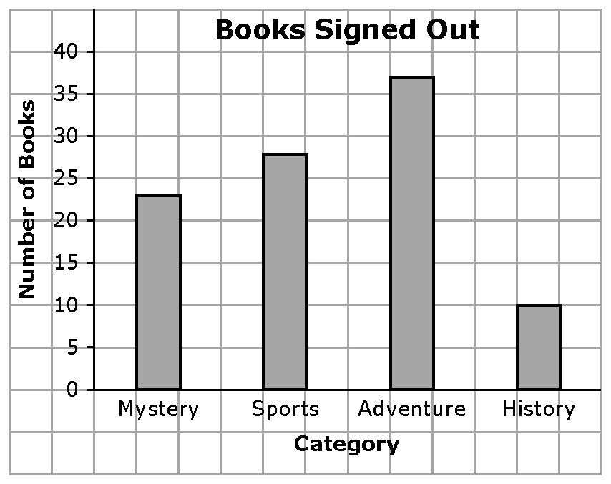

7. Which category of book did the Wong family sign out most often?
8. What percent of books are considered Adventure or Sports?
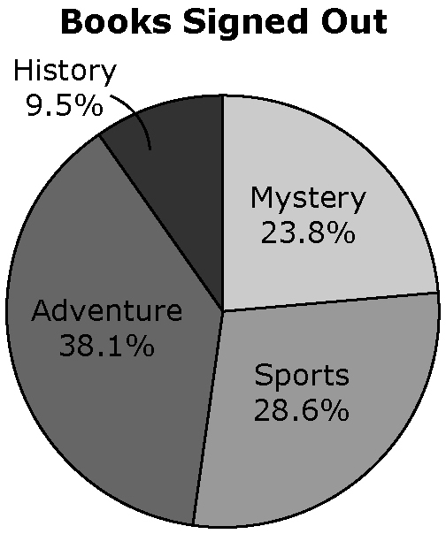
9. From this data, can you determine what category the Wong parents prefer? Explain.
10. Is it possible that the Wong family signed out books other than the categories shown? Explain.
Section 11.2
1. Point B is the centre of the circle. AC is the diameter of the circle. Line k is tangent to the circle at point C. Determine the measure of θ.
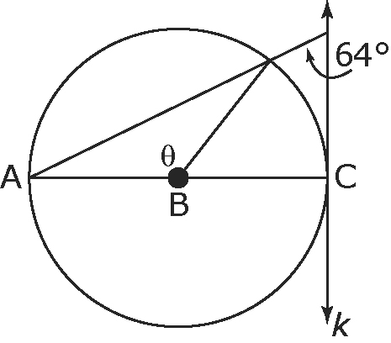
2. Point C is the centre of the circle. What is the measure of JNL?
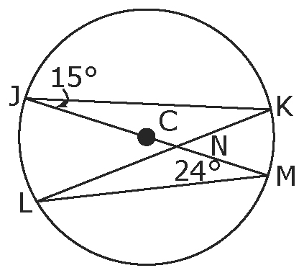
3. Identify seven factors that may affect how data are collected.
4. Customers at a restaurant were asked the following question, “What is your favourite dish at our restaurant?” Identify bias in the question.
5. Develop a survey question to determine the favourite academic subject of students at your school.

Mental Math
6. What percent is 30 of 3000?
7. What percent is 300 of 3000?
8. Calculate 25% of 1200.
9. Write the first letter of the alphabet, next the third letter, and then the fifth letter. Continue the pattern for the rest of the alphabet.
10. Starting with B, write every other letter of the alphabet.
Section 11.3
1. You plan to conduct a survey about how students feel about homework. When do you think would be the most appropriate time to conduct the survey: halfway through the school year, just before final exams, or during the summer? Give a reason.
2. Develop a survey question to find out if students think homework on a daily basis is necessary.
3. A high school is planning a new course for 240 grade 9 students.
a) Identify each of the following types of samples.
• All grade 9 students are invited to respond.
• Students in gym class on Monday morning are surveyed.
b) Will the survey results for the samples in part a) represent the population? Explain.
4. Mary is running for student council. Two days before the election, she decides to poll students about whether they will vote for her.
a) She surveys every third student that walks into the school. What type of sample is this?
b) Is there a bias in her method of sampling? Explain your thinking.
5. Identify and describe the type of sample you would use to find out how many students exercise for 30 min every day.

Mental Math
6. A total of 60% of the workers at a fast food restaurant are willing to go on strike for a 10% increase in pay. There are 150 employees and they earn an average of $9.10 per h.
a) How many people are willing to strike?
b) On average, how much do workers hope to earn per hour?
7. A total of 36 out of 120 grade 9 students prefer pizza to grilled cheese for lunch. What percent of students does this represent?
8. A reunion was held for a family that lives in Alberta and Manitoba. There are 200 family members living in each province. A total of 10% of the family from Alberta did not attend, while 80% of the family from Manitoba did attend. How many family members were at the reunion?
9. There are 300 people running a race. A total of 80% finish within 3 h. Of those that do not finish in this time, 10% do not finish the race. How many people do not finish the race?
10. A chain store decides to survey 25% of the population in three towns about a new product. The population of the towns are respectively 4000, 900, and 800 people. How many surveys must be conducted?

Section 11.4
1. Give an example to help explain how cost might affect the results of a survey.
2. A marketing company surveys college students attending three different colleges in Canada. Explain how this could be a random sample.
3. What type of sample would you consider to be most cost effective? Support your choice.
4. All 340 graduating students from one high school in a city are surveyed about the careers they plan to pursue. A total of 122 students plan to pursue an education-related career. Based on the results, the local university predicts that 36% of new students will register in education. Is this a reasonable prediction? Explain why or why not.
5. All 90 students in grade 9 were surveyed about the activity for the year-end party. The activity choices were rock climbing, swimming, canoeing, hiking, and badminton.
a) What is the theoretical probability that a student will choose canoeing?
b) What assumptions did you make?
c) Would you use theoretical probability or experimental probability to help determine the year-end activity? Explain.

Mental Math
6. Use a bar graph to display the data about favourite ice cream flavours: 15 prefer chocolate; 10 prefer strawberry; and 5 prefer vanilla.
7. Use the data from #6 to create a table that shows the percent of people who prefer each flavour. Show each percent to the nearest whole number.
8. Use the data from #7 to create a circle graph.
9. Is it appropriate to display the data for #7 in a line graph? Explain why or why not.
10. If the survey question had offered “Other” as a choice, would the results be different? Explain your thinking.

