Chapter 6 BLM Answers

BLM 6−1 Chapter 6 Math Link Introduction
1. a) 4 min = 22 km/h; 5 min = 20 km/h
b) Example: The value of t increases in 3s; the value of s decreases in 6s.
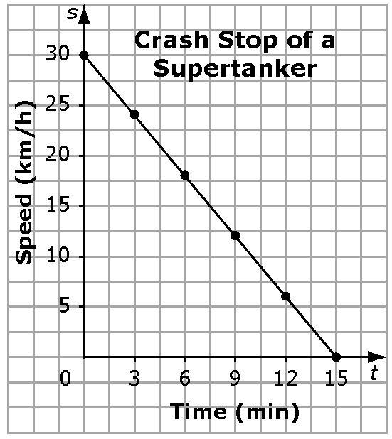
2. a)

b) Time is the variable that is changed.
c) Speed is the variable that changes in response.
d) Example (based on #1b): Yes, the t-values increase by 3 units. The s-values decrease by 6 units.
3. a) –2 b) +30 c) Answers are in italics.
Time, t (min) | Speed, s (km/h) | Pattern
Time, t (min) | Speed, s (km/h) | Multiply t by –2 | Add 30
0 | 30 | 0 | 30
1 | 28 | –2 | 28
2 | 26 | –4 | 26
3 | 24 | –6 | 24
4 | 22 | –8 | 22
5 | 20 | –10 | 20
6 | 18 | –12 | 18
d) s = –2t + 30
4. a) 9 km/h b) 7.33 s
c) Example for a): Substitute t =7 into the equation and solve for s. Example for
b): Substitute s = 8 into the equation and solve for t. After comparing their solution with a classmate, have students correct any errors.

BLM 6−2 Chapter 6 Get Ready
1. a) | Time (t) | Distance Travelled (d)
 | 0 | 5
 | 2 | 8
 | 4 | 10

b) | Slowing Down  Time (t) | Speed  (s)
 | 5 | 60
 | 6 | 50
 | 7 | 40
2. a) Yes, it makes sense because there can be times and temperatures between the ones labelled on the graph.
b) No, it does not make sense because you can sell only whole hamburgers, not fractions of a hamburger.
3. a) This is a linear relation as the difference between consecutive values in each row is the same (15 m in the first row and 2.1 m/s in the second row).
b) This is not a linear relation because the difference between consecutive values of h is not consistent even though the difference in consecutive values of t is consistent.
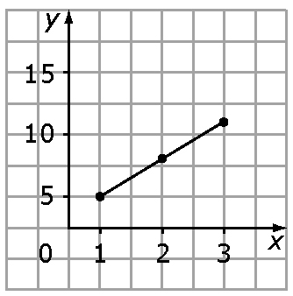
4. (60, 10.5)
5. a) | x | y
 | 1 | 5
 | 2 | 8
 | 3 | 11

b) | n | 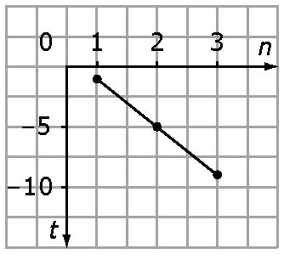  t
 | 1 | –1
 | 2 | –5
 | 3 | –9

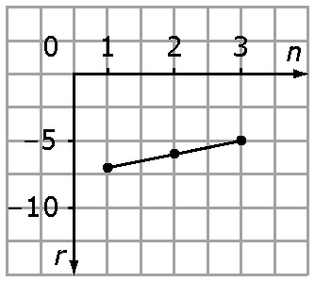
c) | n | r
 | 1 | –7
 | 2 | –6
 | 3 | –5

BLM 6−3 Chapter 6 Warm-Up
Section 6.1
1. Example: A trinomial has one more term than a binomial.
2. 3. Example: Add the exponents of the powers 2 + 1.
3. x² – 9x – 6
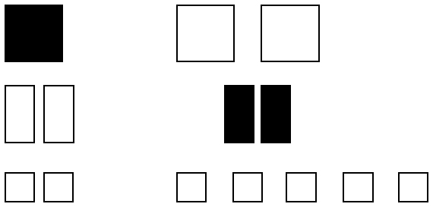
4. a)

b) –x² – 7
5. 14x + 8
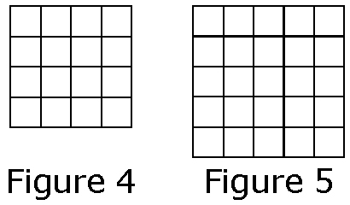
6. a)

b) Example: Add 3, add 5, add 7, add 9.
7. 7 8. –13 9. 4 10. 12

Section 6.2
1. a) Trinomial b) –4+ 5x – 7
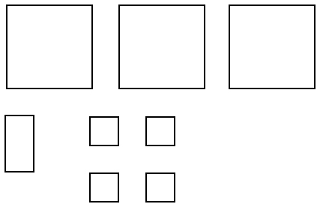
2.

3.
Row Number, r | Number of Happy Faces, h
1 | 2
2 | 5
3 | 8
4. a) Examples:
• Each row has three more happy faces than the previous one.
• Multiplying the row number by 3 and then subtracting 1 gives the number of happy faces in that row.
b) h = 3r – 1
5. h = 3(17) – 1 = 50; 50 happy faces
6. A(0, 2); B(1, 3); C(2, 4); D(3, 5); E(4, 6)
7. Y-values are approximate for B to D. Example: B(4, 11); C(6, 17); D(8, 23)
8. At home
9. 3 km; approximately 0.75 km
10. Example: The value of d stays the same.

Section 6.3
1. a) p = + 70 b) 22 months
2. Example: Approximately $1900
3. Example: Yes, it makes sense to have values for sales between and beyond given sales values.
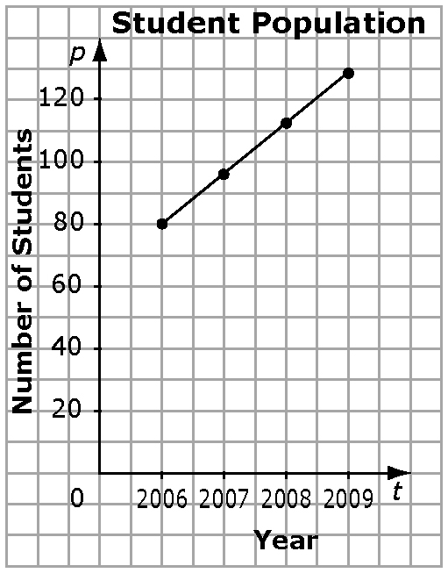
4.

5. Example: For each y-coordinate, the corresponding x-value is 4.
6. Example: Each y-value is five times the corresponding x-value. Or, each x-value is
the corresponding y-value.
7. Example: Each x-value and corresponding
y-value add to 9.

8. Example: Each y-value is 8.
9. Example:
x | y
0 | 3
1 | 5
2 | 7
3 | 9
10. Example:
x | y
0 | 6
1 | 3
2 | 0
3 | –3

BLM 6–4 Chapter 6 Problems of the Week
1. Yes.
2. a) y = 4x + 6
b)

c) Example: Yes, because the value of each variable changes by the same amount each time.
3. a)

b) s = 6t c) s = 4t + 2; 10 d) 3, does not exist
4. a) Example: Yes, because the value of each variable changes by the same amount each time
b) Example: For each half-point increase in voltage, current increases by 30.
c = 20V; when V = 1, c = 20
5. a), b)
x | y =  2x + 1 | y =  3x + 3 | y =  5x + 10
1 | 3 | 6 | 15
2 | 5 | 9 | 20
3 | 7 | 12 | 25
4 | 9 | 15 | 30
5 | 11 | 18 | 35
6 | 13 | 21 | 40
7 | 15 | 24 | 45
8 | 17 | 27 | 50
9 | 19 | 30
10 | 21 | 33
11 | 23 | 36
12 | 25 | 39
13 | 27 | 42
14 | 29 | 45
15 | 31 | 48
16 | 33
17 | 35
18 | 37
19 | 39
20 | 41
21 | 43
22 | 45
23 | 47
24 | 49
c) 1, 2, 4, 8, 16, 28, 32, 44

BLM 6–5 Section 6.1 Extra Practice
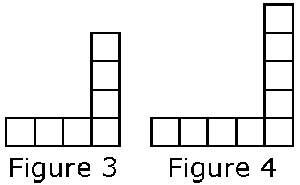
1. a)

b) | Figure Number, f | 1 | 2 | 3 | 4
 | Number of Squares, s | 3 | 5 | 7 | 9
c) Each figure contains two more squares than the previous one.
d) s = 2f + 1 e) 31 f) 34
2. a) | Figure Number, f | 1 | 2 | 3 | 4 | 5
 | Value, v | 1.5 | 5.5 | 9.5 | 13.5 | 17.5
b) v = 4f – 2.5 c) 377.5 d) 60
3. a) t = 5d + 11 b) r = 1.5c – 3.6
4. a) m = 45 + 0.15t
b) Example:
Monthly Bill, m | 1 | 2 | 3 | 4
Number of Text Messages, t | 3 | 5 | 7 | 9
c) $48 d) 233 messages; the $0.05 remainder is not enough for a text message

BLM 6–6 Section 6.1 Math Link
1. a), b) Example: 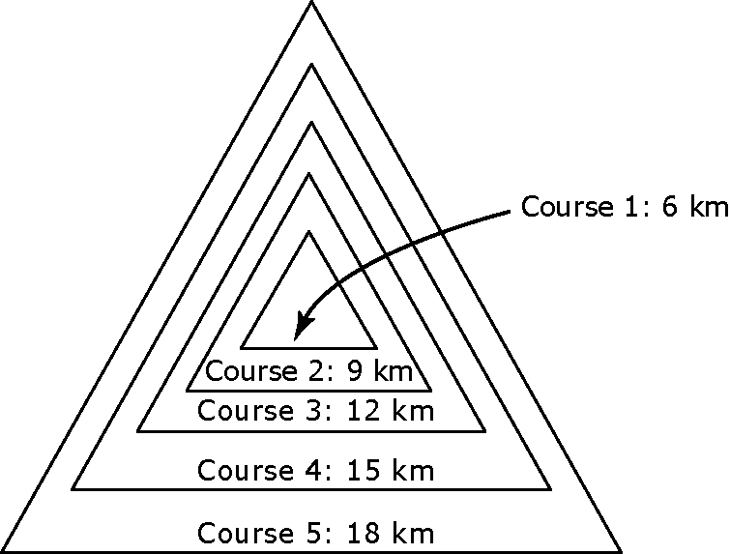
2. a)–c) Example:

Course Number, n | Course Distance, d (km)
1 | 6
2 | 9
3 | 12
4 | 15
5 | 18
d) d = 3n + 3
3. a)–c) Example: Problem: How long would Course 7 be? Solution: 24 km; 24 = 3(7) + 3. Check: Left Side = 24;
Right Side = 3(7) + 3 = 24;
Left Side = Right Side

BLM 6–7 Section 6.2 Extra Practice
1. a) 275 km. Example: Locate 3 on the x-axis, and then find the corresponding coordinate on the y-axis. b) 3.33 h
2. a) 3.5 b) 1.75 3. a) –0.8 b) –4
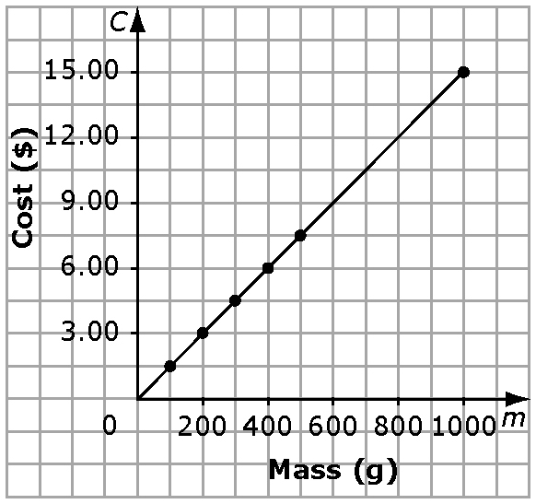
4. a)

b) $12.00 c) 700 g
5. a) Example: It may be reasonable only to interpolate or extrapolate based on whole kilometres because the rental company may not charge for partial kilometres.
b) $170 c) 177 km

BLM 6–8 Section 6.2 Math Link
1. a) Answers are in italics.
Number of Kedges, k | Distance, d (km)
1 | 0.65
100 | 65
500 | 325
1000 | 650
2000 | 1300
b) d = 0.65 k
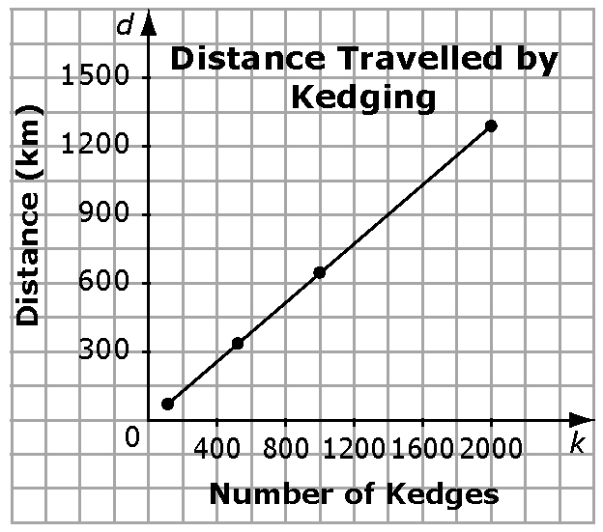
2.

3. a) Example: 1650 kedges b) It would take 1693 kedges to cross the ITCZ.
4. As a class, have students describe the skills learned in Chapter 6.

BLM 6–10 Section 6.3 Extra Practice
1. a) Example:
Time, t (h) | 1 | 2 | 3 | 4 | 5
Distance, d (km) | 90 | 180 | 270 | 360 | 450
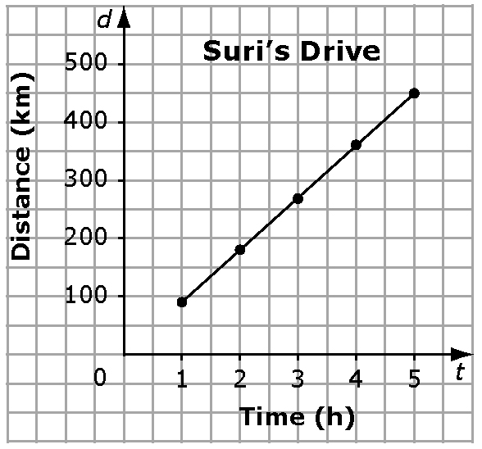
b)

c) 7 h
2. Examples:
a) | a | 1 | 2 | 3 | 4 | 5
 | b | –17 | –19 | –21 | –23 | –25
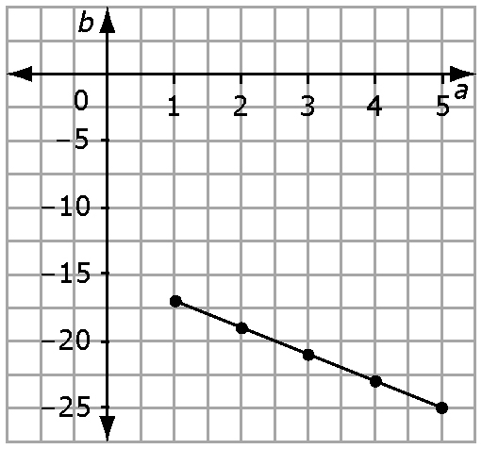
b) | x | 0 | 1 | 2 | 3 | 4
 | t | –3 | –3 | –3 | –3 | –3

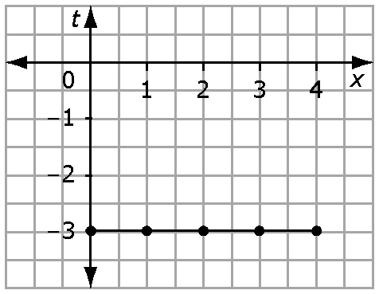
c) | f | 1 | 2 | 3 | 4 | 5
 | g | –1.75 | –1.5 | –1.25 | –1 | 0.75

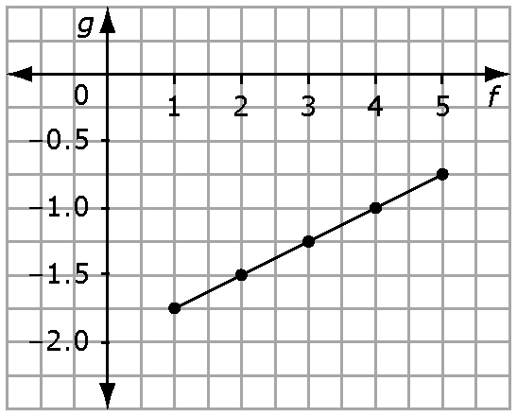
3. a) y = 4
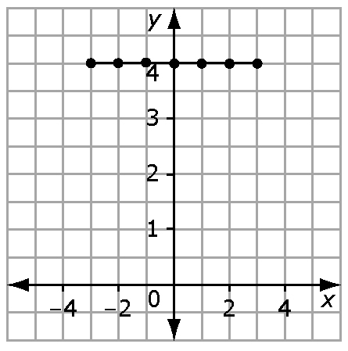
b) g = 0.5a + 3
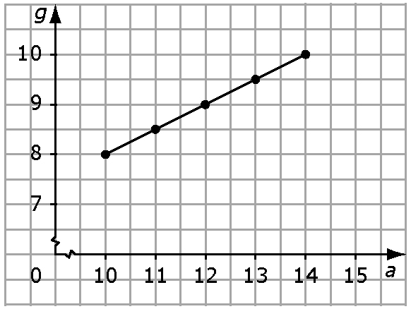
c) d = – 2
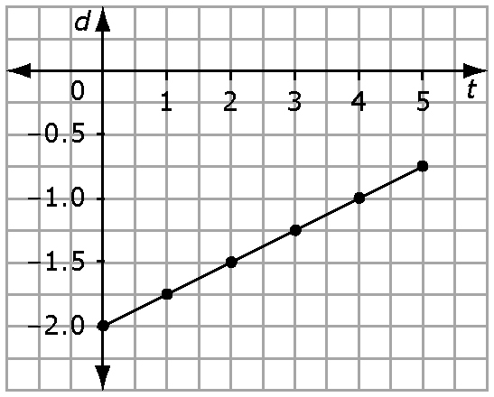

4. a) f = 0.083d b) 408 km
c) Example: Yes, assuming it is possible to drive parts of a kilometre and use parts of a litre of gas

BLM 6–11 Section 6.3 Math Link
1. a)–d) Examples:
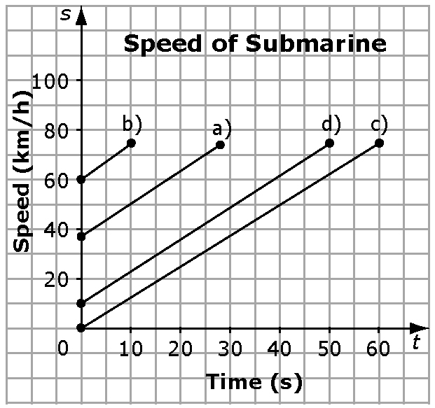
Equation:
b) a starting speed of 0 km/h
Time, t (s) | Speed, s (km/h)
0 | 61.66
10 | 74
c) a starting speed of 61.66 km/h
Time, t (s) | Speed, s (km/h)
0 | 0
10 | 12.33
20 | 24.66
30 | 36.99
40 | 49.33
50 | 61.66
60 | 74
d) a starting speed of 12.33 km/h
Time, t (s) | Speed, s (km/h)
0 | 12.33
10 | 24.66
20 | 36.99
30 | 49.33
40 | 61.66
50 | 74
2. Look for at least one similarity and one difference. Example:
Similarities:
• All graphs end at 74 km/h.
• The equations are the same.
• The graphs show the same angle.
Differences:
• Each graph starts at a different y-coordinate.

BLM 6–12 Chapter 6 Test
1. D 2. A 3. 9 4. –6
5. C = 7 + 0.03p
6. a) e = 50 + 0.75t
b) Example: Left Side = 87.50;
Right Side = 50 + 0.75(50) = 87.50;
Left Side = Right Side

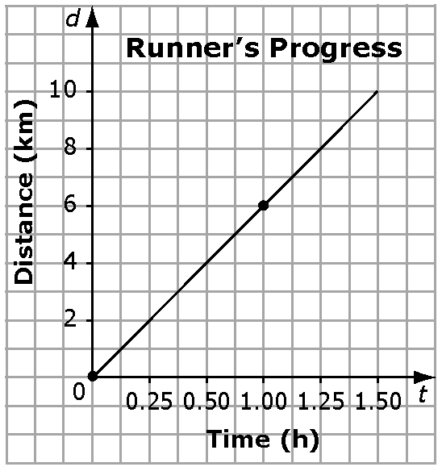
7. a)

b) 1 h 40 min 8.
9. a) s = 3t + 2 b) 29 students
c) 16 tables d) 17 tables. It is not possible to set up partial tables, so a whole 17th table is needed even though only two students will sit there.

BLM 6–13 Chapter 6 Math Link: Wrap It Up!
2. a) Example:
Number of Days, d | 1 | 2 | 3 | 4 | 5
Total Food Energy, C | 6500 | 13 000 | 19 500 | 26 000 | 35 500
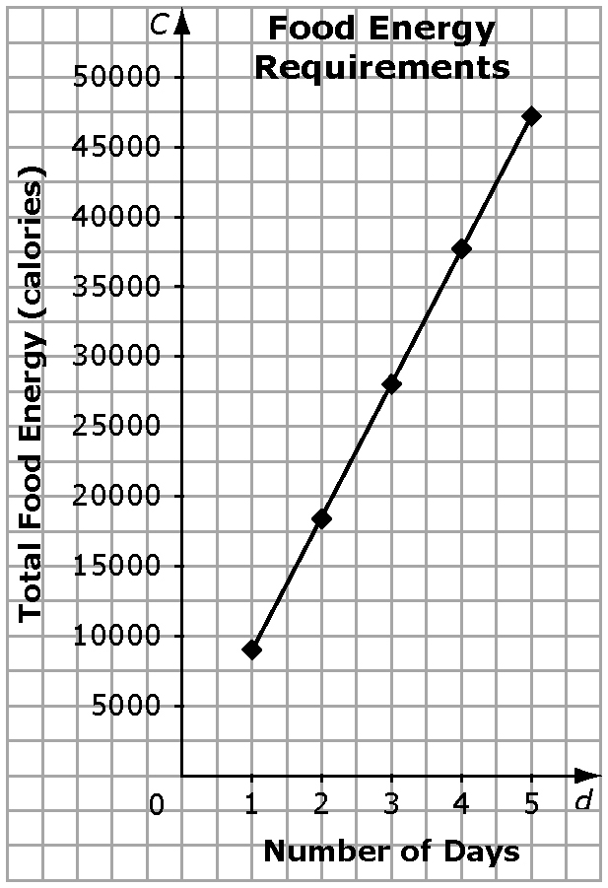
b)

3. a) Example: If we decided to canoe back to Fort McMurray, it would take four more days. How much food energy would be required for a nine-day trip?
b) 58 500 calories

