Chapter 7 Warm-Up

Section 7.1

1. Develop an equation relating the number of lines to the figure number. Use this equation to determine the number of lines in the hundredth figure.
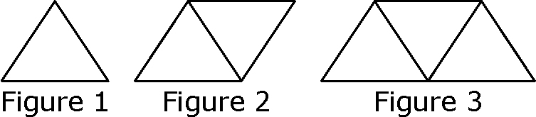
2. Create a table of values of this linear relation. Use it to write the equation of the line.
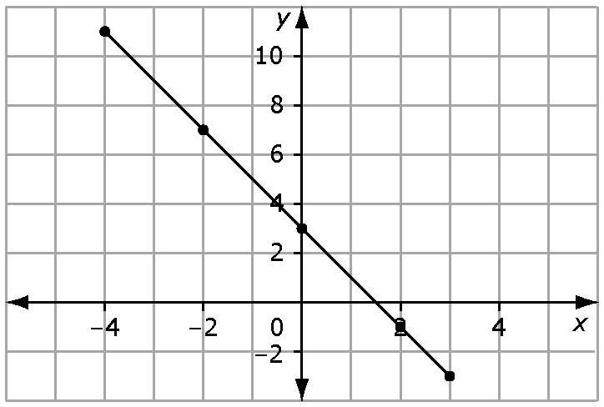
3. The time it takes to cook a roast depends upon its mass. Using the graph, determine the approximate mass of a roast that takes 2.5 h to cook.
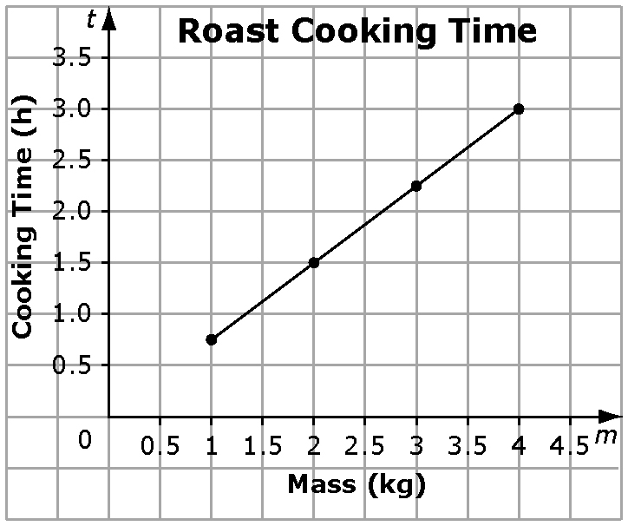
4. On New Year’s Day, you are available to babysit. You will charge $25 for being available for the evening and then $8 for each hour of babysitting. Graph this relation for the first 5 h of babysitting. Then, write an equation.
5. Is this the correct graph for
y = 10? Explain why or why not.
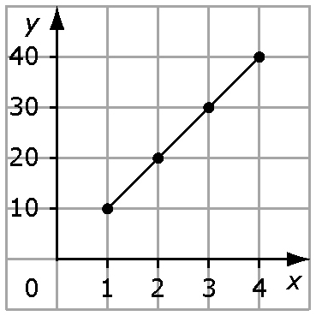

Mental Math
6. Evaluate:
7. Evaluate:
8. Evaluate: –1.5 × (–4)
9. Write 3² × 3⁵ as a single power.
10. Write as a
single power.

Section 7.2

1. A car rental company charges $20 for the day and 58¢ per kilometre used. Write an equation relating the number of kilometres to the rental charge, in dollars.
2. Graph the relation C = 2n + 6.
3. Draw a model to represent
(–2x)(3x). Then, record the product.
4. Find the product:
5. Determine the quotient:
Mental Math
6. Evaluate:
7. Find the product: (–1.2)( –7)
8. Expand: 3(2x – 5)
9. Multiply: –2(x + 5)
10. What product does this model show?
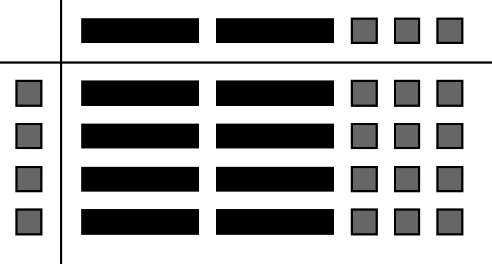
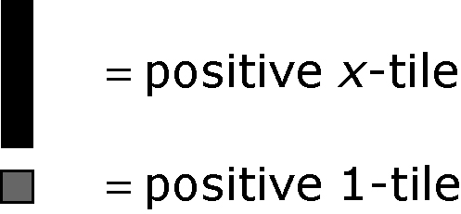

Section 7.3

1. Find the area of this figure.
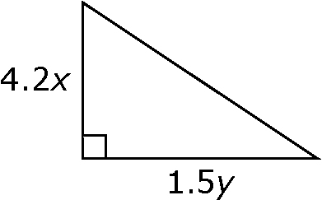
2. What is the missing width in this figure?
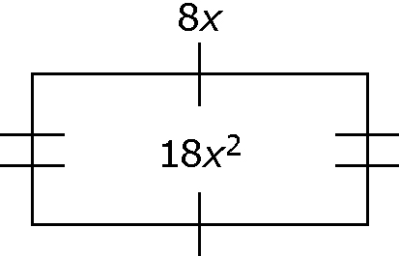

3. What multiplication statement is represented by the algebra tiles? Shaded tiles are positive and white tiles are negative.
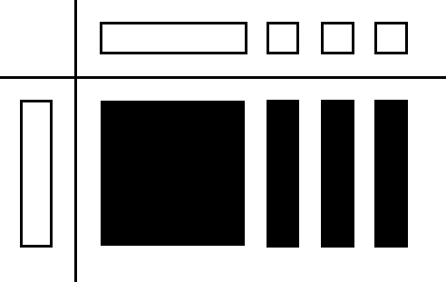
4. Expand: –3x(2x + 5y – 2)
5. Find the product of 1.5x and
–1.4x + 1.2.

Mental Math
6. Divide 6x + 8 by 2.
7. Divide 8x – 12y by –2.
8. What is 18xy divided by –3x?
9. What is –24x divided by –4x?
10. What is –2.4x² divided by 3x?

