The Geometer’s Sketchpad ® 4
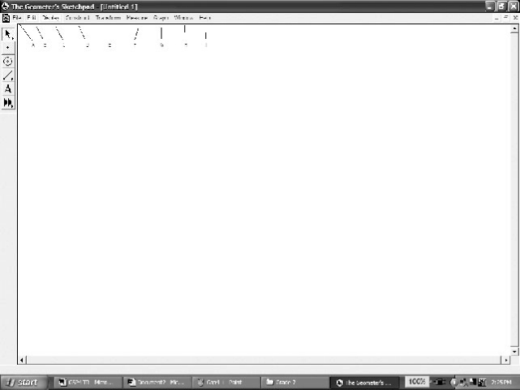
The Menus
File: Used to open, save, close, and print documents.
Edit: Used to undo and redo actions.
Display: Used to control an object’s appearance, and to
label/hide/animate objects.
Construct: Used to construct new geometric objects
based on selected objects in your sketch.
Transform: Used to apply geometric transformations to selected objects.
Measure: Used to give various measures based on selected objects in a sketch.
Graph: Used to create grids and axes for plotting points.
Window: Used to manipulate windows within The Geometer’s Sketchpad®.
Help: Used to access the available help files.
The Toolbox
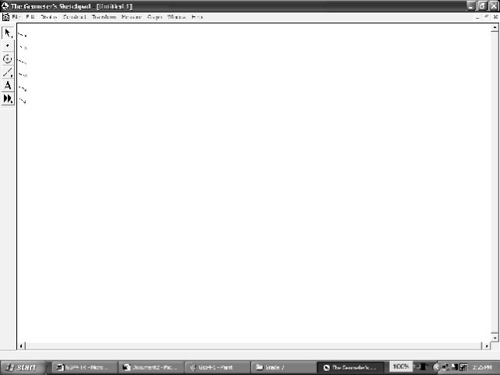
Selection Arrow Tool: Used to select, move, and
transform objects in a sketch.
Point Tool: Used to draw and plot points.
Compass Tool: Used to draw circles.
Straightedge Tool: Used to draw line segments, lines,
and rays.
Text Tool: Used to label/unlabel points and lines, and
to write text or captions within a sketch.
Custom Tool: Allows you to define and use custom tools.
Creating a New Sketch
• To create a new sketch window, from the File menu, choose New Sketch.
The Geometer’s Sketchpad® 4
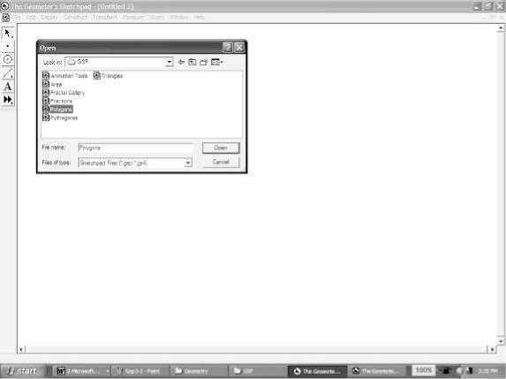
Opening an Existing Sketch
• From the File menu, choose Open….
• Navigate to the directory in which the sketch is saved.
• Click the name of the sketch you wish to open. Click Open.
Saving a Sketch
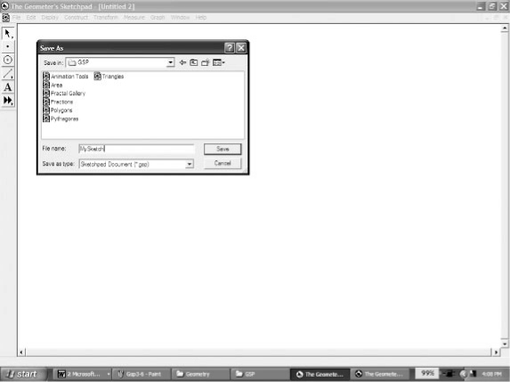
To save a sketch for the first time:
• From the File menu, choose Save
• Navigate to the directory in which you wish to save the sketch
• The Geometer’s Sketchpad® 4 will give the sketch a name in
the Filename text box. To use that one, click Save.
OR
• To give the sketch the name you wish, delete the given name,
and type the name you want into the Filename text box.
Click Save.
To resave a previously saved sketch:
• From the File menu, choose Save.
Closing a Sketch Without Exiting The Geometer’s Sketchpad® 4
• From the File menu, choose Close.
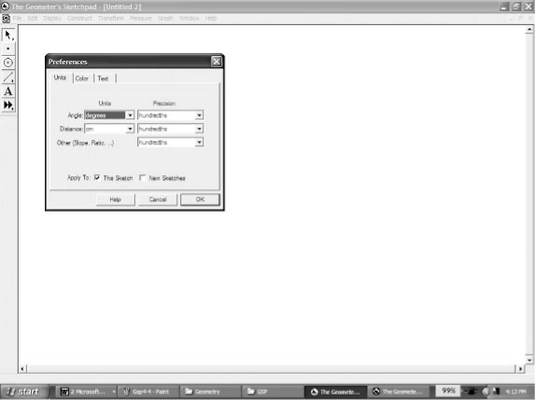
Exiting The Geometer’s Sketchpad® 4
• From the File menu, choose Quit.
Setting Preferences
• From the Display menu, choose Preferences….
• Click the Units tab.
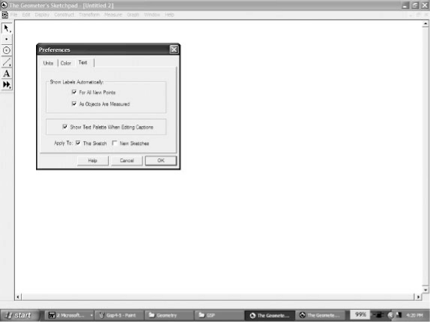
• Select the desired units and precision for Angle, Distance,
and Other.
• If you select Show Labels Automatically/For All New
Points, The Geometer’s Sketchpad® 4 will automatically
label points as you create them.
• If you select Show Labels Automatically/As Objects Are Measured, The Geometer’s Sketchpad® 4 will automatically label measurements you define.
The Geometer’s Sketchpad® 4
By clicking the appropriate box(es) next to Apply To:, you can also choose whether
your selected preferences for Units/Text will apply to only this sketch, or to this sketch
as well as all new sketches.
Selecting Points and Segments
• Click the Selection Arrow Tool. The cursor appears as an arrow.
• Move the cursor to the point or segment you wish to select. When the cursor
becomes a horizontal arrow, click the point, and it will be selected.
• To select more than one point or segment, repeat the above step for each item.
Deselecting
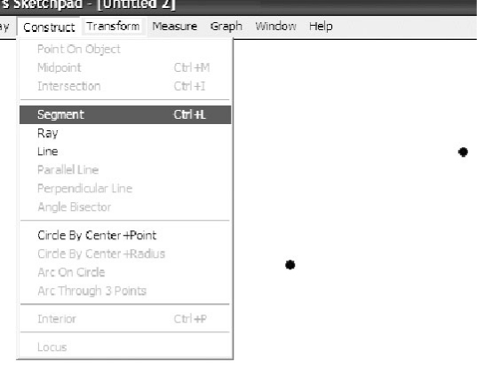
• To deselect a single point or segment, move the cursor to
the point or segment you wish to deselect. When the cursor becomes a horizontal arrow, click and the point or object
will be deselected.
• To deselect all selected items, click any white space.
Constructing Line Segments
• Click the Point Tool, and create two points in the workspace.
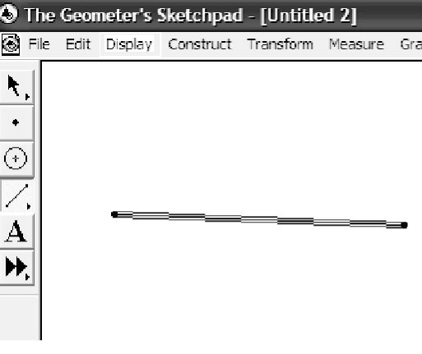
• Click the Selection Arrow Tool, and select both points.
• From the Construct menu, choose Line Segment.
OR
• Click the Straightedge Tool.
• Move the cursor to the workspace.
• Click and hold the left mouse button.
• Drag the cursor to form the segment.
• Release the mouse button.
Constructing Triangles
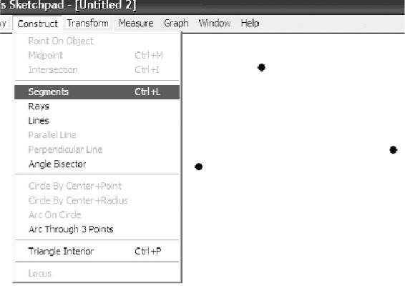
• Click the Point Tool, and draw three points in a
triangular shape in the workspace.
• Click the Selection Arrow Tool, and select the
three points.
• From the Construct menu, choose Segment.
The Geometer’s Sketchpad® 4
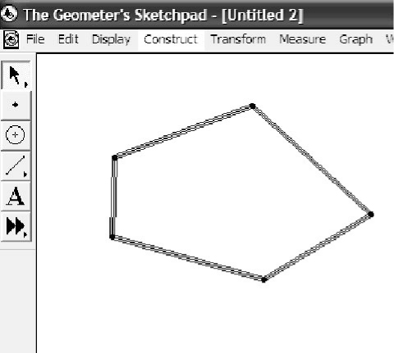
Constructing Polygons
• Click the Point Tool. Draw four or more points in the workspace.
• Click the Selection Arrow Tool, and select all the points in either clockwise or counterclockwise order.
• From the Construct menu, choose Segment.
Constructing Parallel Lines
To construct a line parallel to an existing line:
• Click the Point Tool, and place a point above or below the existing line
• Click the Selection Arrow Tool, and select the point and the line
• From the Construct menu, choose Parallel Line.
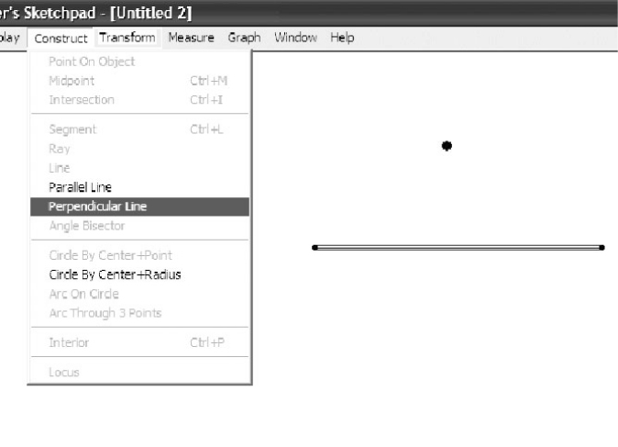 | 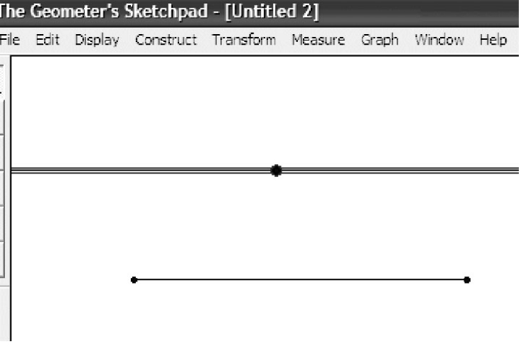
Constructing Perpendicular Lines
To construct a line perpendicular to an existing line:
• Click the Point Tool, and place a point above or below the existing line
• Click the Selection Arrow Tool, and select the point and the line
• From the Construct menu, choose Perpendicular Line.
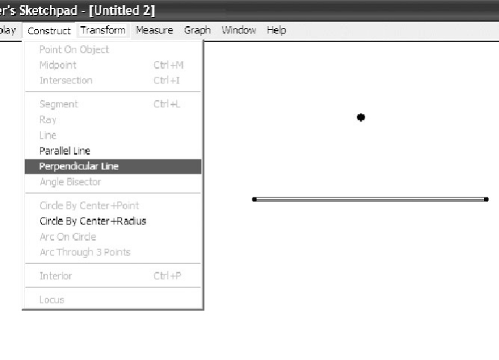 | 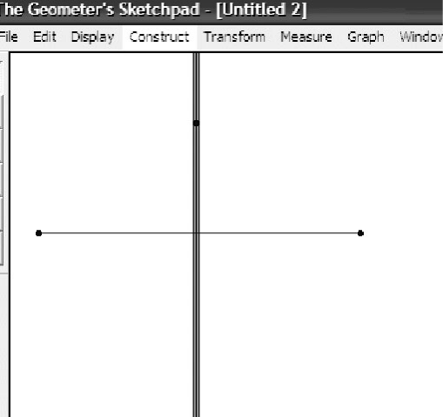
The Geometer’s Sketchpad® 4
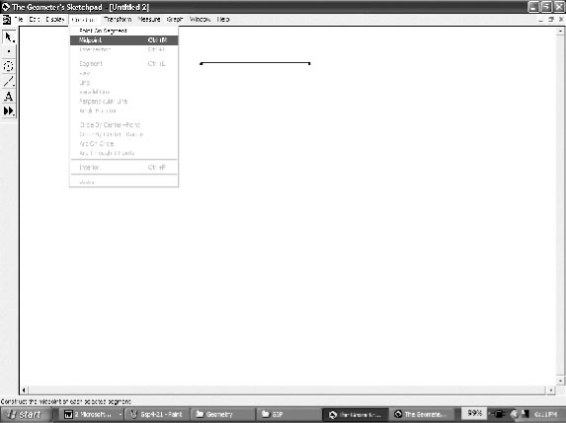
Constructing a Midpoint
To construct a midpoint on an existing line:
• Click the Selection Arrow Tool, and select the line
• From the Construct menu, choose Midpoint. A point will
appear on the line. This point will be fixed at the middle
of the line.
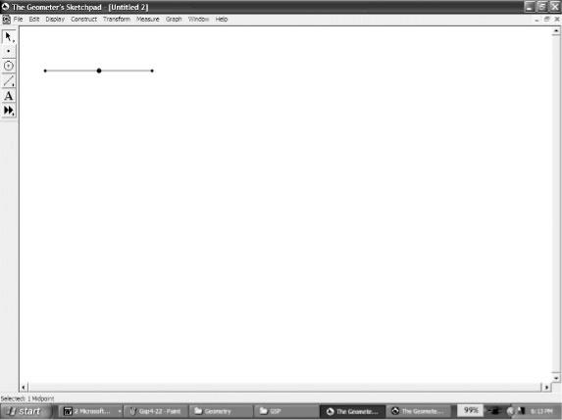
Finding Measures
For all measures, The Geometer’s Sketchpad® 4 will display
the desired measure using the units and precision selected
in Preferences… on the Edit menu.
To measure the distance between two points:
• Ensure nothing is selected
• Select the two points
• From the Measure menu, choose Distance.
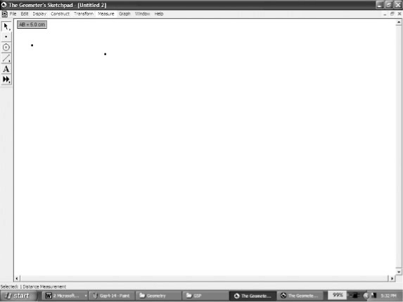
To measure the length of a line segment:
• Ensure nothing is selected
• Select the two points
• From the Measure menu, choose Length.
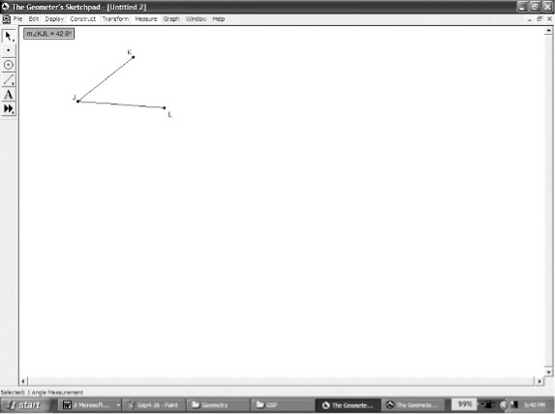 | 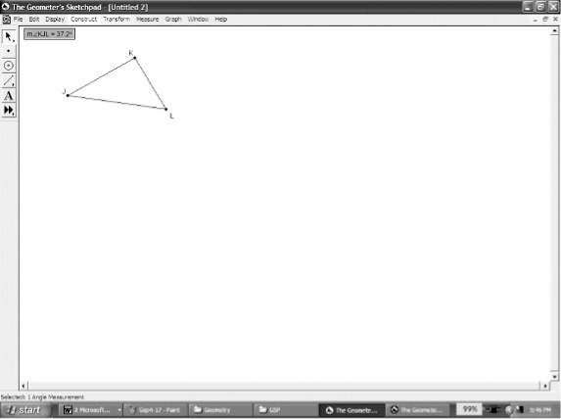
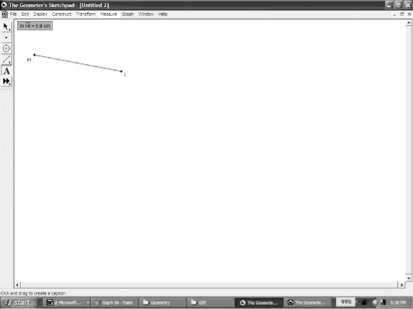
To measure an angle:
• Ensure nothing is selected
• Select the three points that form the angle. Make sure that
the second point selected is the vertex of the angle.
• From the Measure menu, choose Angle.
The Geometer’s Sketchpad® 4
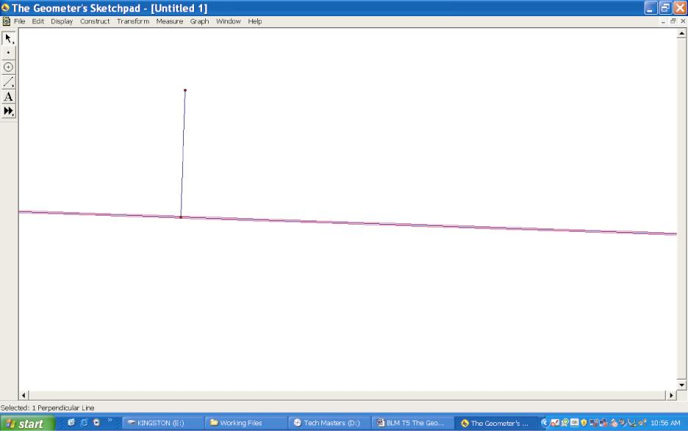
Constructing Right Triangles
• Click on the Straightedge Tool and choose the line segment. Draw a line segment.
• Click on the Selection Arrow Tool. Click on an end point.
• From the Construct menu, choose Perpendicular Line.

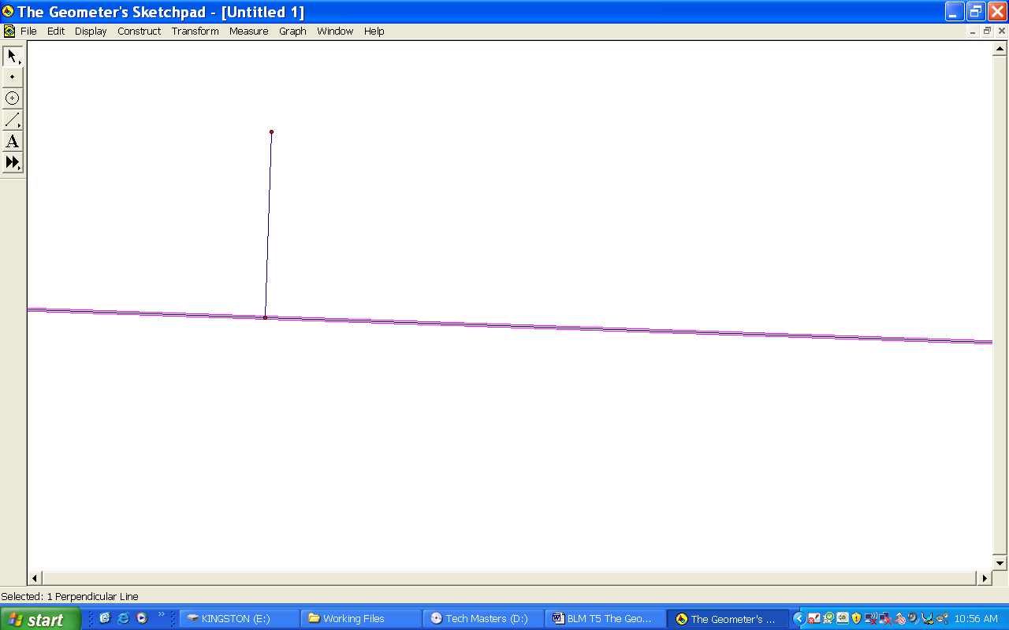

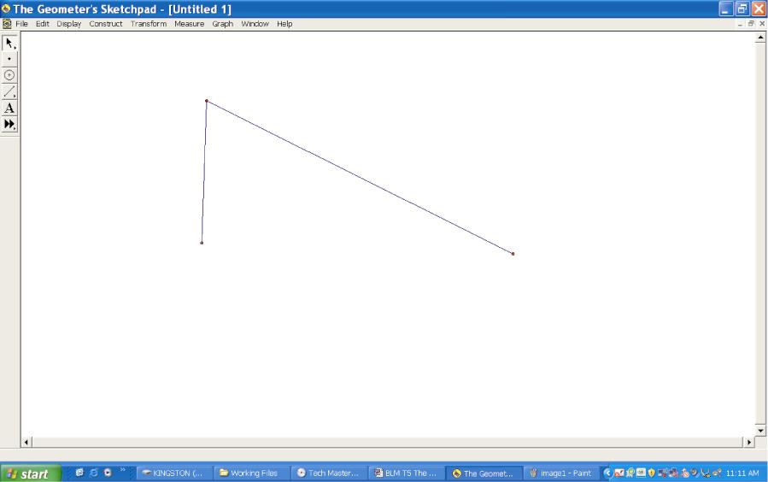
• From the Construct menu, choose Point on Perpendicular Line.
• Select the point and the endpoint of the segment that is not on the perpendicular line.
• From the Construct menu, choose Segment.
• Deselect the third side of the triangle. Select
the perpendicular line.
• From the Display menu, choose Hide Perpendicular Line.

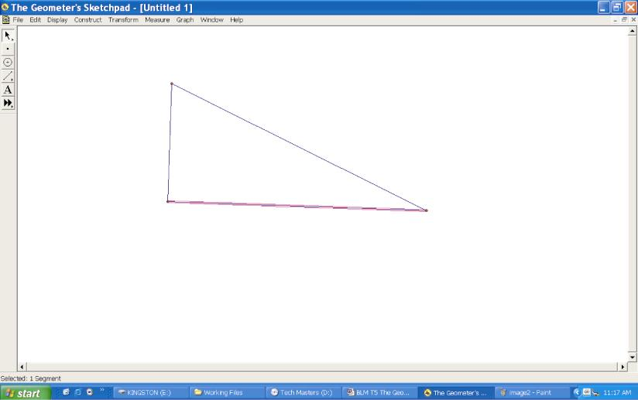
• Select the two end points of the missing side
of the triangle.
• From the Construct menu, choose Segment.

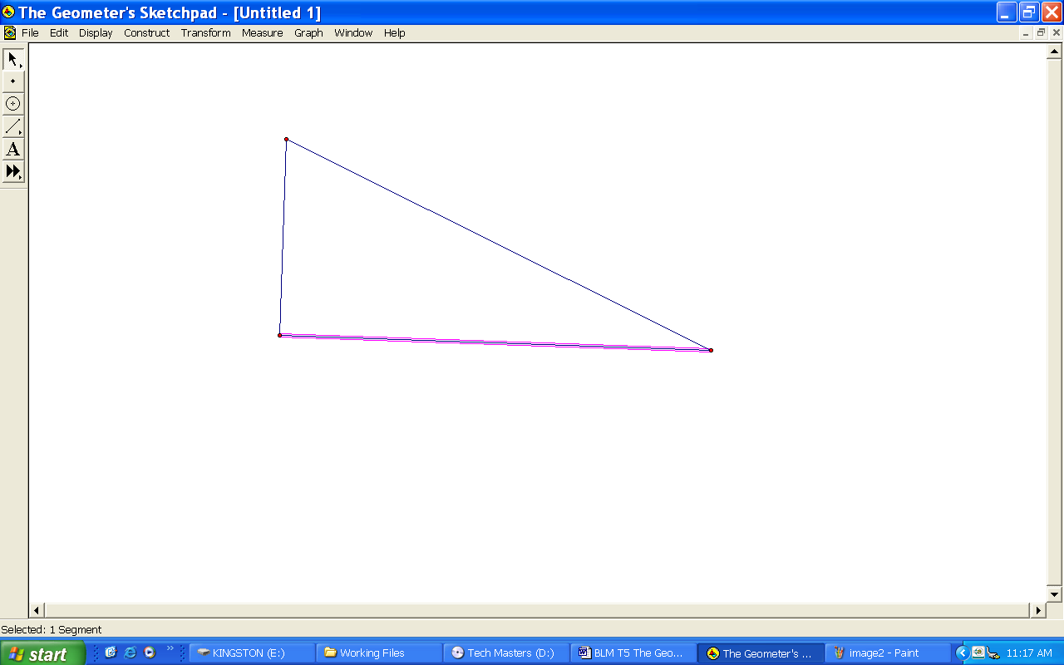
Finding the Trigonometric Ratios
• Construct a right triangle.
• Find the measures of the sides and angles.
• From the Measure menu, choose Calculate. You may have to drag the pop-up window to another location on the screen.
• To calculate a trigonometric ratio, select the measure of the opposite or adjacent side.
• Deselect the ratio.
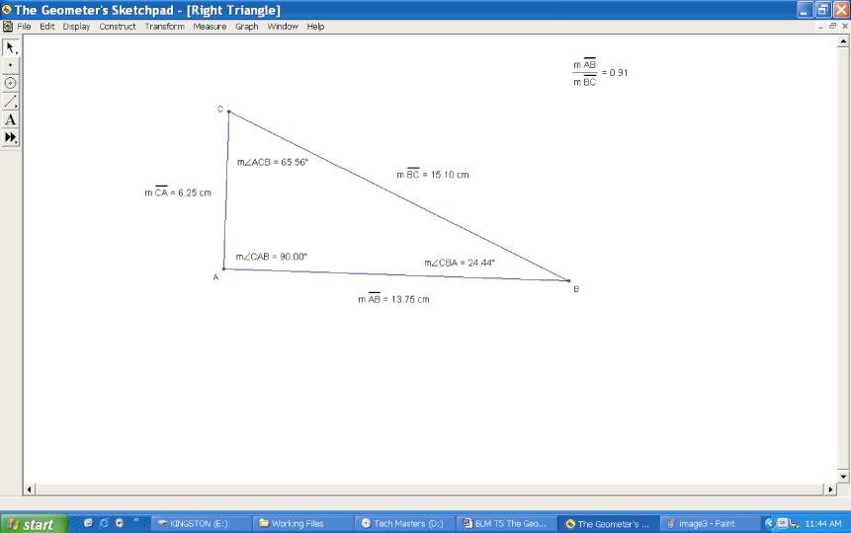

• Choose one of the acute angles and find the sine, cosine and tangent ratios for
the angle. From the Measure menu, choose Calculate.
• Click the Functions button on the New Calculation pop-up window and choose sin.

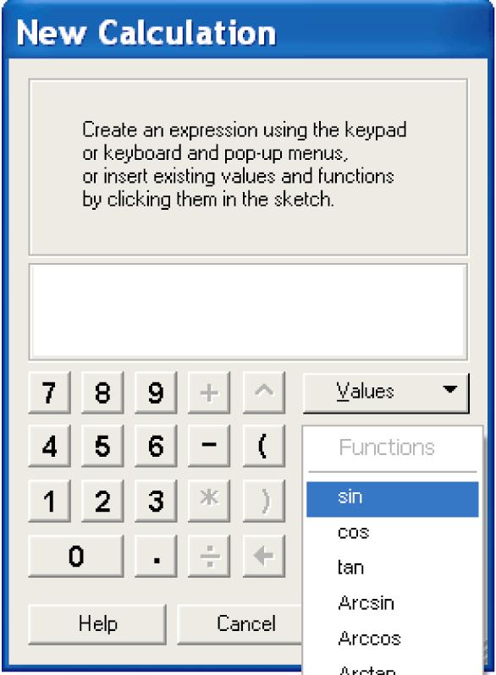

• Select the measure of the acute angle. Click OK.
• Repeat the previous four steps to find the cosine and tangent ratios of the angle.

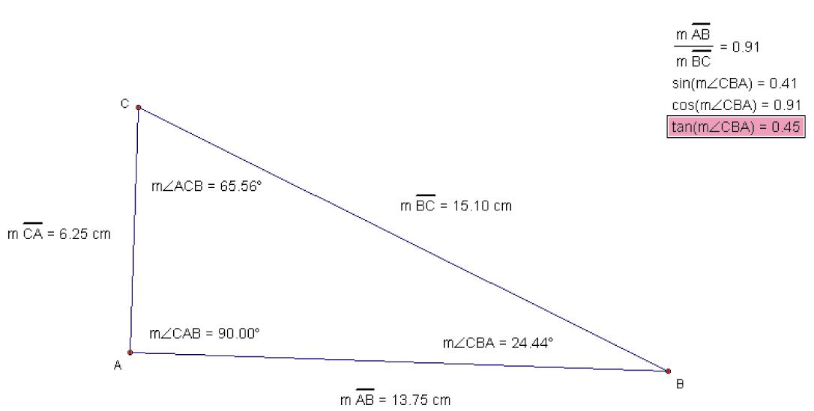

• Click and drag the vertex of the angle you chose. As it moves, notice what happens
to the sine, cosine, and tangent ratios.
Constructing and Measuring Polygon Interiors
The Geometer’s Sketchpad® 4 will measure the perimeter and area of a polygon.
However, you must construct the interior of the polygon first.
To construct the interior:
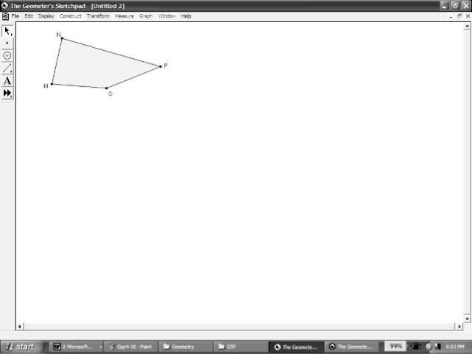
• Select all the points representing the vertices of the polygon.
Here we have a quadrilateral, so four points were selected.
• From the Construct menu, choose Quadrilateral Interior.
The Geometer’s Sketchpad® 4 will call the polygon by its correct name up to five sides, after which it will use
Polygon Interior in the Construct menu.
To measure the perimeter and area:
• Click the polygon’s interior
• From the Measure menu, choose Perimeter
• Click the polygon’s interior
• From the Measure menu, choose Area.
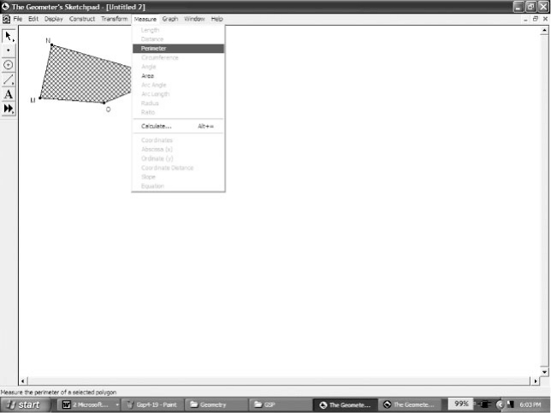 | 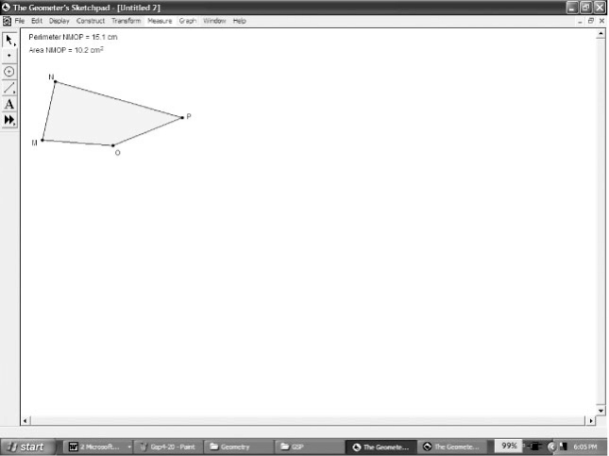

Plotting Points in the Cartesian Plane
• From the Graph menu, choose Define Coordinate System.
• From the Graph menu, choose Plot Points.
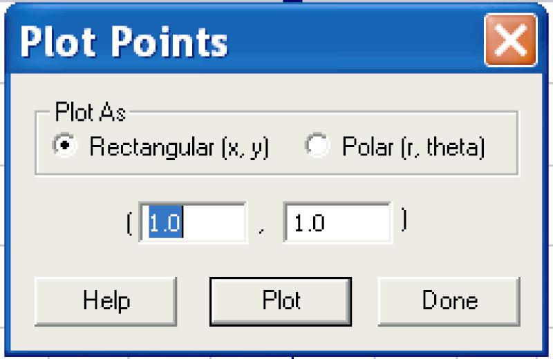

• Press 0, Tab, 2. Click Plot. Press 2, Tab, 3. Click Plot. Click Done.
• Select the points. From the Construct menu, choose Line.
• From the Measure menu, choose Equation.
• From the Graph menu, choose Snap Points.
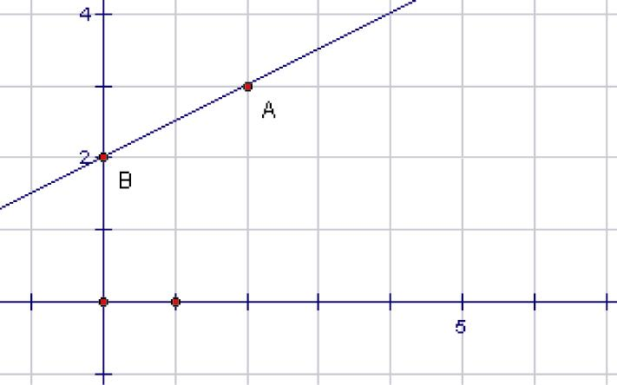

Graphing Quadratic Relations
To graph a quadratic relation:
• From the Graph menu, choose Plot New Function.
• Click the x key, the ^ key, the – key, then the 8 key. Click OK.

Graphing Systems of Equations
• From the Graph menu, choose Plot New Function.
• To plot an equation y or x must be isolated.
Given y + 2x = –5, rearrange the equation to get y = –2x – 5.
• Enter the equation and click OK.
• Deselect all points and equations.
• From the Graph menu, choose Plot New Function.
• Enter the equation y = (2/3)x + 3. Click OK.
• This will allow you to view the intersection point.

