The Computer Algebra System (CAS)
on the TI-89 Calculator
The TI-89 calculator features a Computer Algebra System (CAS) engine that allows you
to perform algebraic operations, such as manipulating and solving algebraic equations.

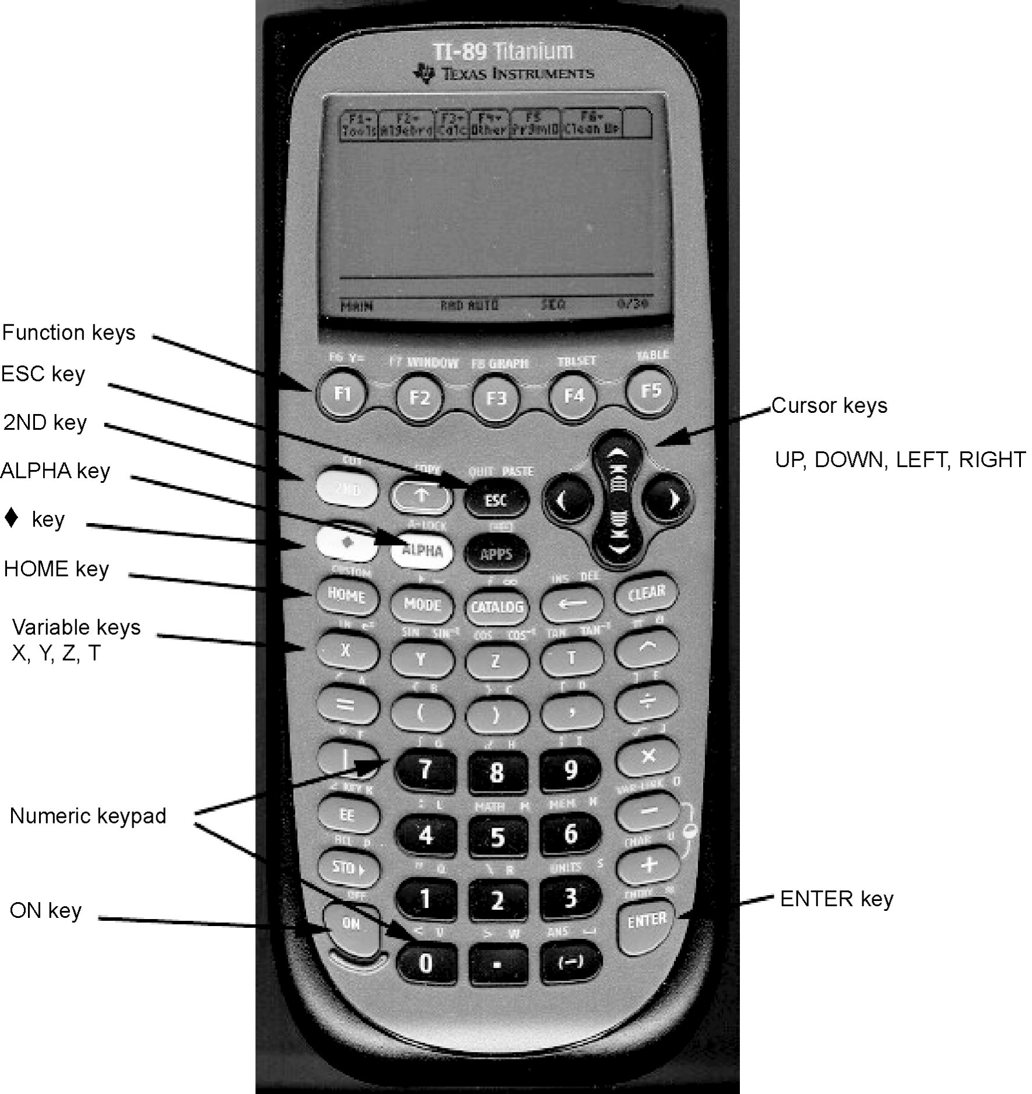

The Computer Algebra System (CAS)
on the TI-89 Calculator
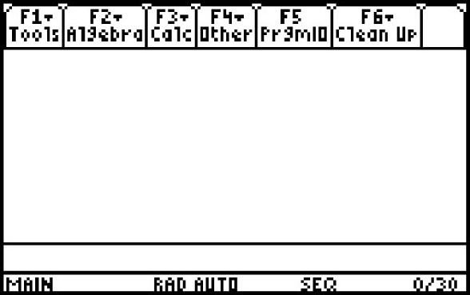
Starting the CAS
Turn on your TI-89 calculator by pressing ´. If you don’t see
the Home screen shown, press ".
The TI-89 Keyboard
Refer to the picture of the TI-89 calculator. Most keys have a
primary function, as well as one or more secondary functions.
For example, the 1 key is usually pressed to enter the number 1.
However, if the blue 2 key is pressed, and then 1, you will
enter opening quotes “. If the white ƒ key is pressed, and
then 1, you will enter the letter q. Some keys have additional
functions labelled in green. If the green ¥ key is pressed, and
then N, you will access the [PASTE] function.
The Function Keys
The CAS uses the functions F1 through F6 to display menus.
F1 through F5 are accessed by pressing the appropriate key.
F6 is accessed by pressing 2 [F6].
Press F1. Notice the menu. To close the menu without making
a selection, press N. This is useful for cancelling a keystroke
that was made in error.
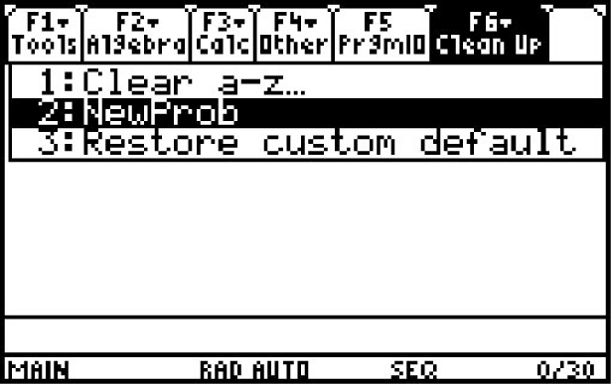
Starting a New Problem
Before starting a new problem, clear any data that may be
stored in memory. Press 2 [F6]. Select 2: NewProb then,
press ¸. This will clear the memory and reset all algebraic
variables. If you do not do this, you may see unexpected
results as you work through CAS solutions.
Note that NewProb also clears the Home screen.
The Computer Algebra System (CAS)
on the TI-89 Calculator
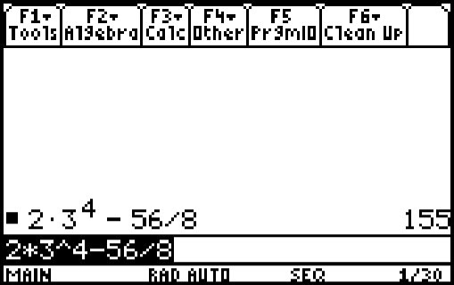
Entering Calculations
The numeric keypad on your TI-89 works just like the keypad
on other graphing calculators, such as the TI-83 Plus or TI-84.
For example, consider the expression 2 × 3⁴ – 56 ÷ 8. Enter the
keystrokes 2 p 3 Z 4 | 56 e 8 ¸.
The answer is 155.
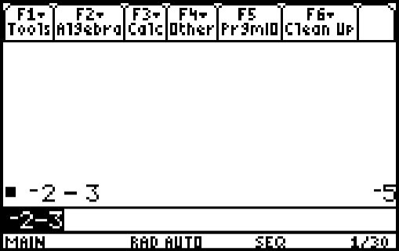
Like the TI-83 Plus and TI-84, the TI-89 has two keys with a minus
sign, the negative key · and the subtract key |. Use the |
key for the operation of subtraction. Use the · key when you
are making an expression negative. For example, to enter –2 – 3,
press · 2 | 3.
Entering and Simplifying Algebraic Expressions
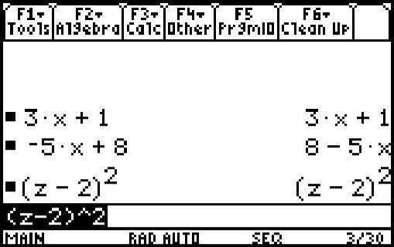
The real power of a CAS lies in an ability to enter and manipulate
algebraic expressions. Four of the variable names have their own
keys: Ù, Ú, Û, and Ü. Others are accessed by pressing
ƒ and other keys.
Clear the Home screen if necessary, using NewProb.
Then, enter the expression 3x + 1. Press ¸.
Notice that the TI-89 enters the expression on the Home screen,
and also retains it in the command line. Enter some more expressions,
such as –5y + 8, and (z – 2)². Notice that the CAS sometimes
changes the format of the expression.
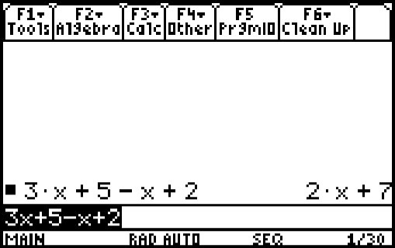
The CAS will simplify expressions by collecting like terms. As an
example, enter the expression 3x + 5 – x + 2, and press ¸.
Notice that like terms have been collected.

The Computer Algebra System (CAS)
on the TI-89 Calculator
Expanding Expressions
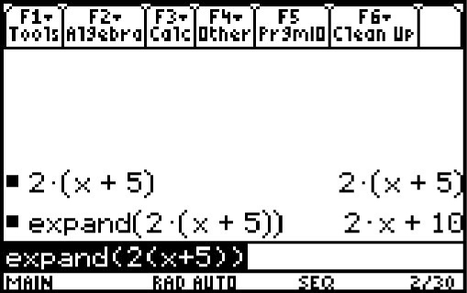
The CAS can use the distributive property to expand algebraic
expressions. Enter the expression 2(x + 5), and press ¸.
Notice that the expression remains unexpanded.
Now, press „, and select 3:expand(.
Press 2 c Ù « 5 d d ¸.
Notice that the CAS has expanded the expression.
Factoring Expressions
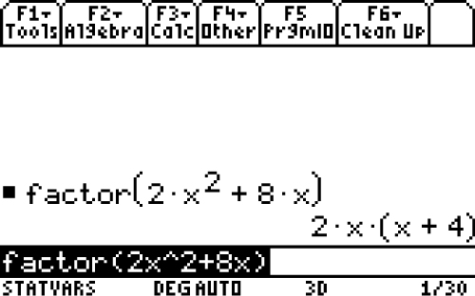
The CAS can common factor expressions.
Press „, and select 2:factor(.
Press 2 Ù Z 2 « 8 Ù d ¸.
Notice that the CAS has factored the expression.
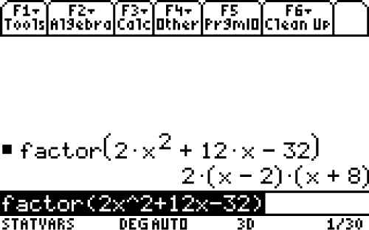
The CAS can factor trinomials.
Press „, and select 2:factor(.
Press 2 Ù Z 2 « 12 Ù | 32 d ¸.
Notice that the CAS has factored the expression.

Evaluating Expressions
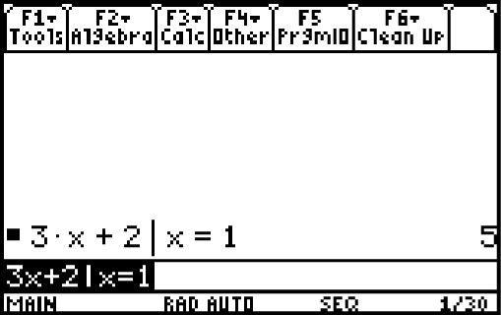
The CAS can evaluate an expression for a particular value of
the variable. Press 3 Ù « 2 Í Ù Á 1 ¸.
Notice that the CAS substituted the value 1 for the variable x, and
then evaluated the expression for an answer of 5.

Entering and Manipulating Equations
The CAS will let you enter an equation, and apply operators to both sides.
For example, enter the equation 3x + 1 = 10. Press ¸.

The first step in solving this equation is to subtract 1 from both sides.
This can be done in two ways.
Enter the equation with –1 on both sides. | Enter (3x + 1 = 10) –1 and press ¸.
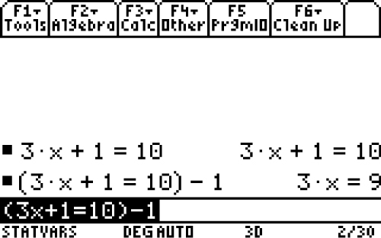

The next step is to divide both sides by 3. This can be done in two ways.
Enter the equation with /3 on both sides. | Enter (3x = 9)/3 and press ¸.
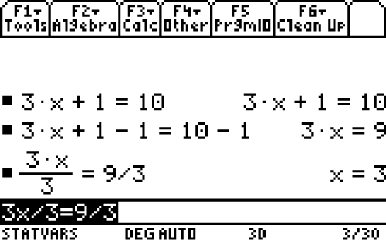 | 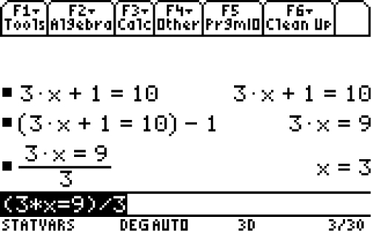

Notice that the CAS displays the value of x that satisfies the equation.
Copying and Pasting Expressions
Press ¥ to copy and paste the equation that you have already entered.
This is a useful feature, especially for long or complicated expressions.
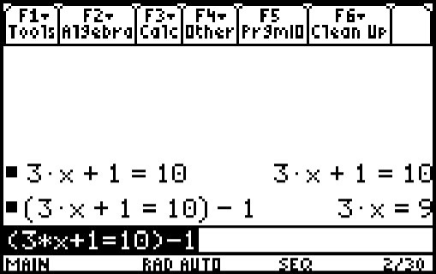
Press } then press M to delete the previous line.
Press † then press M to clear out the last command
prompt. Press c then press }. Press ¥ [COPY].
Press †. Press ¥ [PASTE]. Notice that the equation has
been pasted after the opening bracket.
The Computer Algebra System (CAS)
on the TI-89 Calculator
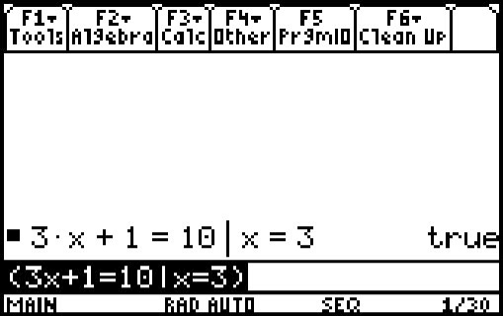
Checking a Solution
You can use the CAS to check a solution to an equation.
Suppose that you solved the equation 3x + 1 = 10,
and found that x = 3.
Press c 3 Ù « 1 Á 10 Í Ù Á 3 d ¸.
Notice that the CAS returns a value of “true” if the solution is correct.
Entering Other Variables
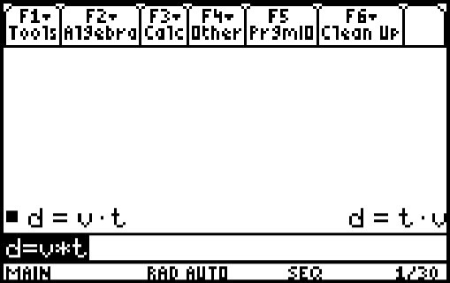
You may find a problem in which it is convenient to use variables other
than X, Y, Z, or T. You can access these by pressing ƒ.
For example, suppose that you want to enter the equation d = vt.
Press ƒ [D] Á ƒ [V] p Ü ¸
Note: when you want to multiply two variables, such as v and t,
you must put a multiplication operator between them.
Solving Variable Equations
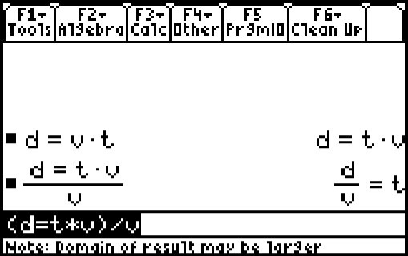
You can use the CAS to solve equations for a particular variable.
For example, suppose that you want to solve d = vt for v.
You must divide both sides by t.
Enter the equation d = vt as shown in the section Entering Other
Variables. Press ¸ c ¥ [COPY] ¥ [PASTE] d
e ƒ [V] ¸.
Graphing Features
Entering Data into Lists
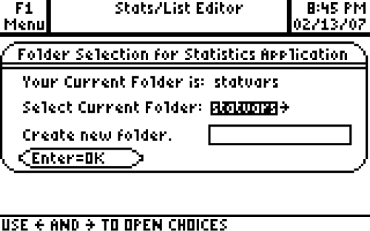
Press O and scroll to Stats/List Editor and press ¸.
Press ¸ to select the default Folder
Selection for Statistics Application
• Enter these data into list1
–5, –4, –3, –2, –1, 0, 1, 2, 3, 4, 5.
• Enter these data into list2
–52, –30, –12, 2, 12, 18, 20, 18, 12, 2.

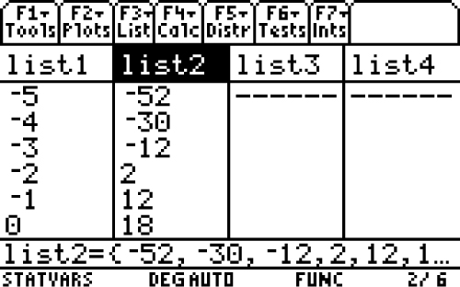
To use the List Editor as a Spreadsheet for the data
in list2, scroll up to the top of the list so that the
listname list2 is highlighted.

Press M then † to clear the list.
Press } to highlight the listname list2.

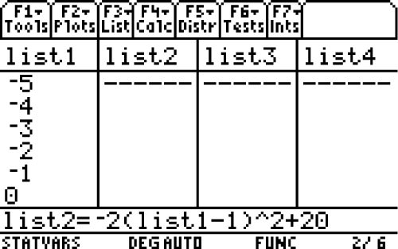
To generate data in list2 press · 2 c … ¸
Scroll down to listname titled list1 so that it is highlighted
and press ¸ | 1 d Z 2 « 20 ¸.
In this way the List Editor is being used as a spreadsheet.

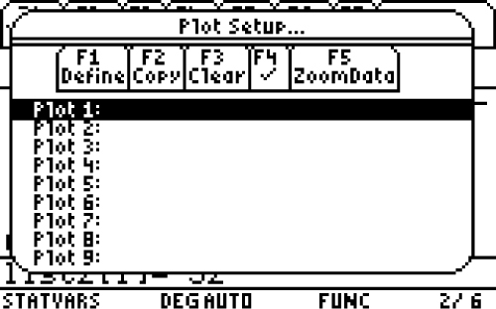
Setting up the Plot
To construct a scatter plot of the data in list1 and list2,
press „ from within the Stats/List Editor and
select 1 for Plot Setup.

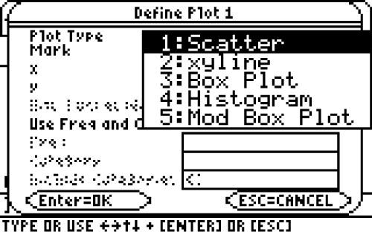
Press ƒ to set up the plot.
A scatter plot is the default graph type.
Press ~ to see the other types of plots
available. Press ¸ to select Scatter.

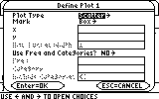
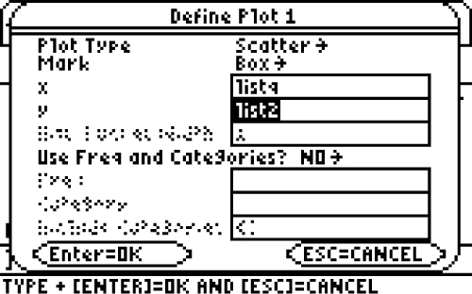
Press the † twice. Input the listname for x.
Press 2 [ALPHA] then type the word L, I, S, T.
Press ƒ to turn off the Alpha-Lock then press 1.
Press † once. Input the listname for y as list2.

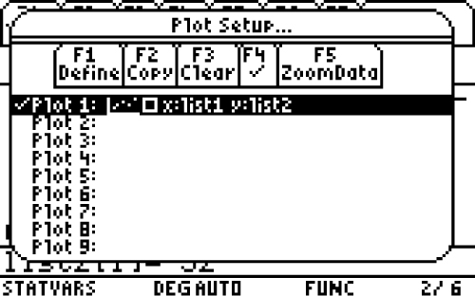
Press ¸ to complete the plot set-up.

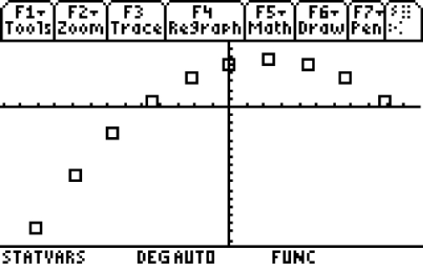
To construct the scatter plot,
press ‡ for ZoomData.

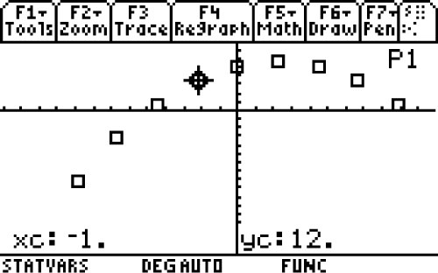
Tracing Data Points
To trace the data, press … and
press | ~.

Re-Graphing a Set of Data Points
To Re-graph the equation, press † or ¥ ….

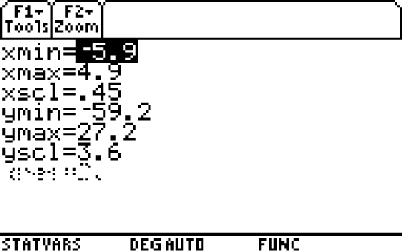
Setting the WINDOW
Press ¥ „.
The current window settings will be seen.
These values can be changed if desired.

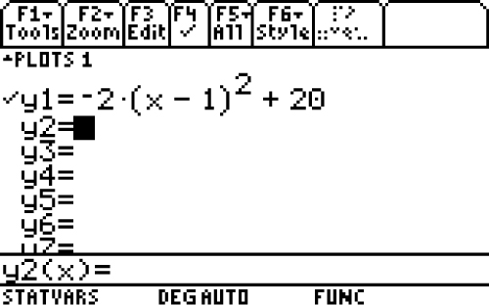
Inputting an Equation
To input an equation, press ¥ ƒ.
Press · 2 c Ù | 1 d Z 2 « 20 ¸
to paste the information from the command prompt line to y1.

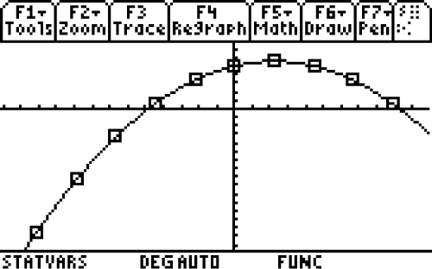
Press ¥ … to graph the equation.

For More Information
You can obtain more information on the operation of your TI-89 calculator in the calculator manual. You can also download an electronic version of the manual in PDF format at www.education.ti.com.

