Microsoft® Excel
Open
Access Microsoft® Excel from the Start menu or directly from a desktop icon.
The Basics
The Microsoft ® Excel spreadsheet screen is called a worksheet.
• Each cell has a cell address. For example, the address of the active cell shown is D3 (column D, row 3).
• The toolbar contains the most commonly used functions from the menus, such as
Save, Print, Copy, and Paste.
• The formula bar displays the address and the contents of the cell in which you are currently working.
• The Chart Wizard takes you through the steps of creating a chart (graph) that displays
the data in the spreadsheet.

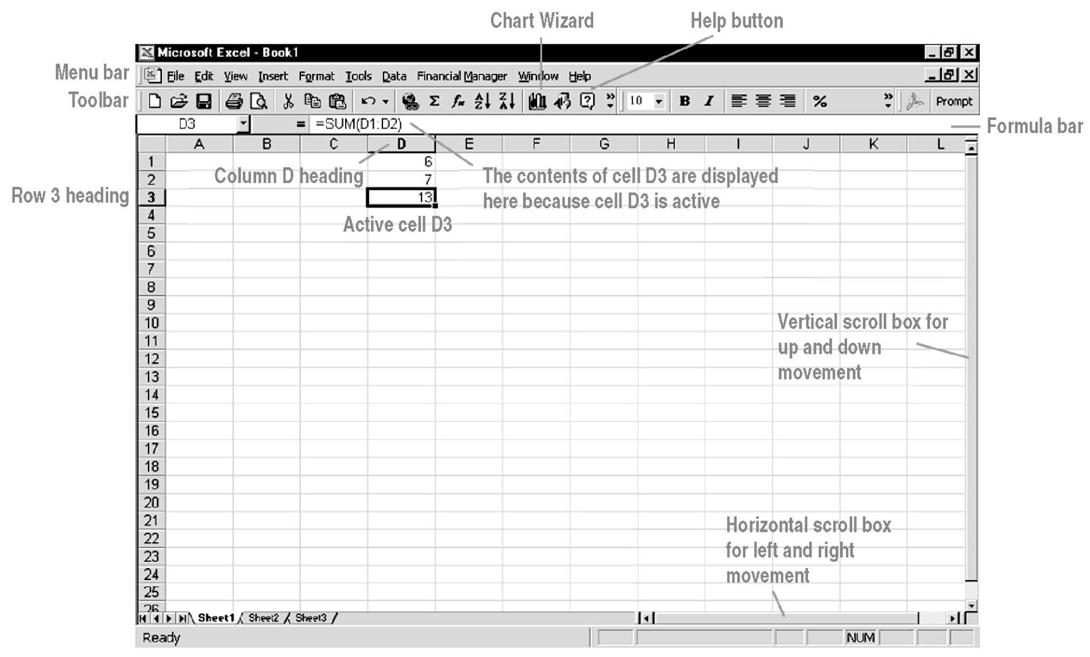

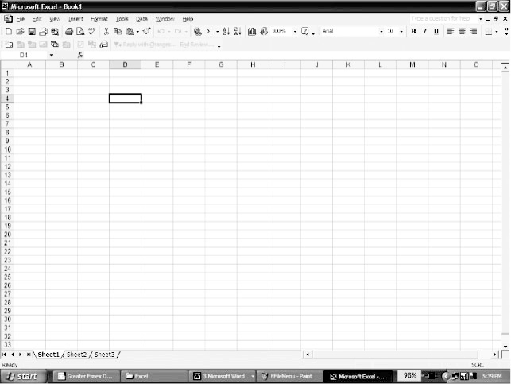
Microsoft® Excel
To highlight an entire column,  click the column letter. | To highlight an entire row, click  the row number. | To select the cell into which you wish to enter data, click the cell.
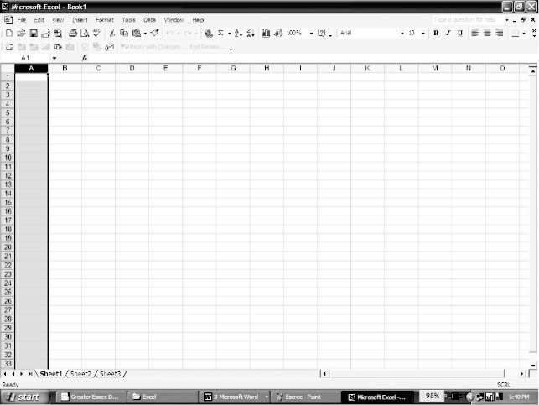 | 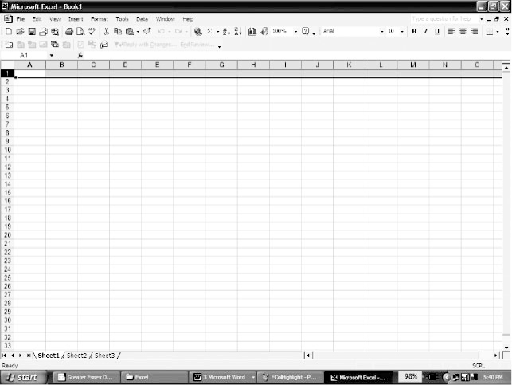
Menus
To display a menu, click on the menu name in the menu bar.
File | Edit | Options
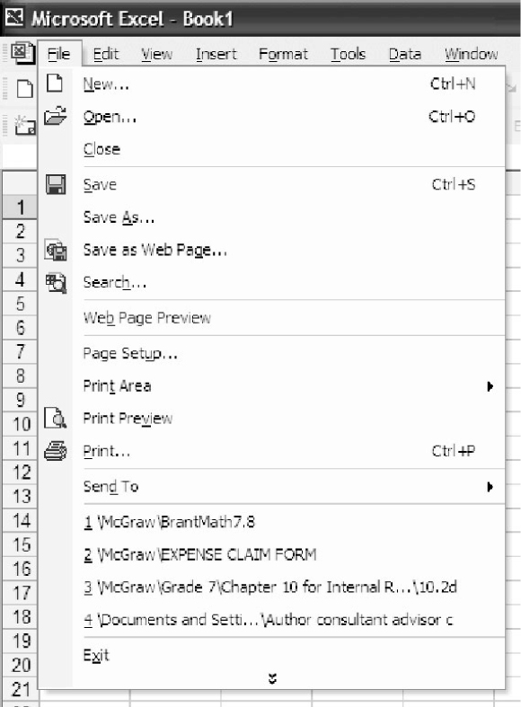 | 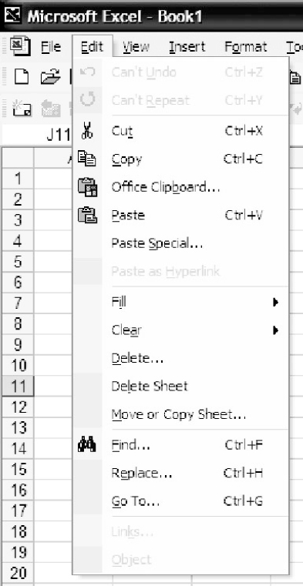 | 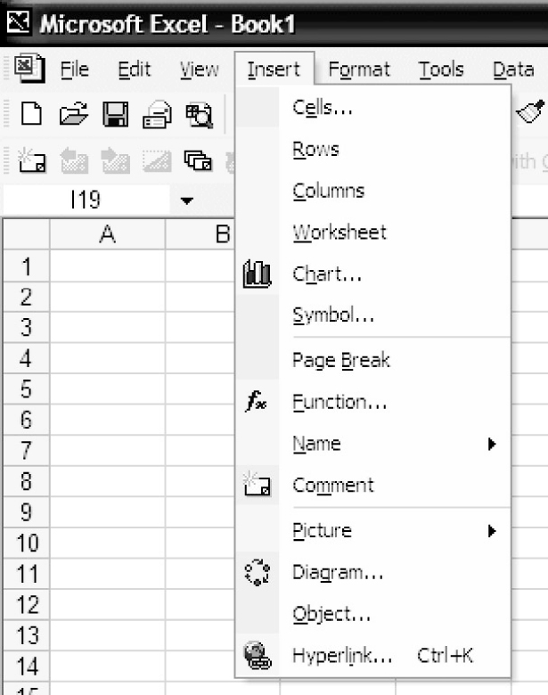
Use this menu to Save your file,  to Print your file, or to Open an existing file. | Use this menu to Copy or Cut highlighted data, to Paste data previously copied, or to Fill  a selected row or column. | Use this menu to create a graph  by clicking the Chart… menu command.

Microsoft ® Excel
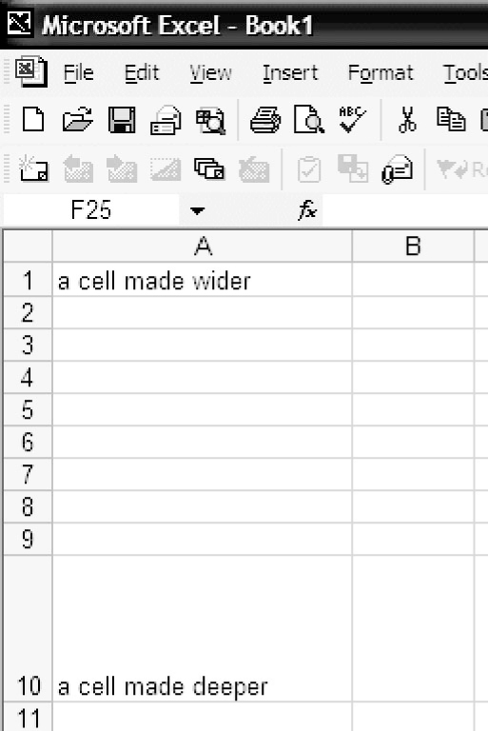
Cell Sizing
To adjust cell size, click on the edge of
the cell column heading (A, B, …), and
drag to widen or click on the bottom of the
cell row heading (1, 2, …), and drag
to deepen.

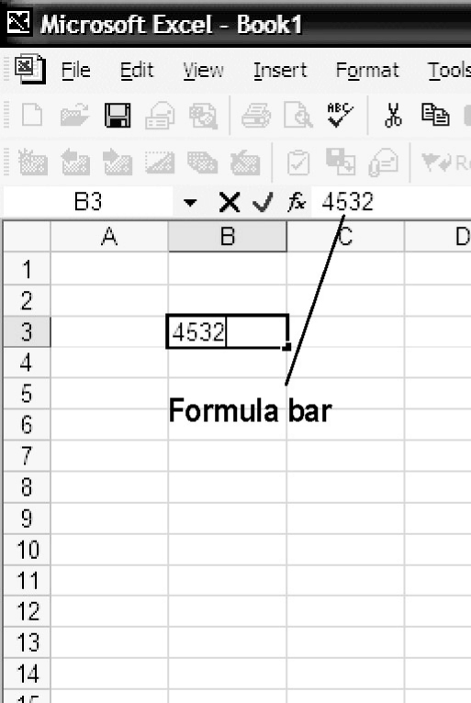
Entering Data
Click on the cell in which you wish to
enter data (in this case B3), and type in
your data. The data can be numeric,
alphabetic, or alphanumeric. You may
deepen/widen the row/column as necessary
to hold the data. To edit existing data,
click the cell, then click the formula bar.
Creating a Scatter Plot and Line or Curve of Best Fit
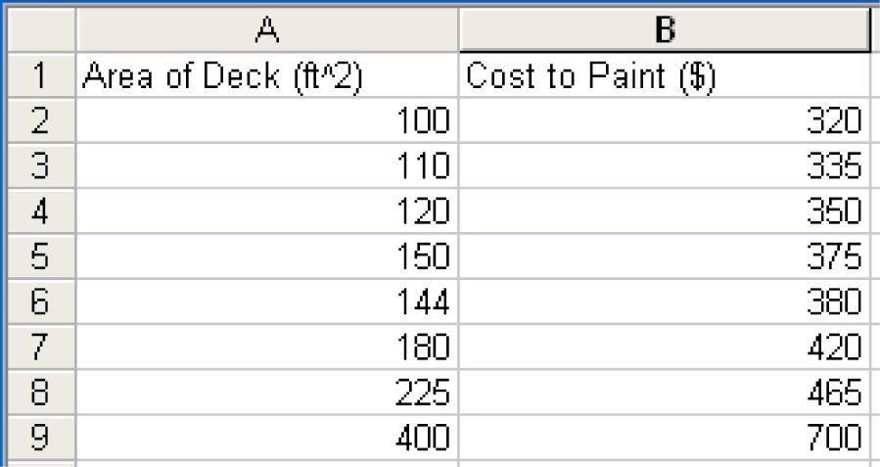
Enter the data in columns A and B. Then,
draw a scatter plot and a line or curve
of best fit.

Construct a Scatter Plot
Highlight the cells containing the data. Click and hold the left mouse button at Cell A1, and drag the highlighted region to cell B9. Release the mouse button. | Click on Insert and select Chart. The Chart Wizard pop-up window appears. Select XY (Scatter) from the Chart Type. options. Click on Next. | Click on Next.
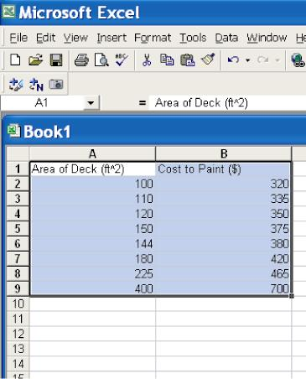 | 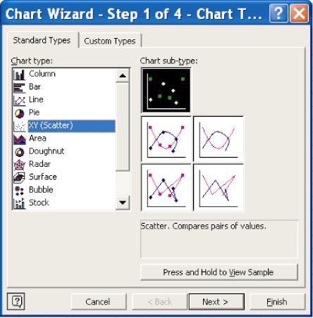 | 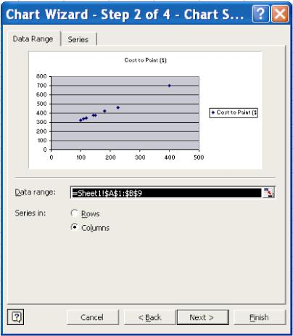
Enter the titles for the axes. Click in the box for x and type, “Area of Deck (ft²)”. Click in the box for y and type, “Cost ($)”. The graph automatically applies the axis titles to the graph. | Click on the Legend tab. Click on the Show Legend check box to turn off the legend. It is not necessary for this graph. Click on Next. | Click on Finish.
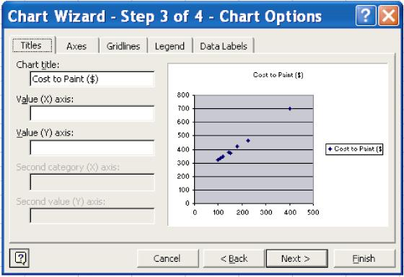 | 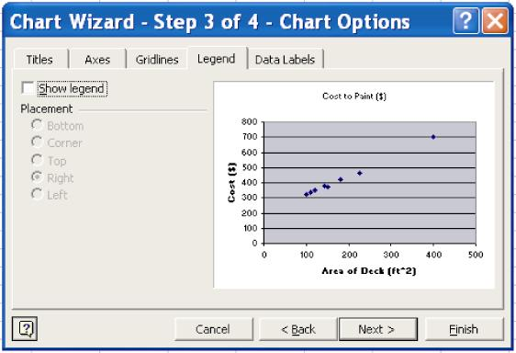 | 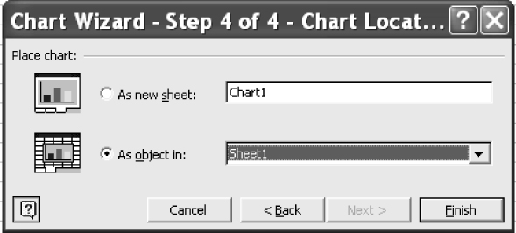

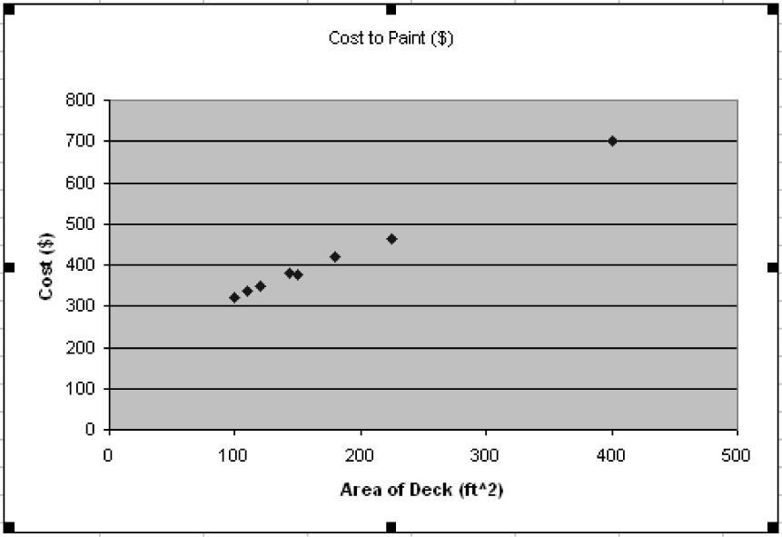

Construct a Line of Best Fit
Right-click on one of the points, and select Add Trendline. | The default trendline is linear. If the data appear to be quadratic, choose Polynomial fit and use the default order of 2. Click on the Options tab. | Click on the Display equation on chart check box. Click on the Display R-squared value on chart check box. Click OK.
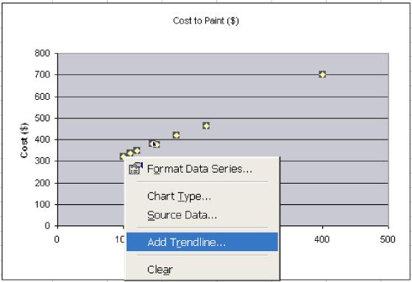 | 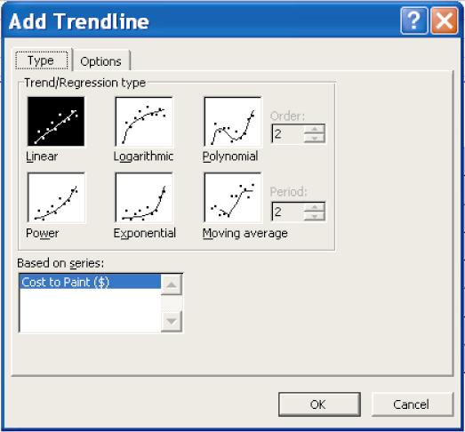  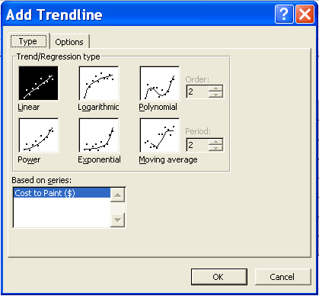 | 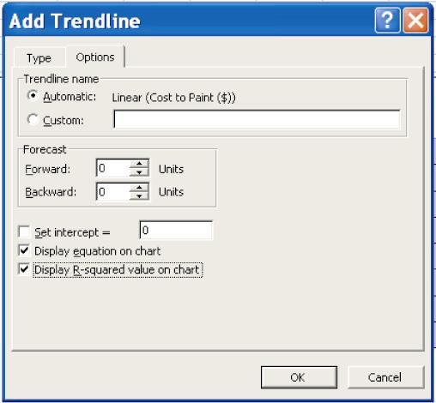

The graph now has a line of best fit with the equation and R-squared (Co-efficient of Determination) displayed.

