Cabri Junior
Starting Cabri Jr.
Press O, Scroll Down to Cabri Jr. and press Í.

Press any key to start the dynamic geometry calculator application.

Cabri Jr. Menus
The softkeys, the top row of calculator keys, drive the Cabri Jr menus.

Press o to access the  F1 menu. These functions allow you to manage the file constructed. | Press p to access the F2 menu. These functions allow you to construct geometric objects. | Press q to access the  F3 menu. These functions allow you to construct secondary objects.
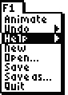 | 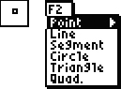 | 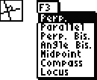
Press r to access the F4 menu. These functions allow you to perform transformations. | Press s to access the F5 menu. The functions allow you to display various properties of objects. | Press ~ to access the submenu for menu items that have an arrow pointing right. Press | to get back.
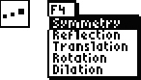 | 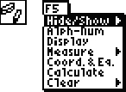 | 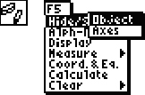

The top left corner of the screen shows the active tool. The tool for measuring distance and length is shown. In the screens above, you will see other active tools. | To back out of a menu without selecting an option press e. This also clears the active tool and returns the user to the Cabri Jr. sketch. Notice the pointer is a black arrow | This message pops up on your screen when your calculator has been idle too long. Press Í to continue.
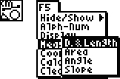 |  | 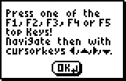

Constructing a Triangle
To construct a triangle  press p and press † to scroll down to Triangle, press Í. | The triangle tool becomes active and the cursor becomes a pencil, which can be moved by pressing and holding the arrow keys. The pencil cannot move diagonally. Move the pencil tip to a region in the bottom right corner. | Press Í to mark the first vertex. Then push and  hold | to move the pencil tip horizontally to a region in the left corner.
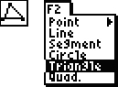 | 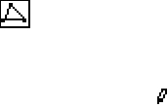 | 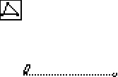

Press Í to mark the second vertex. Press and  hold } to move the pencil tip vertically to a region in the top left corner. | Press ~ to move the pencil to the left of the centre of the screen so the triangle is not right angled. Press Í. The lines will change from dashed to solid when the triangle is complete. | Press e to deactivate the Triangle Tool. Notice the triangle and box in the corner disappear. Move the pointer off the vertex. It will change to a solid arrow.
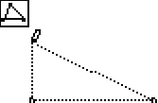 | 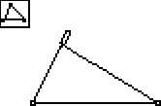 | 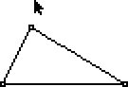

Highlighting and Grabbing Objects
Follow the steps in the previous section, Constructing a Triangle, to construct a triangle.

The solid arrow is the regular pointer. Move the pointer so it is over the top vertex. It changes to a hollow pointer and the point shimmers. This indicates the point is highlighted. | Press ƒ to grab the point. A hand will appear. Use the arrow keys to move the vertex. | Press e to release the vertex. The hand will turn to a hollow pointer.
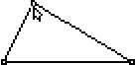 | 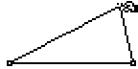 | 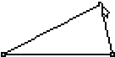

Move the pointer over a  side to highlight it. The  side will begin to shimmer. Press ƒ to grab the side. Press ~ to move the side to the right. Note the vertex on the left side of the screen does not move. | Press Í or e to release the side. The hand will change to a hollow pointer. Wait until all sides are shimmering and then press ƒ. | Press the arrow keys  to centre the triangle.  Press e to release the triangle. The dashed lines become solid again. Move the pointer off the triangle and the hollow pointer becomes a solid pointer.
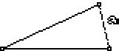 | 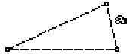 | 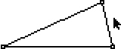

Adding Labels
Construct your own triangle by following the instructions above in the section titled, “Constructing a Triangle”.

To add labels to the vertices press s and scroll down to Alph-num. Press Í to activate the alpha-numeric label tool. | Press the Arrow keys to move the text pointer to the top vertex. When the point shimmers press Í. This will attach the label to the vertex. | Press a to insert the letter A.
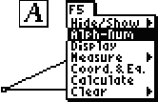 | 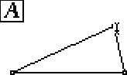 | 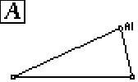

Press Í to Complete the label. Press the arrow keys to move the label tool to the bottom right vertex. Watch for the shimmering point next to the label tool. | Press Í to start the label. Press O to insert the letter B. Press Í to finish the label. | Move to the left-most vertex. Press Í. Press c  to insert the letter C.  Press Í. Press e to de-activate the label tool.
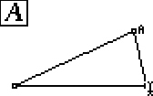 | 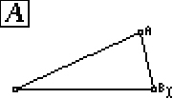 | 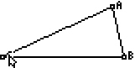
The label, C, is under the hollow pointer but inside the triangle. Press ƒ to grab it. Move the label outside the triangle by pressing |. Press e to release the label. Press } until the pointer is off the label.
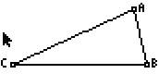

Finding Measures (Angles and Distances)
Construct a triangle by following the instructions in the section titled,
“Constructing a Triangle”.

MEASURING ANGLES
Press s and scroll down to Measure. Press ~ to view another menu.  Press † to highlight Angle. Press Í to activate the Angle tool. | To measure an angle you must select three vertices. The second one selected is the angle measured.  Move the pencil pointer to the left-most vertex  using the arrow keys.  Press Í when the point at the vertex is shimmering. Move the pencil pointer  to the top-most vertex  using the Arrow keys.  Press Í when the point at the vertex is shimmering. | Move the pencil pointer to the right-most vertex  using the Arrow keys and press Í. The angle will automatically ‘fly’ toward the top-most vertex with a hand tool attached. Press the arrow keys to move the angle inside the triangle. Press e to release the angle.
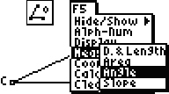 | 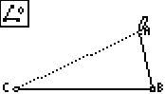 | 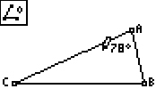
The angle tool is still the active tool. Measure the other angles. Move the angle measures inside the triangle. After you move the last angle measure inside the triangle press Í  to release the angle.  Press e to de-activate the Angle tool. | Move the pointer over the top-most vertex. Watch  for the point to shimmer. Press ƒ to grab the vertex. Press } and watch the angles change. | Press e to release the point. Notice that the label has moved with the vertex.
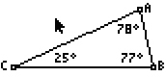 | 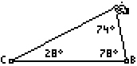 | 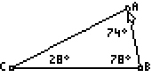

MEASURING DISTANCES
Press s and scroll down to Measure. Press ~ to view another menu. If  D. & Length is not highlighted Press the appropriate arrow key to highlight it. Press Í to activate the D. & Length tool. | Move the pencil pointer to an edge of the triangle. Note the pencil pointer changes to a solid horizontal arrow pointing to the left once it is over top the side of a triangle. Also the side of the triangle begins to shimmer. | Press Í and the length of the line will ‘fly’ in to the image. Press the arrow keys to place this measure next to the side it measures. Press e to release the measure.
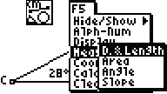 | 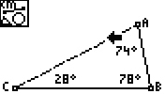 | 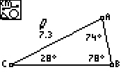
Remember the D. & Length tool is still active. Measure the lengths of the other sides.  After all sides are measured press e to de-activate the tool. | Move the pointer to the left-most vertex until the point shimmers. Press ƒ to grab the point. Press ~ to move the vertex. Notice that angles and lengths of sides are changing. Notice that the labels move with the vertices but the measures do not. | Press | to bring the  vertex back so that the angle is within the triangle. Press e to release the vertex. Press † to move the hollow pointer off the vertex. It will become a regular pointer.
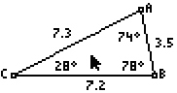 | 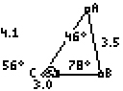 | 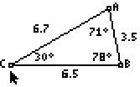

Formatting Issues
Sometimes an error occurs. You may wish to Undo or Delete the error.
UNDO | DELETE
To undo, press o and scroll down to Undo. Press Í and the last item will be undone. | To delete an item there must not be any tool active. There should be no picture in the upper left corner of the screen. If there is, press e to de-activate the tool. Move the pointer over the object you wish to delete and press {. The object and anything attached to it will be deleted.
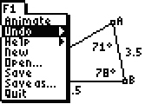

Sometimes you wish to increase/decrease the accuracy of the measures used.
INCREASE ACCURACY | DECREASE ACCURACY
To increase the accuracy of a measurement there must not be any tool active. There should be no picture in the upper left corner of the screen. If there is, press e to  de-activate the tool. Move the pointer over the value of the measurement you wish to change and press y Ã. Each time you press this combination of keys the accuracy will be improved by 1 decimal place to a maximum of 2 decimal places. | To decrease the accuracy of a measurement there must not be any tool active. There should be no picture in the upper left corner of the screen. If there is, press e to de-activate the tool. Move the pointer over the value of the measurement you wish to change and press y f. Each time you press this combination of keys the accuracy will be decreased by 1 decimal place to a minimum of zero decimal places (whole number).
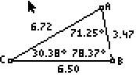 | 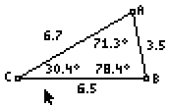

Sometimes you wish to save your file.
SAVING A FILE
Press o and scroll down to Save.  Press Í. | Type a name. It can be no more than 8 characters. The default is alpha characters for the name. Press ¶, ¯, ¡, « and j to access the letters T, R, I, N and G. The name can have numbers but ƒ needs to be pressed prior to the number being entered. Notice the 1 appears in the top left corner of the screen to denote numeric entry. Press Â.
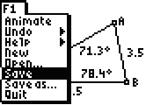 | 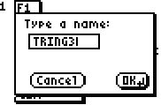
If you want letters after the number entered, press ƒ again. The 1 in the top left corner of the screen will disappear denoting that alpha key entry is active. Press a to enter the letter A. Notice the OK button on the screen has a shadow on the right and bottom side. This means that the OK button is highlighted. To save the file, press Í. | To Cancel the save press | to highlight the Cancel button. Notice the shadow on the right and bottom side of the OK button has switched to the Cancel button. Press Í to activate the Cancel button.
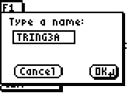 | 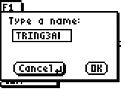

Constructing a Right Triangle
If there is another image on your calculator screen when you start Cabri Jr., press o, scroll down to New and  press Í. | If asked to save changes press | so the No button is highlighted. Press Í to begin a new image. | Press p, scroll  down to Segment and  press Í to activate the segment tool. Press Í to mark the first end point. Press and hold † to construct the segment. Finish the segment by pressing Í to mark the other end point.
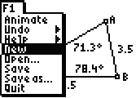 | 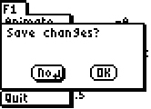 | 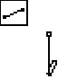
Press e to deactivate the Segment tool.  Press q. If Perp is highlighted press Í to activate the Perpendicular tool. | Move the pencil pointer to the bottom-most point of the segment until the point shimmers. Press Í to select the point. The line segment will begin to shimmer and the pencil pointer will become a horizontal solid arrow. | Press Í to select line segment. A perpendicular line to the segment will be created through the point  in the previous step.  Press e to deactivate the tool.
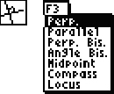 | 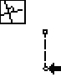 | 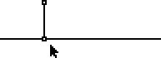

Press p, scroll to Point, if necessary,  press ~, scroll to Point on and press Í to activate the Point on tool. | Move the pencil pointer using the arrow keys to the perpendicular line close to the right side of the screen. The line will shimmer. | Press Í to construct a point at the tip of the pencil. Press e to deactivate the Point on tool. The dashed line will become a solid line. Press and hold † to move the pointer off the point.
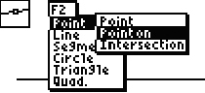 | 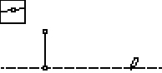 | 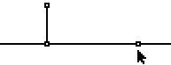
To hide the perpendicular line press s, scroll to Hide/Show, if necessary, and press Í to activate the Hide/Show tool. | Move the regular pointer to the perpendicular line. It will change to an eraser tool when it is over the line. The line will begin to shimmer. Press Í to hide the line. The dashed line changes to a dotted line. | Press e to deactivate the tool and the dotted line disappears. The perpendicular line is hidden.
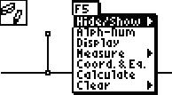 | 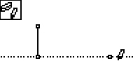 | 

Construct segments from the endpoints of line segment to the point on the hidden perpendicular line. Press p, scroll to Segment and press Í to activate the tool. Move the pencil pointer over the point on the hidden perpendicular line and  press Í. Move to the bottom-most end point of the line segment. Make sure it is shimmering. | Press Í to construct the end point of the current line segment. Construct the other line segment of the triangle while the Segment tool is still active. Be  sure to watch that the  points shimmer before pressing Í.  Press e to deactivate the Segment tool. | Move the pointer to the top-most vertex of the triangle constructed. The regular pointer changes to a hollow pointer and the point shimmers. Press ƒ to grab the point. Press |. The triangle will rotate but the angles remain unchanged. Press e to release the point.
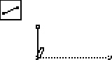 | 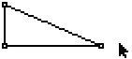 | 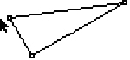

Graphing Points
If there is another image on your calculator screen when you start Cabri Jr., press o, scroll down to New and  press Í. | If asked to save changes press | so that the No button is highlighted.  Press Í to begin a  new image. | To turn the axes on,  press s, scroll to Hide/Show, if necessary and press ~. Press † to highlight Axes and  press Í to activate  the grid.
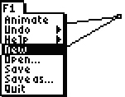 | 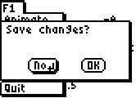 | 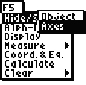

To construct a line  press p, scroll to Line and press Í to activate the Line tool. | Move the pencil pointer  to Quadrant 2 and  press Í to mark the first point. Press and  hold ~ to move the pencil pointer to Quadrant 1. Press and hold } to move the pencil pointer up so the line is not horizontal. | Press Í to mark another point on the line. The dotted line will become a solid line.  Press e to deactivate the Line tool.
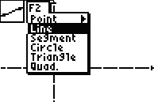 | 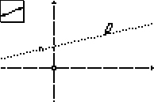 | 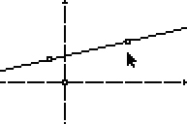
Create a line parallel to the  x-axis through the point in Quadrant 2. Press q, scroll to Parallel and  press Í to activate the Parallel tool. | Move the pencil pointer over the point in Quadrant 2 so the point shimmers.  Press Í to select it. Move the pencil pointer over the x-axis so the pointer changes to a solid horizontal arrow pointer. The line will shimmer. | Press Í to select the  x-axis. A horizontal line will be created through the point in Quadrant 2.
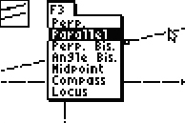 | 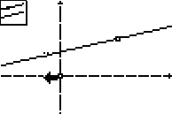 | 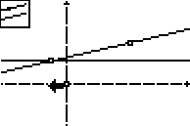

Create a line parallel to the  y-axis through the point in Quadrant 1. Highlight the point. Press Í. Move the pointer over the y-axis. The line will shimmer. | Press Í to select the  y-axis. A vertical line will be created through the point in Quadrant 1. Press e. | Construct a point of intersection. Press p, scroll to Point, press ~, scroll to Intersection and  press Í.
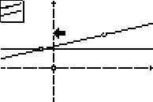 | 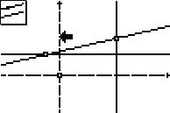 | 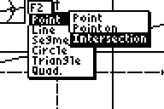
Highlight the vertical line. Press Í. Highlight the horizontal line. Press Í. A point will appear at the intersection of the two lines. Press e. | Measure the slope of the original line. Move the regular pointer to the line. The pointer changes to a hollow pointer. | Press s, scroll to Measure, ~ to get another menu, scroll to Slope and press Í to activate the Slope tool.
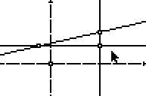 | 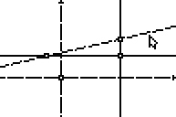 | 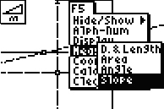

The pointer becomes a solid horizontal arrow. The Slope tool is active. Press Í to select the line and the measure will appear with a hand attached. Use the arrow keys to move the slope measure to the top right corner of the screen.  Press Í to release the slope measure. | Press Í or e. Measure the length of the vertical line segment of the right triangle (RISE).  Press s. Since Measure is already highlighted, press ~ to get another menu. Scroll to D. & Length and press Í. | Move the pointer to the top-most point of the vertical leg of the triangle. Press Í. Move to the bottom-most point of this leg and  press Í. The length will appear with a hand attached. Move the measure outside the triangle and press Í.
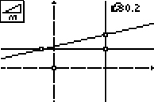 | 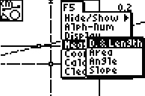 | 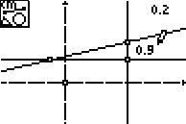
Move the pointer to the left-most point of the horizontal leg of the triangle.  Press Í. Move to the right-most point of this leg and press Í. Move the measure outside the  triangle and press Í. Press e. | Move the pointer over  to each value and  press y Ã. Keep pressing these keys until 2 decimal places are seen. If a measure is a whole number the calculator will not show any digits after the decimal point. | To calculate the value of  the ratio rise over run,  press s, scroll to Calculate and press Í to activate the Calculate tool.
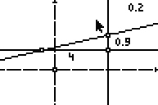 | 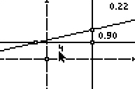 | 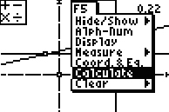

Move the pointer over the rise. Press Í. Press ¥. Move the pointer over the run. Press Í. The ratio (slope) is calculated and shown with a hand attached. Move it to the bottom right of the screen and press Í. Press e. | Move the pointer to the point in Quadrant 1 at the top of the rise of the right triangle and press ƒ to grab it. | Press }. Note the changes in the rise as the point moves upward. The slope measured in two ways does not change. The measure in the top right corner was the slope of the line and the measure in the bottom right corner was the ratio of rise to run of two points on the line.
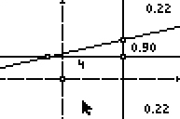 | 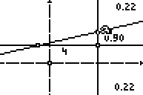 | 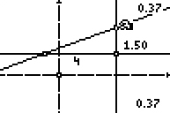
Press Í to release the point. Use the arrow keys to move the pointer to the point in Quadrant 2 at the left-most point of the run of the right triangle and press ƒ to grab it. Press ~. Note the changes in the run as the point moves. The slope measured in two ways does not change. | Press Í to release the point. Press s, scroll to Coord. & Eq. and  press Í to activate the tool. Use the arrow keys to move the pointer over the slanted line. The pointer will change to a solid horizontal arrow. | Use the arrow keys to move the pointer over the slanted line. The pointer will change to a solid horizontal arrow. Press Í and the equation of the line will appear with a hand tool. Move the equation to the bottom left corner of the screen.
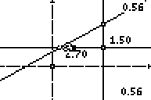 | 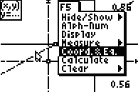 | 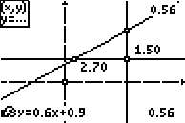

Press Í to release the equation. Press e to deactivate the tool. Move the pointer over top of the equation and press y Ã to increase the accuracy to two decimal places. Note that the value of slope is seen in the equation.
