Random Number Generator
You can use a random generator in a spreadsheet program such as Microsoft® Excel to help you compare theoretical and experimental data.

A spreadsheet has a random number generator called rand(). Whenever it is called, it returns a value greater than or equal to 0, but less than 1.

If you multiply by 2, 2 * rand(), it returns a number greater than or equal to 0, but less than 2. If you use the integer function, int(2 * rand()), you can cut off the decimal part of the number, returning either a 0 or a 1.

Use a 0 to represent a girl, and a 1 to represent a boy.

Open Microsoft® Excel.

Type “girl-0, boy-1” in cell A1.

Type “First Child” in cell B1.

Type “Second Child” in cell C1.

You can adjust the width of the cells.


Move the cursor between A and B
until the double arrow shows.

Left-click the mouse, and drag
to make column A wider. Adjust the widths of columns B and C in the same way.
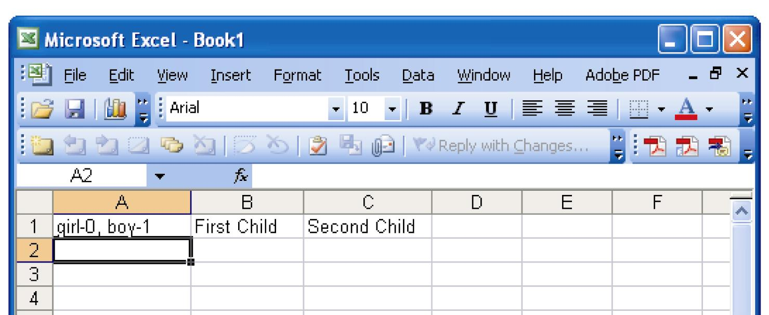
When you are
finished, the
spreadsheet will
look like this.

Type “Family 1” in cell A2.

Type “=int(2 * rand())” in cell B2 and cell C2.

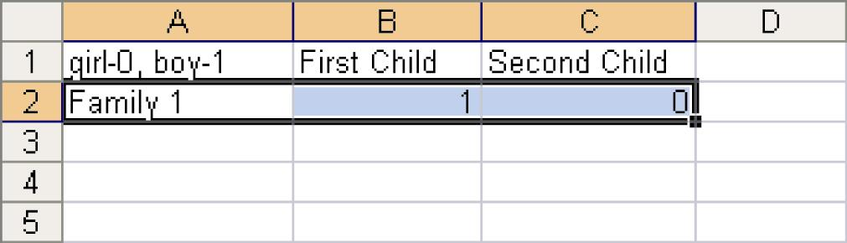
Click in cell A2 and drag to cell C2.

The spreadsheet will look like this.

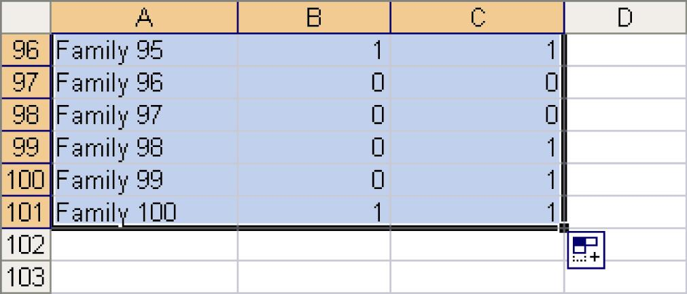
Click on the black square in the
lower right corner of cell C2,
and drag down to cell C101.

This will copy the family number
and the random number generators
for a total of 100 families.

You can resample for another 100 families by holding down the CTRL key, and pressing “R”. Every time that you do this, the spreadsheet will recalculate all of the random numbers.

