Section 5.5 Extra Practice
Jeremy is about to take 2 free throws in a basketball game. The team’s records show that he has a or 2 out of 3 chance of sinking the basketball into the hoop for each shot. His team needs both points to win.

1. Use a paper clip with a pencil and the spinner below to test how successful Jeremy will be in 12 sets of free throws. Record your results in the table.
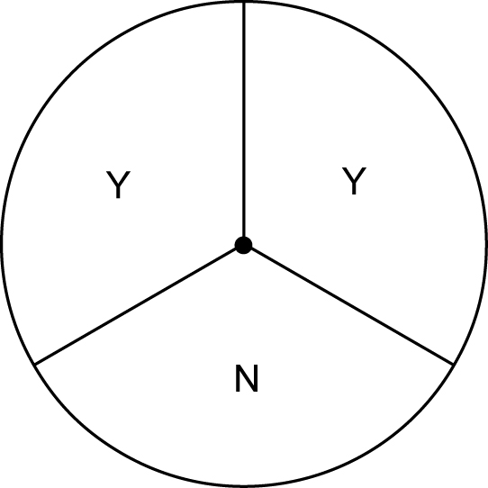 | Trial | First Attempt  (Yes or No) | Second Attempt  (Yes or No) | Both Attempts Successful  (Yes or No)
 | 1
 | 2
 | 3
 | 4
 | 5
 | 6
 | 7
 | 8
 | 9
 | 10
 | 11
 | 12

2. What is the experimental probability that Jeremy’s team won the game?
a) Write the experimental probability as a fraction.
b) Convert this fraction to a percent. You may need a calculator.

3. What is the theoretical probability that Jeremy’s team won the game?
a) Create a tree diagram to find the possible outcomes.
b) Write the theoretical probability as a fraction.
c) Convert this fraction to a percent.
4. Compare the experimental probability with the theoretical probability.

