Chapter 5 Test
For questions #1 to #6, choose the letter representing the term that best matches each statement. Each letter may be used more than once or not at all.

1. ____ A die is tossed 5 times and a six shows up twice giving a probability of .  2. ____ These are the successful results in a probability experiment.  3. ____ Tossing a coin and spinning a spinner at the same time are examples.  4. ____ These are all the possible results in a probability experiment.  5. ____ When tossing a coin, heads is expected to have a probability of .  6. ____ In a lottery, every outcome has an equal chance of occurring. | A outcomes  B probability  C favourable outcomes  D independent events  E sample space  F random  G theoretical probability  H experimental probability
For #7 to #10, select the best answer.
7. A basket contains 4 yellow, 3 red, and 3 blue slips of paper. Without looking, Navida reaches in to pull out one slip. What is the probability that it is red?
A B C D

8. Which of the following gives the correct way to calculate the probability of an event?
A B
C D

9. The probability of an accident occurring is P(accident) = 0.28. What is the probability that an accident does not occur?
A 0.14 B 0.56 C 0.28 D 0.72

10. A student rolls a six-sided die three times in a row. The first roll results in a 6 and the second roll also results in a 6. What is the probability that the third roll will result in a 6?
A B C D
Short Answer

For #11 to #15, use a separate piece of paper.
11. Jorge tosses a coin and then rolls a four-sided die. Draw a tree diagram to show the sample space.

12. What is the probability of randomly choosing a grey ball from the box? Show your answer as a fraction and a percent.

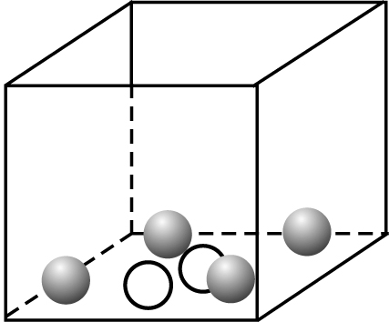

13. If you pick one letter at random from the word possibilities, what is the chance that it will be a vowel? Show your answer as a fraction and a percent.

Extended Response

14. Kirsten has a spinner and 4 balls as shown below. She spins the spinner and selects one ball at random.
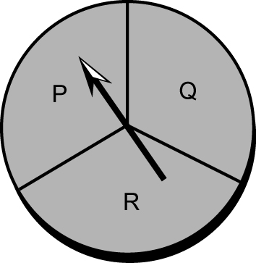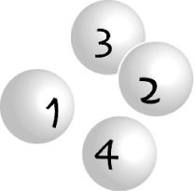
a) Use a table to show all of the possible outcomes.
b) How many outcomes will result in Q and an even numbered ball?
- What is P(Q, even numbered ball) as a decimal and a percent?

15. Dominic and Tony are playing a board game with a pair of six-sided dice. If Dominic can roll a total of five using the two dice, he will win the game.
a) What are all of the possible sums Dominic can roll using the pair of dice?
b) Circle the outcomes that could win the game for Dominic.
c) What is the probability that Dominic will win the game on this roll? Show your answer as a fraction and a percent.

