Chapter 5 MathLinks 7
Student Resource Answers

5.1 Probability, pages 163–164
3. a) , 1 : 4, 25% b) , 2 : 5, 40%
c) , 0 : 3, 0% d) , 6 : 6, 100%
4. a) 3 b) , 2 : 3, 66.7%
5. a) , 3 : 8, 37.5% b) , 4 : 8, 50%
c) , 7 : 8, 87.5%
6. a) , 3 : 9, 33.3% b) , 1 : 9, 11.1%
c) , 7 : 9, 77.8%
7. a) or 60% b) or 80%
8. a) , 0.35 b) , 0.15
9. a) , 0.05, or 5% b) , 0.5, or 50%
c) , 0.2, or 20%
10.
11. or 0.08 or . Answers may vary. There are 5 s between the 12 and 1. There are 60 s in 1 min.
12. Answers may vary. In order to be guaranteed of having at least 1 of each colour, you would have to select all the marbles.

5.2 Organize Outcomes, pages 169–170
4. a), b) |  |  | Spin
4. a), b) |  |  | Tiger | Bear | Monkey
 | Tile Choice | Hungry | hungry, tiger | hungry, bear | hungry, monkey
 | Tile Choice | Sleepy | sleepy, tiger | sleepy, bear | sleepy, monkey
 | Tile Choice | Playful | playful, tiger | playful, bear | playful, monkey
 | Tile Choice | Angry | angry, tiger | angry, bear | angry, monkey
c) Yes. Choosing a tile has no effect on the spin.

5. a), b) |  |  | Card
 |  |  | Moon | Sun | Cloud | Star | Rainbow
 | Colour | Black (B) | B, Moon | B, Sun | B, Cloud | B, Star | B, Rainbow
 | Colour | White (W) | W, Moon | W, Sun | W, Cloud | W, Star | W, Rainbow
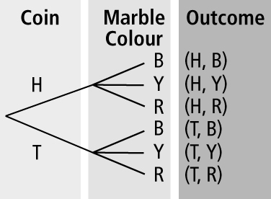
6. a), b)

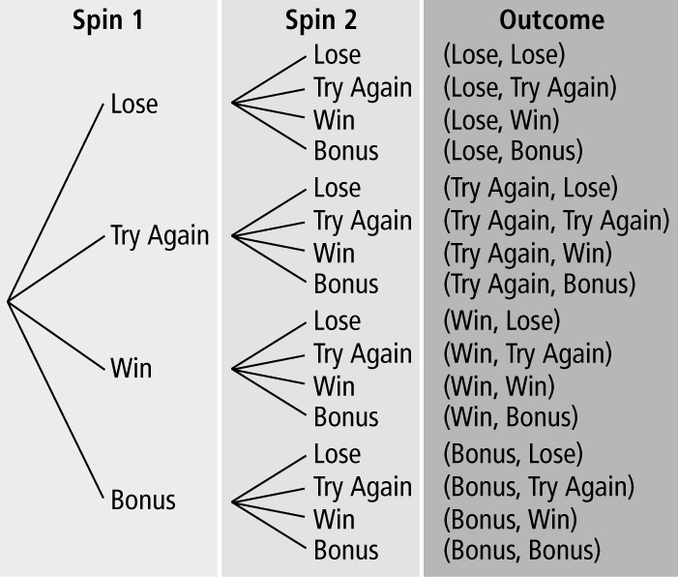
7. a), b)

c) Answers may vary.
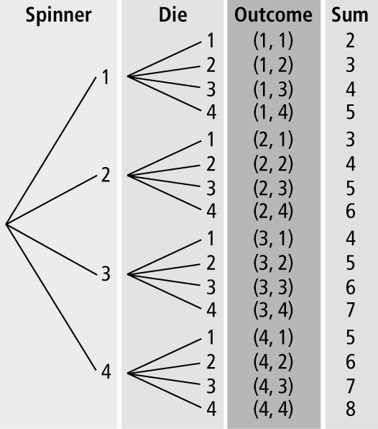
8. a), b) c) 5

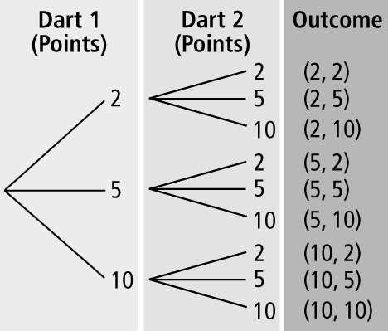
9. a)
b) No. Answers may vary. The numbered areas are not equal in size.

10. a) (juice, chicken), (juice, beef),
(juice, vegetarian), (milk, chicken), (milk, beef), (milk, vegetarian)
b) Answers may vary.
 |  | Taco
 |  | Chicken (C) | Beef (B) | Vegetarian (V)
Drink | Juice (J) | J, C | J, B | J, V
Drink | Milk (M) | M, C | M, B | M, V
11. Answers may vary. Spin a spinner that is divided into 3 sections labelled A, B, and C, and then roll a 4-sided die numbered 1, 2, 3, and 4.
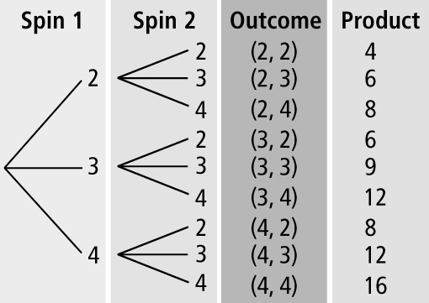
12. a), b)

c) or 11.1%
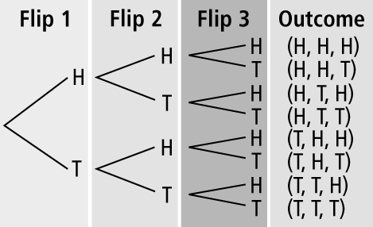
13. a), b)

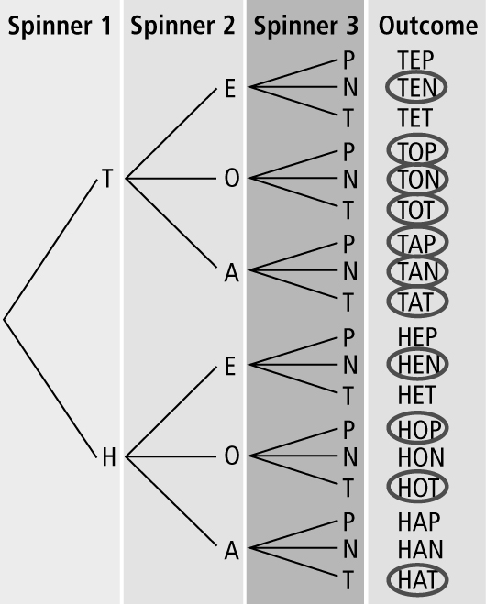
14. a) and c)
b) Answers will vary.

5.3 Probabilities of Simple Independent Events, pages 175–176
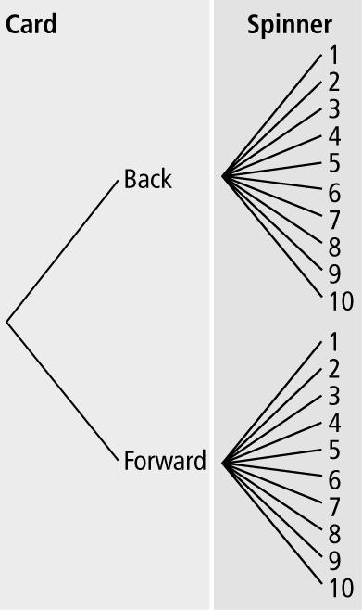
3. a) b) or 5%

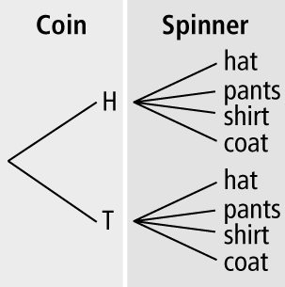
4. a) b) or 25%
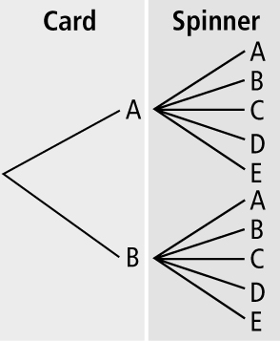
5. a) b) 10 c) or 10%

6. a)
 |  | Spinner
 |  | 1 | 2 | 3 | 4 | 5
Marble | Purple | purple, 1 | purple, 2 | purple, 3 | purple, 4 | purple, 5
Marble | Black | black, 1 | black, 2 | black, 3 | black, 4 | black, 5
Marble | Yellow | yellow, 1 | yellow, 2 | yellow, 3 | yellow, 4 | yellow, 5
Marble | Green | green, 1 | green, 2 | green, 3 | green, 4 | green, 5
Marble | Red | red, 1 | red, 2 | red, 3 | red, 4 | red, 5
b) or 4% c) or 8% d) or 8%
7. a)
 |  | Spinner
 |  | Glass | Feather | Mirror | Stone
Marble | Red | red,  glass | red, feather | red, mirror | red,  stone
Marble | Green | green, glass | green, feather | green, mirror | green, stone
Marble | Yellow | yellow, glass | yellow, feather | yellow, mirror | yellow, stone
Marble | Black | black, glass | black, feather | black, mirror | black, stone
Marble | Blue | blue, glass | blue, feather | blue, mirror | blue, stone
b) or 5% c) or 20%
8. a) Answers will vary. For example, make a tree diagram or draw a table.
b) or 10%
9. a)
 |  | Die
 |  | 1 | 2 | 3 | 4 | 5 | 6
Coin Flip | Heads (H) | H, 1 | H, 2 | H, 3 | H, 4 | H, 5 | H, 6
Coin Flip | Tails (T) | T, 1 | T, 2 | T, 3 | T, 4 | T, 5 | T, 6
b) or 8.3% c) or 33.3%
10. Answers may vary. For example: i) Flip a coin, then roll a 4-sided die. ii) Flip a coin, then select a tile from a bag where there are 4 tiles, numbered 1, 2, 3, and 4.
11. a) |  |  | Card 2
 |  |  | Black (B) | White (W)
 | Card 1 | Black (B) | B, B | B, W
 | Card 1 | White (W) | W, B | W, W
b) or 25% c) or 50%
12. a), b)
 |  | Die 2
 |  | Raven (r) | Osprey (o) | Eagle (e) | Hawk (h) | Falcon (f) | Crow (c)
Die | Raven (r) | r, r | r, o | r, e | r, h | r, f | r, c
Die | Osprey (o) | o, r | o, o | o, e | o, h | o, f | o, c
Die | Eagle (e) | e, r | e, o | e, e | e, h | e, f | e, c
Die | Hawk (h) | h, r | h, o | h, e | h, h | h, f | h, c
Die | Falcon (f) | f, r | f, o | f, e | f, h | f, f | f, c
Die | Crow (c) | c, r | c, o | c, e | c, h | c, f | c, c
c) or 5.6% d) or 2.8%
e) or 100%
13. a) or 50% b) or 25%
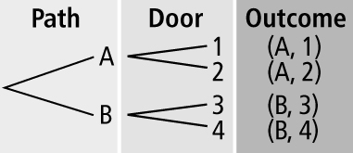
c)

d) 0 or 0%. The mouse cannot reach
door 3 from path A.
14. a) Answers will vary. One of the spinners has 4 equal divisions with the following sections: volleyball, basketball, softball, and football. The other spinner has 3 equal divisions with the following sections: floor hockey, dodge ball, and trampoline.
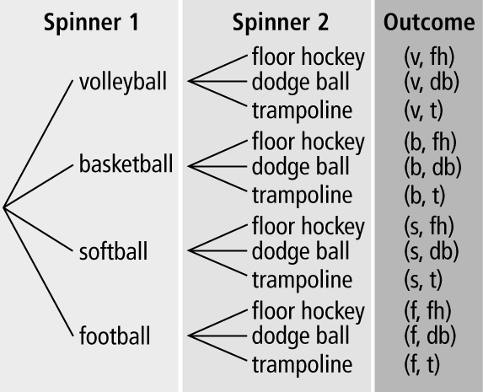
b)

c) or 8.3% d) or 100%
e) or 33.3%
15. a) (0, 1), (0, 3), (0, 5), (0, 7), (0, 9),
(2, 1), (2, 3), (2, 5), (2, 7), (2, 9),
(4, 1), (4, 3), (4, 5), (4, 7), (4, 9),
(6, 1), (6, 3), (6, 5), (6, 7), (6, 9),
(8, 1), (8, 3), (8, 5), (8, 7), (8, 9)
b) or 4% c) (6, 1), (6, 3), (6, 5),
(6, 7), (6, 9), (8, 1), (8, 3), (8, 5),
(8, 7), (8, 9); or 10%

5.4 Applications of Independent Events,
pages 181–182
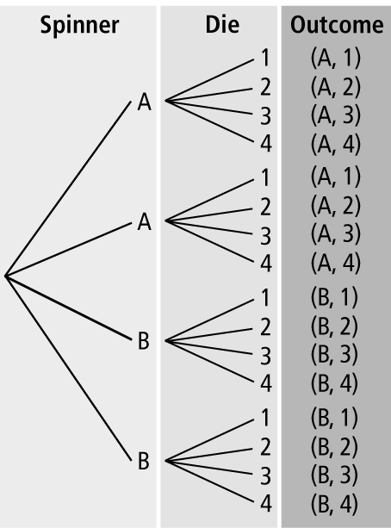
3. a) b) or 12.5%
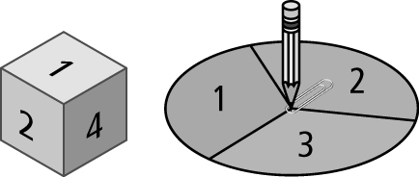
4. a) b) or 5.6%

5. a)
 |  | Die
 |  | Eat | Work | Play | Sleep
Spinner | Morning (M) | M, eat | M, work | M, play | M, sleep
Spinner | Afternoon (A) | A, eat | A, work | A, play | A, sleep
Spinner | Evening (E) | E, eat | E, work | E, play | E, sleep
b) or 8.3% c) or 16.7%
6. a) |  |  | Card
 |  |  | 2 | 3 | 4 | 5
 | Die | 1 | 1, 2 | 1, 3 | 1, 4 | 1, 5
 | Die | 2 | 2, 2 | 2, 3 | 2, 4 | 2, 5
 | Die | 3 | 3, 2 | 3, 3 | 3, 4 | 3, 5
 | Die | 4 | 4, 2 | 4, 3 | 4, 4 | 4, 5
 | Die | 5 | 5, 2 | 5, 3 | 5, 4 | 5, 5
 | Die | 6 | 6, 2 | 6, 3 | 6, 4 | 6, 5
b) or 16.7% c) or 25%
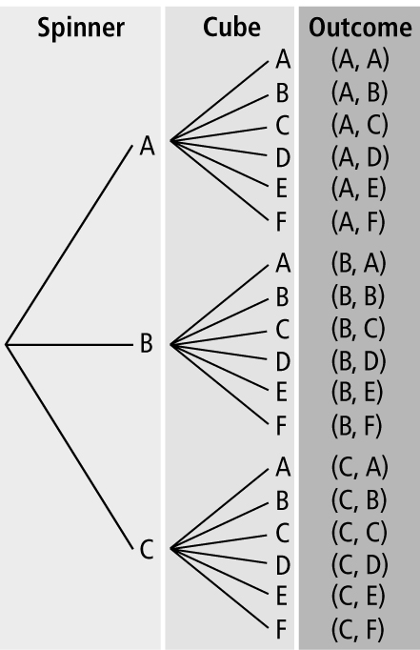
7. a) b) or 5.6%
c) or 16.7%

8. a) |  |  | Throw 2
 |  |  | 2 | 2 | 3 | 3 | 5
 | Throw 1 | 2 | 2, 2 | 2, 2 | 2, 3 | 2, 3 | 2, 5
 | Throw 1 | 2 | 2, 2 | 2, 2 | 2, 3 | 2, 3 | 2, 5
 | Throw 1 | 3 | 3, 2 | 3, 2 | 3, 3 | 3, 3 | 3, 5
 | Throw 1 | 3 | 3, 2 | 3, 2 | 3, 3 | 3, 3 | 3, 5
 | Throw 1 | 5 | 5, 2 | 5, 2 | 5, 3 | 5, 3 | 5, 5
b) or 36% c) or 52%
9. a) 100% b) 0% c) or 37.5%
10. a) or 25% b) or 16.7%
c) or 58.3%
11. a) |  |  | Song 2
 |  |  | A | A | B | C | D
 | Song 1 | A | A, A | A, A | A, B | A, C | A, D
 | Song 1 | A | A, A | A, A | A, B | A, C | A, D
 | Song 1 | B | B, A | B, A | B, B | B, C | B, D
 | Song 1 | C | C, A | C, A | C, B | C, C | C, D
 | Song 1 | D | D, A | D, A | D, B | D, C | D, D
b) or 16%

5.5 Conduct Probability Experiments, pages 187–189
4. a) 2 boys b) or 26% c) or 25%
5. a) or 27% b) or 25%
c) Answers will vary. The experimental probability is greater than the theoretical probability.
6. a) or 35% b) or 25%
c) Answers will vary. The experimental probability is greater than the theoretical probability.
7. a) or 60% b) or 50%
c) Answers will vary. The experimental probability is greater than the theoretical probability.
8. a), b), and d) Answers will vary.
c) or 50%
9. a) 7 b) or 14% c) or 10%
d) Answers may vary.
 |  | Right Button
 |  | 1 | 2
Left Button | S | S, 1 | S, 2
Left Button | N | N, 1 | N, 2
Left Button | A | A, 1 | A, 2
Left Button | C | C, 1 | C, 2
Left Button | K | K, 1 | K, 2
10. Answers will vary.
11. a) or 23.6% b) or 25%
c) or 24.5%
12. Answers will vary. 13. Answers will vary.

Chapter 5 Review, pages 190–191
1. favourable, possible 2. experimental
3. tree diagram 4. random; an event where every outcome has an equal chance of occurring
5. or 2 : 5 or 40%
6. a) or 0:10 or 0%
b) or 2:10 or 20%
c) or 3:10 or 30%
d) or 6:10 or 60%
7. |  |  | Spinner
 |  |  | Broccoli | Beans | Carrots
 | Coin | Salad (S) | S, broccoli | S, beans | S, carrots
 | Coin | Cooked (C) | C, broccoli | C, beans | C, carrots

8. a) |  |  | Dessert
 |  |  | Sundae (S) | Pie (P)
 | Dinner | Quiche | quiche, S | quiche, P
 | Dinner | Burger | burger, S | burger, P
 | Dinner | Surprise | surprise, S | surprise, P
 | Dinner | Special | special, S | special, P
b) 8
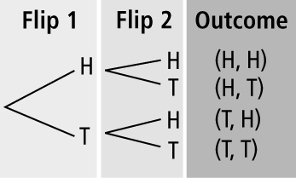
9. a) b) or 25%

10. a)
 |  | Pail
 |  | Nail (n) | Screw (s) | Screw (s) | Screw (s) | Screw (s) | Hook (h) | Hook (h)
Tool Box | Hammer (H) | H, n | H, s | H, s | H, s | H, s | H, h | H, h
Tool Box | Screwdriver (S) | S, n | S, s | S, s | S, s | S, s | S, h | S, h
Tool Box | Pliers  (P) | P, n | P, s | P, s | P, s | P, s | P, h | P, h
Tool Box | Tape Measure  (T) | T, n | T, s | T, s | T, s | T, s | T, h | T, h
b) or 3.6% c) 0
11. a) Answers may vary. Roll a 4-sided die and then spin a 4-section spinner.
b) or 25% c) or 25%
d) or 37.5%

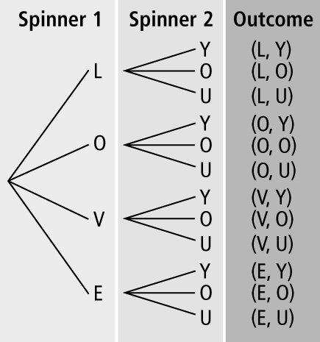
12. a) b) or 8.3%
c) or 91.7%

13. a) b) c) Answers may vary. The probability in a) is based on the results of an experiment.
14. a) or 40% b) or 50% c) The theoretical probability is greater than the experimental probability.

Chapter 5 Practice Test, pages 192–193
1. A 2. B 3. C 4. D 5. B
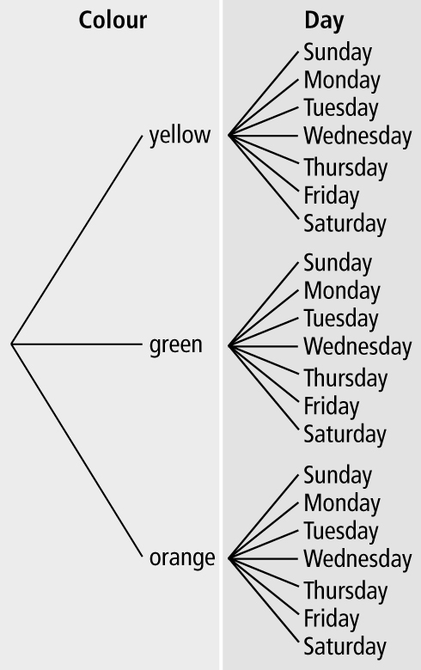
6.

7. |  |  | Meal
 |  |  | Wrap | Pizza | Salad
 | Drink | Milk (M) | M, wrap | M, pizza | M, salad
 | Drink | Apple juice (A) | A, wrap | A, pizza | A, salad

8. a) No. Answers will vary. Two of the
4 sections on the spinner are labelled beans.
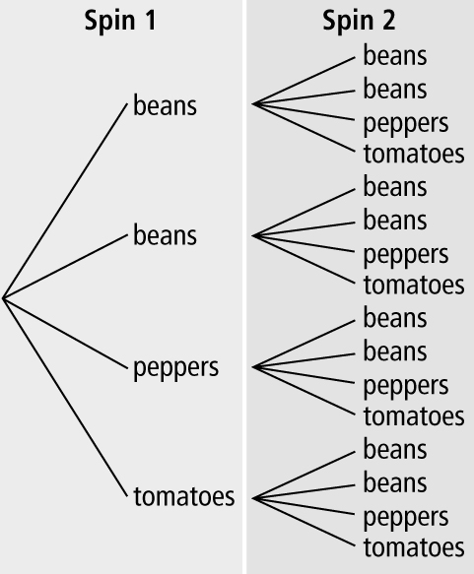
b)

c) or 25% d) or 62.5%
9. a)

 |  | Spin 2
 |  | 1 | 2 | 3 | 4 | 5
Spin 1 | 1 | 1, 1 | 1, 2 | 1, 3 | 1, 4 | 1, 5
Spin 1 | 2 | 2, 1 | 2, 2 | 2, 3 | 2, 4 | 2, 5
Spin 1 | 3 | 3, 1 | 3, 2 | 3, 3 | 3, 4 | 3, 5
Spin 1 | 4 | 4, 1 | 4, 2 | 4, 3 | 4, 4 | 4, 5
Spin 1 | 5 | 5, 1 | 5, 2 | 5, 3 | 5, 4 | 5, 5
b) or 20% c) 8% d)

10. a) The spinner has 5 equal sections: 4 are marked in and 1 is marked miss. Spin the spinner twice and record the outcomes.
b) |  |  | Spin 2
 |  |  | In (I) | In (I) | In (I) | In (I) | Miss (M)
 | Spin 1 | In (I) | I, I | I, I | I, I | I, I | I, M
 | Spin 1 | In (I) | I, I | I, I | I, I | I, I | I, M
 | Spin 1 | In (I) | I, I | I, I | I, I | I, I | I, M
 | Spin 1 | In (I) | I, I | I, I | I, I | I, I | I, M
 | Spin 1 | Miss (M) | M, I | M, I | M, I | M, I | M, M
c) 75% d) or 64%
e) The experimental probability is greater than the theoretical probability.

