Chapter 5 BLM Answers

BLM 5–2 Probability
1. a) b) = c)
2. a) 50% b) 100% c) 25% d) 75%
3. a) 50%; b) 75%;
c) 30%;
4. a) ; 0.75; 75%
b)
c) = ; 0.25; 25%
5. 62.5%; ; 0.625
6. Class 3 Tally: llll llll lll; 16
7.
  Car Colour | Number of Cars
  Red | llll llll
  Blue | llll
  White | llll ll
  Silver | llll lll

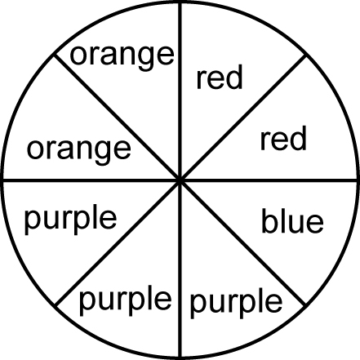
8. a) b)

BLM 5–3 Section 5.1 Extra Practice
1. a) b)
c)
2. a) b)
c)
3. a) b) ≈ 0.33333
c) 0.333 × 100% ≈ 33.3%
4. a) b)
c)
5. P(unsalted) == 0.5 = 50%
6. P(barbecue-flavoured) = = 0.2 = 20%
7. P(M) = = 0.2 = 20%
8. P(vowel) =
9. P(consonant) =

BLM 5–5 Section 5.2 Extra Practice
1. a)
 | 1 | 2 | 3 | 4 | 5 | 6
Yellow | Y,1 | Y,2 | Y,3 | Y,4 | Y,5 | Y,6
Red | R,1 | R,2 | R,3 | R,4 | R,5 | R,6
Blue | B,1 | B,2 | B,3 | B,4 | B,5 | B,6
Green | G,1 | G,2 | G,3 | G,4 | G,5 | G,6
b) (Y,1),(Y,2),(Y,3),(Y,4),(Y,5),(Y,6),
(R,1),(R,2),(R,3),(R,4),(R,5),(R,6),
(B,1),(B,2),(B,3),(B,4),(B,5),(B,6),
(G,1),(G,2),(G,3),(G,4),(G,5),(G,6)
2. a)
 | 1 | 2 | 3 | 4
Red | R,1 | R,2 | R,3 | R,4
White | W,1 | W,2 | W,3 | W,4
b) (W,1),(W,2),(W,3),(W,4),(R,1),(R,2),
(R,3),(R,4)

BLM 5–7 Section 5.3 Extra Practice
1. random, equal, heads, tails
2.
   | Heads | Tails
  Heads | H,H | H,T
  Tails | T,H | T,T

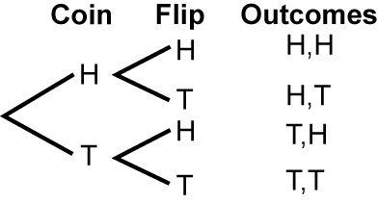
3.

4.
 | Fraction | Decimal | Percent
a) P(2 different results) |  | 0.50 | 50%
b) P(H,H) |  | 0.25 | 25%
c) P(at least one H) |  | 0.75 | 75%

BLM 5–8 Section 5.4 Extra Practice
1. a) Check that students have a card with
Forward on one side and Back on the other. They can use this manipulative to help them list all outcomes.
b)
 | 1 | 2 | 3 | 4 | 5 | 6
Forward | F,1 | F,2 | F,3 | F,4 | F,5 | F,6
Back | B,1 | B,2 | B,3 | B,4 | B,5 | B,6

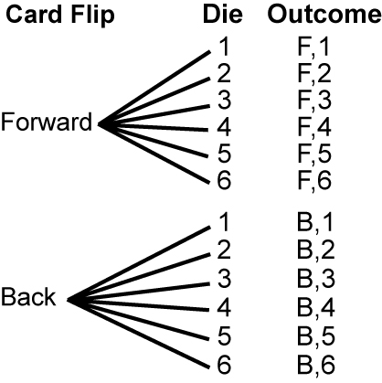
c) d) 12

2. a) P(F,3) = ≈ 8.33%
b) P(1 or 2) = = ≈ 33.3%
c) = 0.5 = 50% d)

BLM 5–12 Section 5.5 Extra Practice
1. Answers will vary.
2. a), b) Answers will vary.
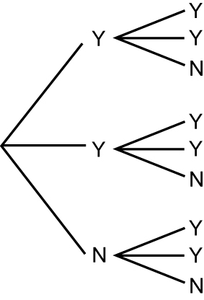
3. a) b) c) ≈ 44.4%

4. Answers may vary.
BLM 5–13 Chapter 5 Test
1. H 2. C 3. D 4. A 5. G
6. F 7. D 8. A 9. D 10. A

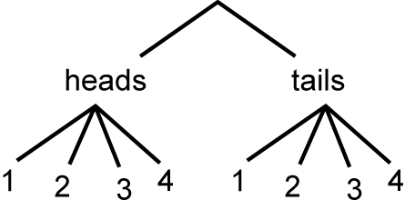
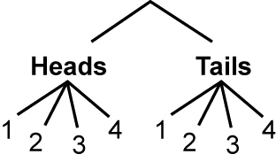
11.

12. = ≈ 66.7% 13. ≈ 46.2%
14. a)
 | 1 | 2 | 3 | 4
P | P,1 | P,2 | P,3 | P,4
Q | Q,1 | Q,2 | Q,3 | Q,4
R | R,1 | R,2 | R,3 | R,4

b) 2 c) P(Q, even numbered
ball) = =
15. a), b)
 | 1 | 2 | 3 | 4 | 5 | 6
1 | 1, 1 | 1, 2, | 1, 3 | 1, 4 | 1, 5 | 1, 6
2 | 2, 1 | 2, 2 | 2, 3 | 2, 4 | 2, 5 | 2, 6
3 | 3, 1 | 3, 2 | 3, 3 | 3, 4 | 3, 5 | 3, 6
4 | 4, 1 | 4, 2 | 4, 3 | 4, 4 | 4, 5 | 4, 6
5 | 5, 1 | 5, 2, | 5, 3 | 5, 4 | 5, 5 | 5, 6
6 | 6, 1 | 6, 2 | 6, 3 | 6, 4 | 6, 5 | 6, 6
c) = ≈ 11.1%

