Chapter 5 Self-Assessment
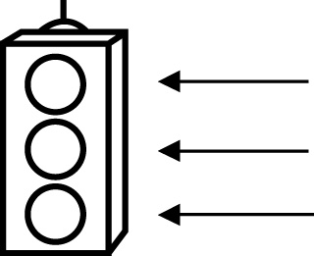 | RED I have not started moving in this area.  YELLOW I am moving along with caution in this area.  GREEN I am moving along confidently in this area.

BEFORE | DURING  (What I can do if I mark yellow or red.) | AFTER  (Proof that I can do this.)
5.1
  I can find the probability of an event in several different ways. | 
I can give answers as probabilities from 0% to 100%.
5.2
I can explain how to identify an independent event.
I can determine the outcomes of two independent events.
I can organize the outcomes of two independent events using tables and tree diagrams.
5.3
I can solve probability problems involving two independent events.

5.4
I can use tree diagrams, tables, and other graphic organizers to solve probability problems.
5.5
I can conduct a probability experiment and organize the results.
I can compare experimental probability with theoretical probability.

