Probability
1. What fraction of each figure is shaded?
a)


b)

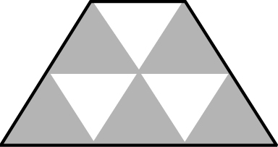
c)

2. What percent of each rectangle is shaded?
a)

b)

c)

d)

3. What is the value of D in each diagram? Write each answer as a percent and an equivalent fraction.
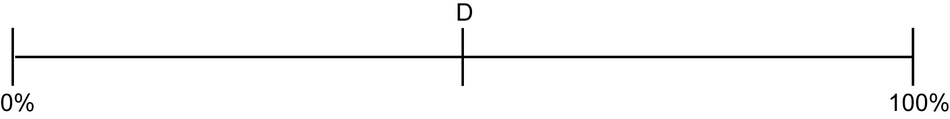
a)

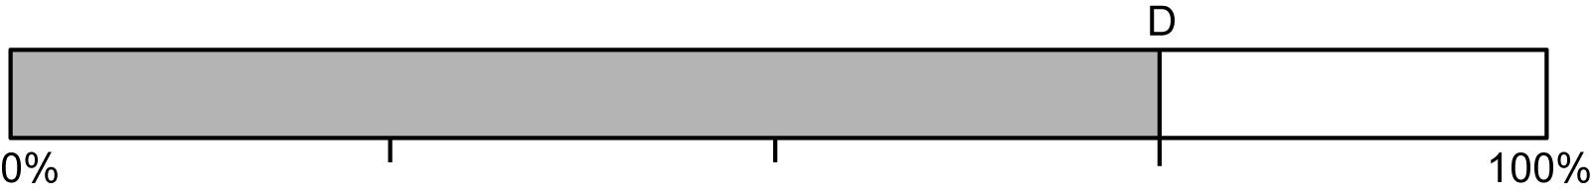
b)

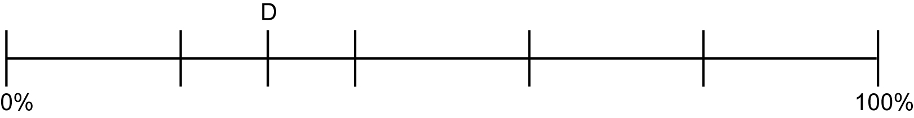
c)

4. What is the value of the shaded part of each figure? Write each answer as a fraction, a decimal, and a percent.

  a) | 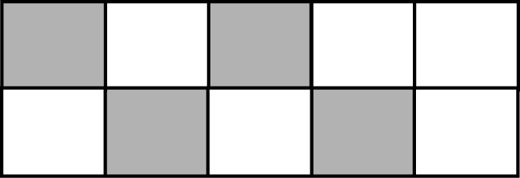  b) | 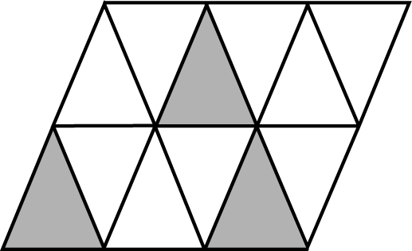  c)

5. What is the value of the non-shaded part of the figure? Write each answer as a fraction, a decimal, and a percent.

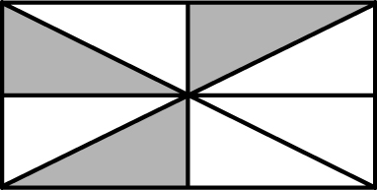

6. The chart shows the number of students in four grade 7 classes who walk to school. Part of the chart is not completed. Fill in the tally for Class 3 and the total for Class 4.

Class | Tally | Total
Class 1 | 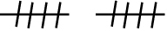 | 10
Class 2 |  | 22
Class 3 |  | 13
Class 4

7. Two students counted the number of cars of various colours as they walked to school. Make a tally chart showing the data the students collected.

Car Colour | Number of Cars
Red | 10
Blue | 5
White | 7
Silver | 8

8. a) Colour the spinner below red, blue, purple, and the rest orange.
b) What fraction of the spinner is orange? How do you know that your answer is correct?
