Section 5.1 Math Link
This worksheet will help you with the Math Link on page 164.

a) How many different dice shapes can you build or draw with up to 12 faces. Use the table to help keep track of your shapes.

Number of Sides on Each Face | Number of Faces | Sketch of Die
3 | 4 | 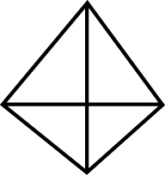
3 | 8
4 | 6

Write each answer as a fraction, a ratio, and a percent.

b) What is the probability of rolling a 7 using an eight-sided die?

There is one favourable outcome, .

There are possible outcomes.

or : or %

c) What is the probability of rolling a number less than 7 using a 12-sided die?
d) What is the probability of rolling a 5 using a four-sided die?
e) What is the probability of rolling a 1, 2, 3, or 4 using a four-sided die?

