Section 5.2 Math Link
This worksheet will help you with the Math Link on page 170.

1. You roll a pair of six-sided dice.
a) Complete the table to show the sample space. Then calculate the sum of each outcome. The first one is done for you.
 | 1 | 2 | 3 | 4 | 5 | 6
1 | 1, 1 = 2
2
3
4
5
6
b) What sum appears most frequently?
c) What sum appears least frequently?

2. You roll a pair of four-sided dice.
a) Complete the tree diagram to show the sample space and the sum of each outcome.
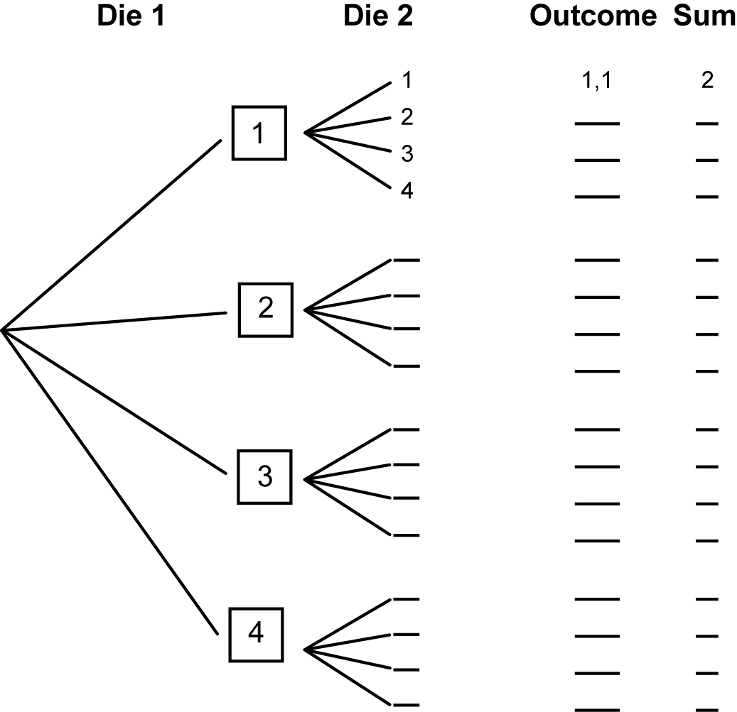
b) What sum appears most frequently?
c) What sum appears least frequently?

