Section 5.3 Extra Practice
1. Fill in each blank with the correct word. Use the word list to help you.

equal | heads | random | tails

In a _________ event, every outcome has an _________ chance of occurring. When you flip a coin, for example, the coin can turn up _________ or _________.

2. Complete the table to show the possible outcomes of flipping two coins.
 | Heads | Tails
Heads
Tails

3. Complete the tree diagram to show the possible outcomes of flipping one coin twice.
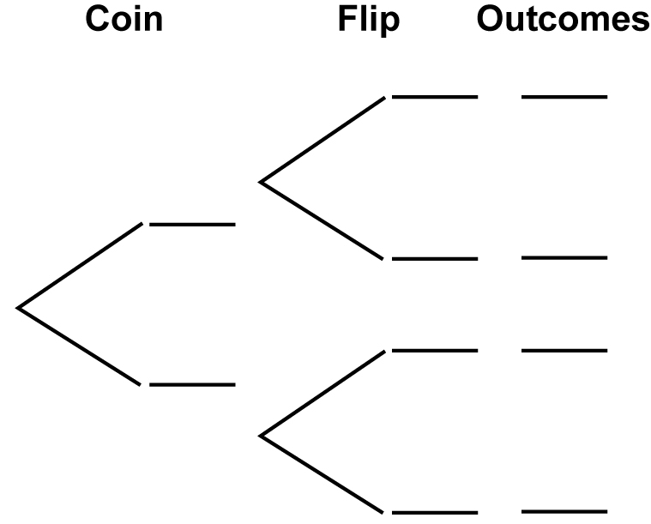
4. Use the tree diagram from #3 to find the probability of each of the following as a fraction, a decimal, and a percent.

Outcome | Fraction | Decimal | Percent
a) P(2 different results)
b) P(H,H)
c) P(at least one H)

