Chapter 10 Self-Assessment
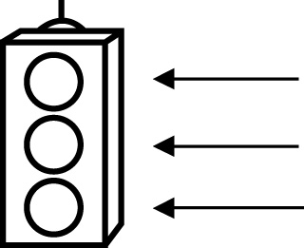 | RED I have not started moving in this area.  YELLOW I am moving along with caution in this area.  GREEN I am moving along confidently in this area.

BEFORE | DURING  (What I can do if I mark yellow or red.) | AFTER  (Proof that I can do this.)
10.1

I can describe patterns using words, tables, or diagrams.
I can use patterns with repeating decimal numbers.
10.2
I can write an expression to represent a pattern.
I can identify a constant, a numerical coefficient, and a variable.
I can write a word statement as an expression.
10.3
I can model an expression.
I can evaluate an expression.
I can make a table
of values for an expression.
10.4
I can graph a linear relation.
I can make a graph for a table of values.
I can describe the relationship shown on a graph.
I can match linear relations to graphs.

