Patterns and Expressions
1. The number of squares is increasing in the following pattern.

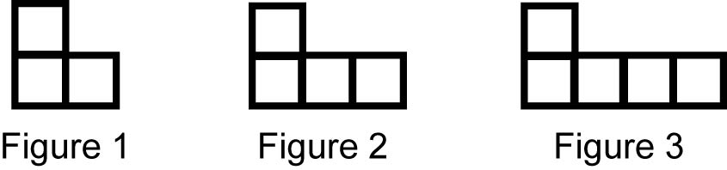

a) Draw a picture showing Figure 4 in the pattern.
b) Make a table showing the number of squares for the first five figures.

2. Build or draw the fourth figure in the following pattern. Justify your answer.

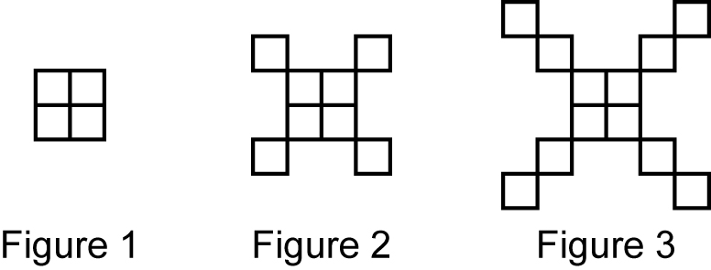

3. Copy and complete the following chart using this rule: The number of people is one more than triple the figure number.

Figure Number | 1 | 2 | 3 | 4
Number of People

4. The following chart shows the number of triangles in a pattern.

Figure Number | 1 | 2 | 3 | 4
Number of Triangles | 2 | 5 | 8

a) How many triangles are in Figure 4?
b) What rule uses the figure number to describe the number of triangles?

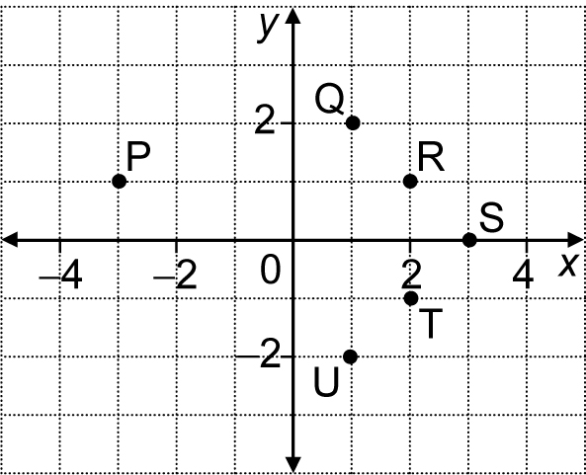
5. Use the coordinate grid shown to help answer the following questions.
a) Which point has coordinates (2, –1)?
b) What are the coordinates of S?
c) Which two points have the same value for their
y-coordinates?
d) Which three points could be joined to form a
right-angled triangle? Give as many answers
as possible.

