Section 10.1 Math Link
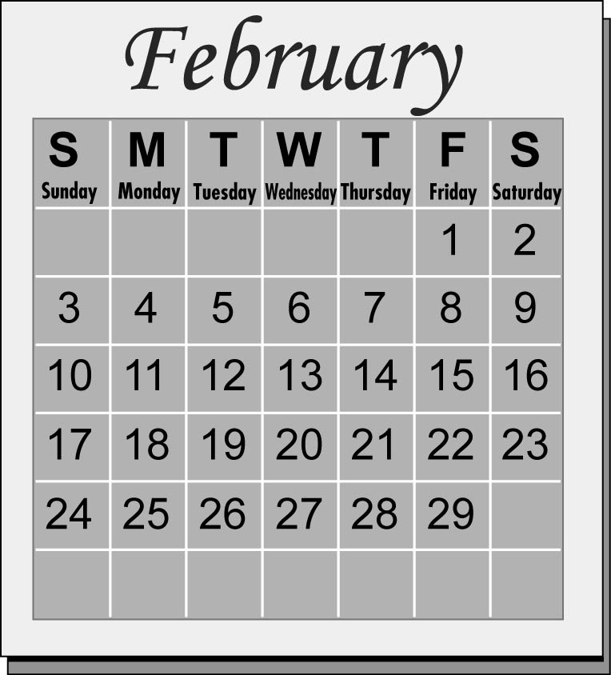
This worksheet will help you with the Math Link on page 357.

A calendar has 365 days, unless it is a leap year. Every four years, the month of February has 29 days. That means a leap year has 366 days.

1. What day of the week is your birthday this year? _______________

2. If next year is not a leap year, what day will your birthday be next year? ______________

3. If next year is a leap year, what day will your birthday be? ______________

4. Make a table that shows what day your birthday will be over the next five years.
Start with this year. Circle any years that
are leap years.
Year | Day

5. a) Describe in words a pattern for the day
of the week that your birthday will be
each year.__________________________________________________
__________________________________________________________
b) Describe how the pattern will change in a leap year.
__________________________________________________________

6. Record the number of days in a regular year. You will use this number to uncover the mystery pattern at the end of the chapter. ______________

