Section 10.2 Extra Practice
1. Complete the table.

Expression | Variable | Numerical Coefficient | Constant
a) | x | 4 | 9
b) 3a − 7
c)
d)
e)

2. Study the pattern of rectangles made from toothpicks.

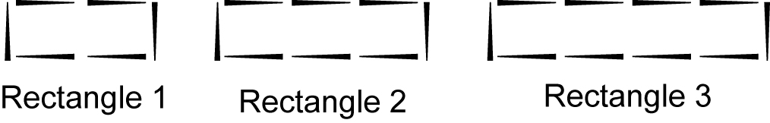

a) Draw the next rectangle in the pattern.

b) Complete the table for the four rectangles.

Rectangle | Perimeter (P)
1 | 6
2
3
4

c) What would the perimeter be for Rectangle 10? Show your work.

d) What is an expression for the perimeter of any rectangle in this
pattern in relation to the rectangle number?

