Section 10.2 Math Link
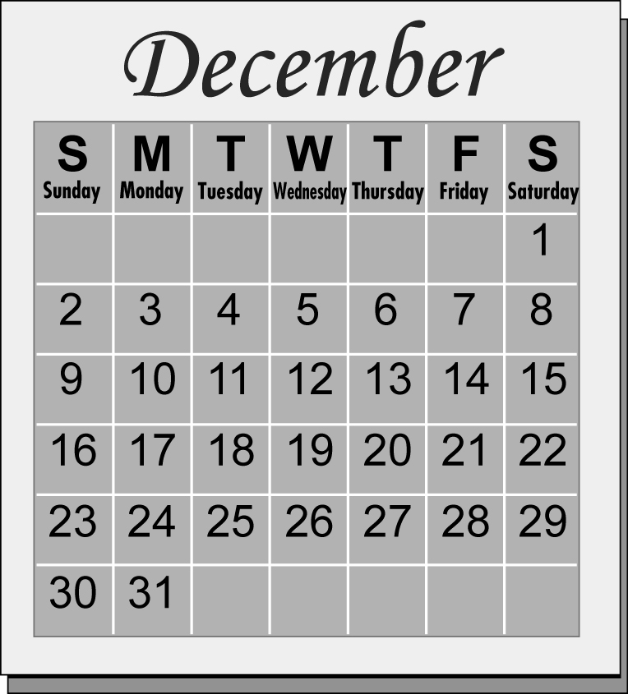
This worksheet will help you with the Math Link on page 364.

1. Outline a 3 3 square on the calendar.

2. Write the numbers in the grid below.

3. What is the sum of all the numbers in your 3 3 square? ____

4. Repeat using a different 3 3 square.

5. What is the sum of the numbers in your new square? ____

6. Look at the middle number in each square. Describe an easy way to find the sum of each 3 3 square using the middle number.
______________________________________________________________
______________________________________________________________

7. Use m to represent the middle number. Write an expression in relation to m for the sum of all the dates in a 3 3 square.

____ m = sum of all the numbers in a 3 3 square

8. Record the numerical coefficient in your expression from #7. You will use this number to uncover the mystery pattern at the end of the chapter. ________

