Section 10.3 Math Link
This worksheet will help you with the Math Link on page 371.

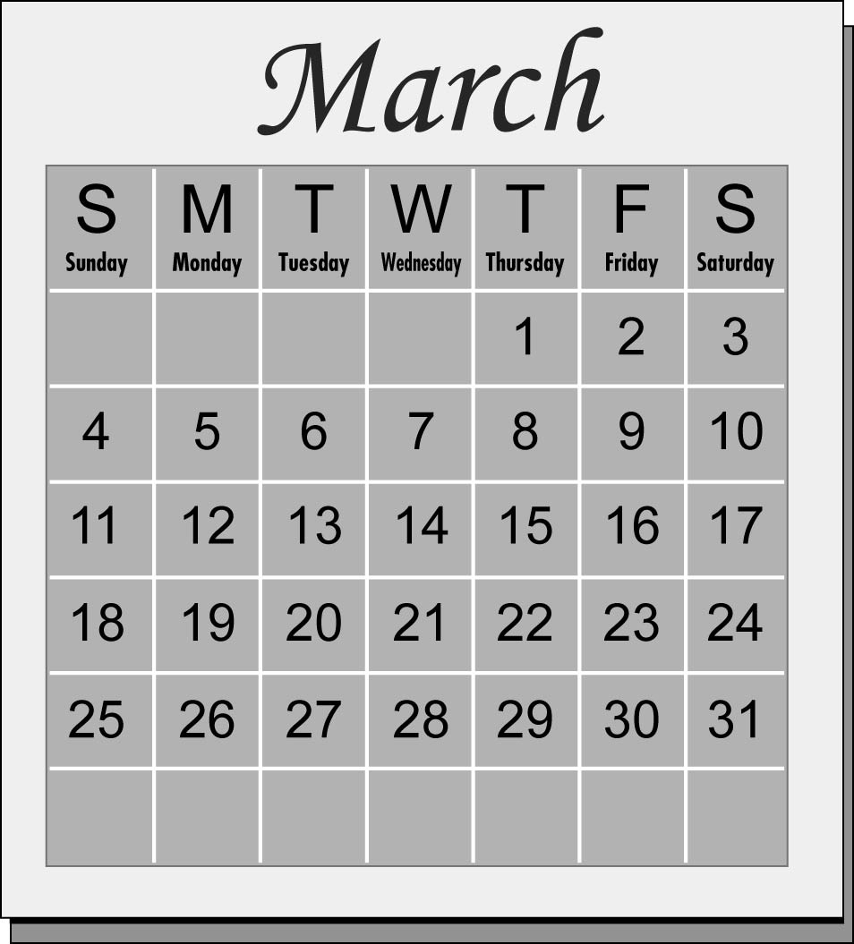

1. Use the calendar to fill in the following information.
a) First Thursday in March: ____ b) First Friday in March: ____
Second Thursday in March: ____ Second Friday in March: ____
Sum of the two numbers: _____ Sum of the two numbers: ____
c) First Saturday in March: ____ d) First Sunday in March: ____
Second Saturday in March: ____ Second Sunday in March: ____
Sum of the two numbers: _____ Sum of the two numbers: _____

2. Fill in the table.
Term Number | Sum
1
2
3
4

3. a) Describe what pattern you notice.
___________________________________________________________
b) Look at the sums. Write an expression for the pattern based on the term
number. ____________________________________________________

4. Substitute to determine the next three numbers in the pattern:
Term Number | Sum
5
6
7

5. a) Do you think the same expression would work for a different month?
YES NO Explain. ___________________________________________
b) At the bottom of this page, test your prediction using a different month.
Show your work. Was your prediction accurate? YES NO
Explain. ____________________________________________________
___________________________________________________________

6. Record the numerical coefficient in your expression from #3b). You will
use this number to uncover the mystery pattern at the end of the
chapter. ______________

