Section 10.4 Math Link
This worksheet will help you with the Math Link on page 381.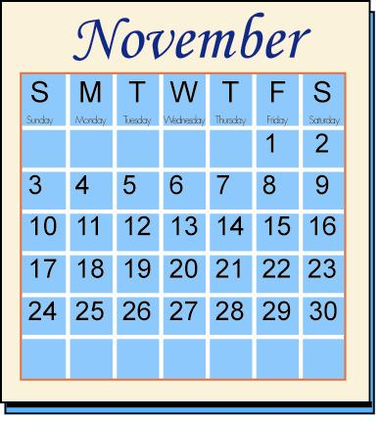

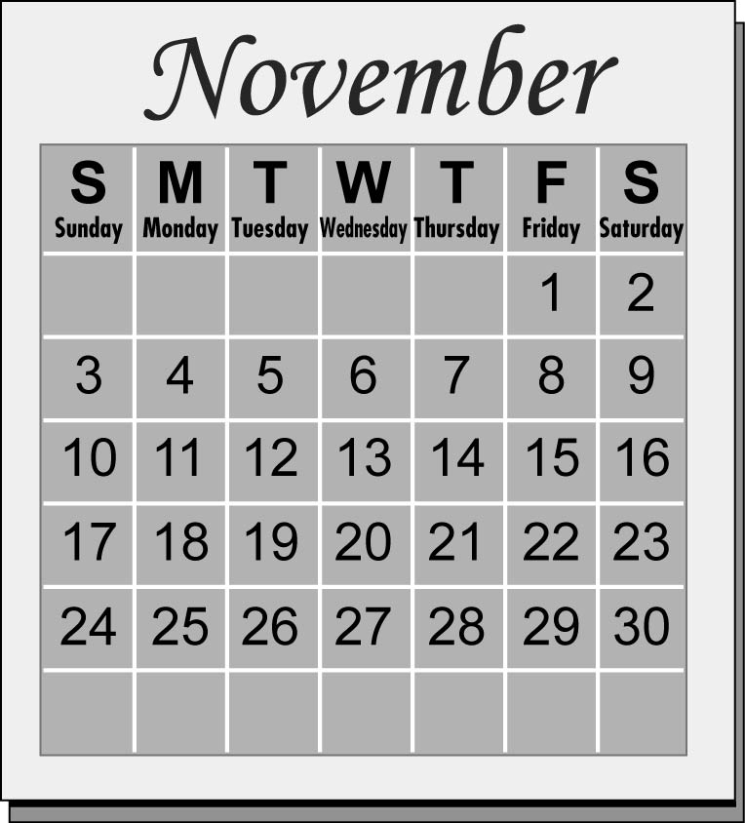

Use the calendar to help answer the following questions.

1. a) What is the date for the first Friday in November? ____
b) What is the date for the second Friday in November? ____
c) What is the date for the third Friday in November? ____

2. Complete the table of values for your
results from #1.
Friday | Date
1
2
3

3. a) Write an expression for the dates of
Fridays in November.
___________________________________________

4. Determine the dates for all Fridays in November.
Record your results in the table.
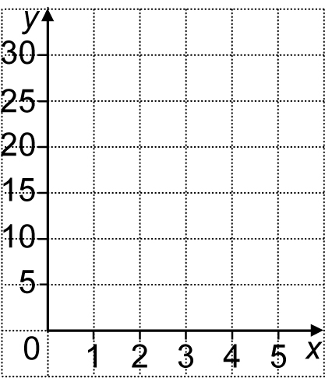
5. Graph your table of values on the
coordinate grid.

6. Repeat #3 to #5 using another day of the week.
Date

7. Compare the patterns in your two graphs. Explain the similarities and differences.
Similarities: ___________________________________________________
___________________________________________________
Differences: ___________________________________________________
___________________________________________________

8. Record the numerical coefficient for your expression in #3a). You will use this number to uncover the mystery pattern at the end of the chapter.
____

