Chapter 10 Test
Match each statement on the left with a term on the right.

1. ____ x in the expression  2. ____ 2 in the expression  3. ____ is an example of one  4. ____ 15 in the expression | A table of values  B expression  C constant  D numerical coefficient  E variable

For #5 to #8, circle the best answer.

5. Which one of the following is equal to ?
A 0.7 B 0.797979 C 0.0777… D 0.777…

6. Determine the value of when .
A 2 B 12 C 32 D 48

7. Using the relationship which of the ordered pairs is not correct?
A (3, 1) B (4, 3) C (5, 5) D (6, 6)

8. Which graph represents the linear
relation shown in the table of values?
x | 2 | 3 | 4 | 5
y | 1 | 3 | 5 | 7

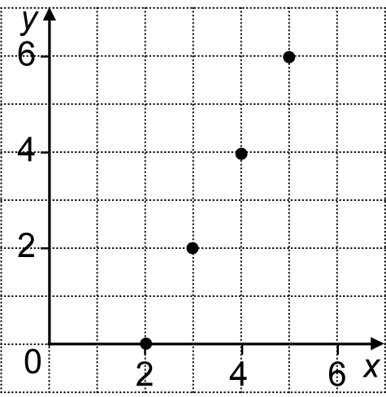  A | 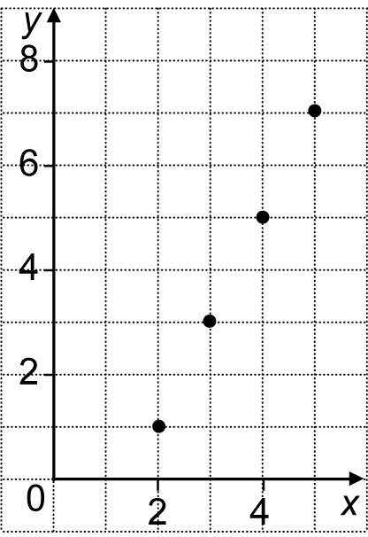  B | 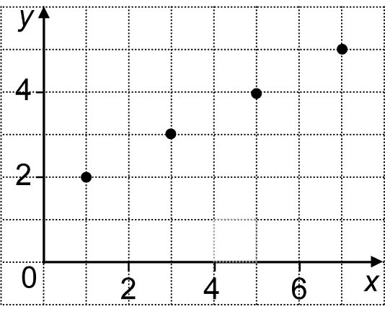  C

Short Answer

9. Look at the following pattern:
What is as a decimal number? ____
10. a) The Pizza Shack charges $8 for each pizza. No matter how many pizzas
you order, they charge $5 for delivery. Using p for the number of pizzas,
what is an expression for the cost to have pizzas delivered to your home?
__________________________________________________________
b) What is the cost of five pizzas? Write your answer as a sentence.
__________________________________________________________

11. The diagram shows that a cabin with one room has two doors, a cabin with two rooms has five doors, and a cabin with three rooms has eight doors.
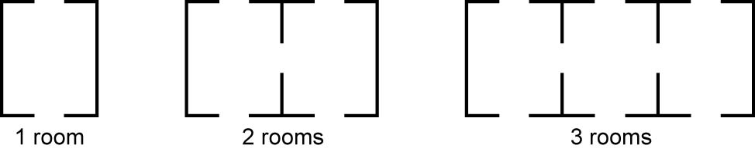
a) If the pattern continues, how many doors does a cabin with five rooms
have? Write your answer as a sentence.
__________________________________________________________
b) What is an expression for the pattern? Tell what your variable
represents.
__________________________________________________________

Extended Response
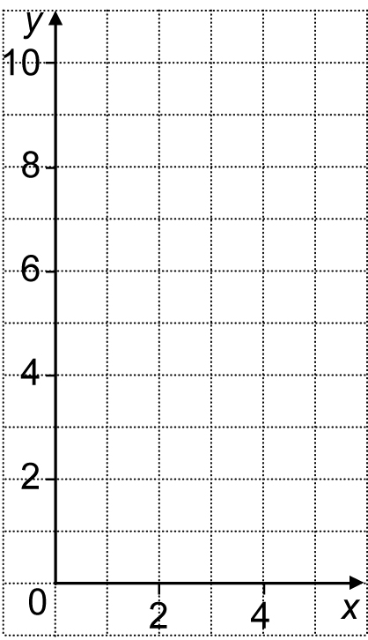
12. a) For the linear relationship
y = 2x − 1 complete the
following table of values.
x | y
2
3
4
5
b) Graph the values in the table
onto the coordinate grid provided.
c) Describe a pattern in real life
that the linear relation y = 2x − 1
could represent. Make sure you explain
what both x and y represent.
___________________________________________
___________________________________________
___________________________________________
___________________________________________
___________________________________________

