Puzzling Expressions
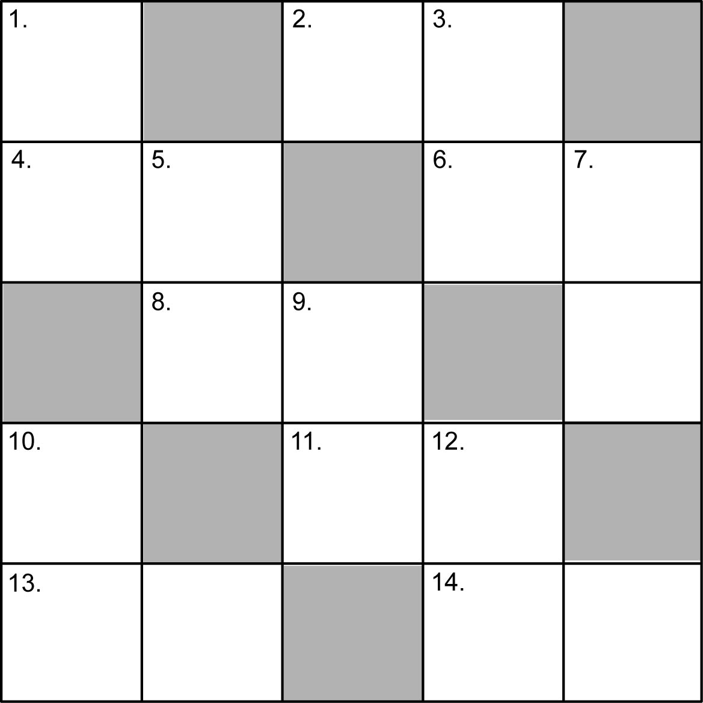

Across
2. x + 2; x = 9
4. 6a; a = 12
6. 4z − 1; z = 11
8. ; n = 24
11. 7v; v = 8
13. 15 + 5b; b = 5
14. 4(k + 1); k = 6

Down
1. 3y − 3; y = 10
3. 2c + 6; c = 4
5. 3m − 3; m = 8
7. 5t + 10; t = 4
9. 8s + 1; s =3
10. 20 − 2g; g = 3
12. 10u − 8; u = 7

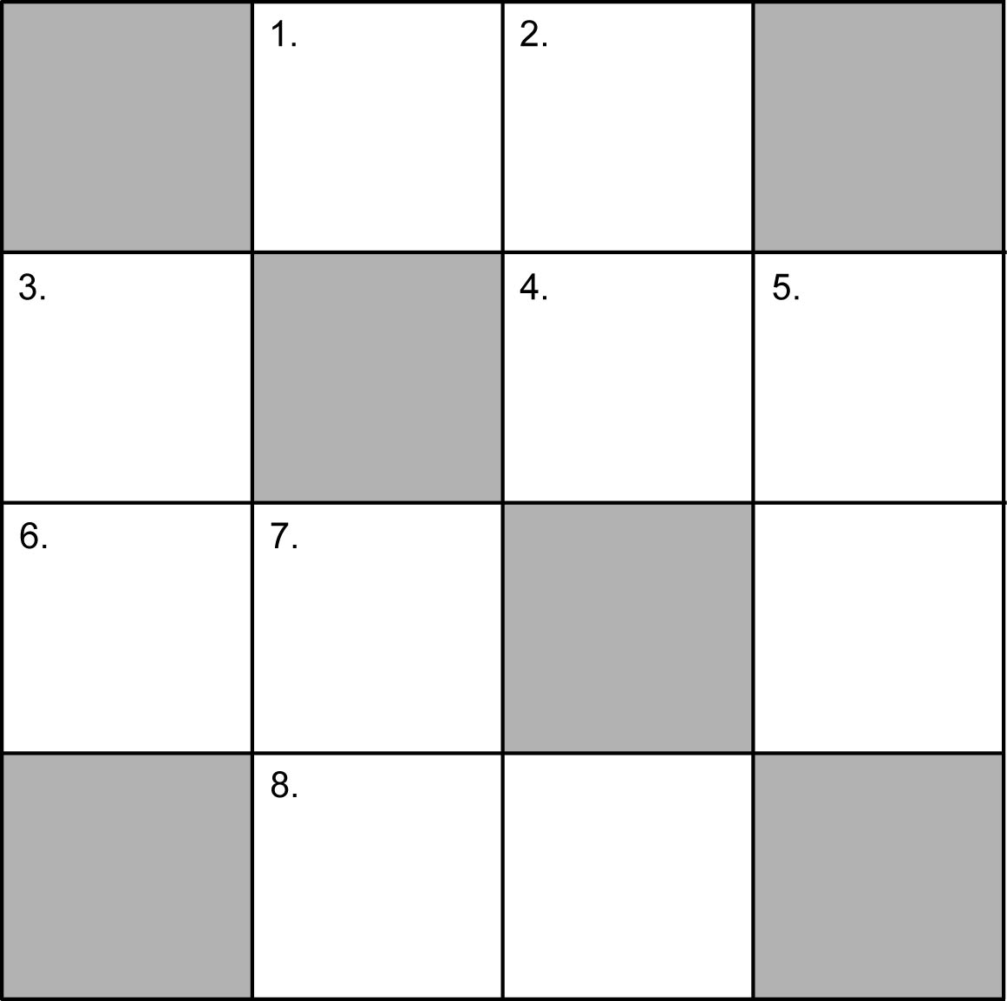

Across
1. _________________
4. _________________
6. _________________
8. _________________

Down
2. _________________
3. _________________
5. _________________
7. _________________

