Chapter 10 MathLinks 7
Student Resource Answers

10.1 Describe Patterns, pages 354–357
5. a) Answers may vary. Each figure has 2 more squares than the previous figure.

b)
6. a) Each figure has 3 more dots than the previous figure.
b) 15
7. a) , , ,
b) Answers may vary. In the fraction pattern, is added to each fraction to get the next fraction in the pattern. In the decimal pattern, 1 is added to each decimal number to get the next decimal number in the pattern.
c) d) 4.166… or
8. a) Answers may vary. In the fraction pattern, the value of the numerator increases by 1. In the decimal pattern, the repeating decimal is the numerator of the fraction multiplied by 9. Each repeating decimal number increases by b) 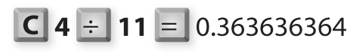
c) . The numerator of 6 multiplied by 9 is 54, which is the repeating decimal.
d) . Answers may vary. For example, the numerator of 9 multiplied by 9 is 81, which is the repeating decimal.
9. a) 400. Subtract 400 from the previous number.
b) 4.6. Add 1.1 to the previous number.
c)  Add one side to the previous polygon.
d)
10. a) | A | 1 | 2 | 3 | 4
 | B | 10 | 20 | 30 | 40
 | C | 100 | 200 | 300 | 400
 | D | 1000 | 2000 | 3000 | 4000
b) A: Add 1 to the previous number.
B: Add 10 to the previous number.
C: Add 100 to the previous number.
D: Add 1000 to the previous number.

11. a) Squares: The number of squares in the figure increases by the figure number. Colour: Alternate between adding green and red squares by adding 2 green, then 3 red, 4 green, 5 red, and so on.
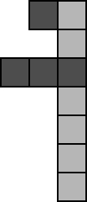
b) Answers may vary. For example,
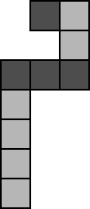
c) Answers may vary. For example,
12. a) The numerator is the repeating decimal.
b) , 1 c) The decimal equivalent of is not a repeating decimal.
d) Answers may vary. For example, the pattern of repeating decimals continues.
e) | Fraction | Decimal Number | Fraction | Decimal Number
 |  | 1
 |  |  |  | 2
f)
13. a) Answers may vary. | 1 | 2 | 3
 | 11 | 12 | 13
 | 21 | 22 | 23
b) Answers may vary. 1 + 12 + 23 = 36;
3 + 12 + 21 = 36. The two sums are equal. c) Answers may vary.
d) Answers may vary. The sum of one diagonal equals the sum of the other diagonal in the same 3 × 3 square.
e) Answers may vary. The sum of one diagonal equals the sum of the other diagonal in the same 2 × 2 square.
14. a) Answers may vary. | 2 | 3
 | 9 | 10
b) Answers may vary. 2 × 10 = 20;
3 × 9 = 27 c) Answers may vary.
d) Answers may vary. The difference between the product of the diagonals in each 2 × 2 square is 7.
15. a) , , 1, , , …
b) Answers may vary.
16. a) 162
b) If there are tens digits in the six numbers, add them and then multiply this value by 10 to get value #1. Add the ones digits in the six numbers to get value #2. Add values #1 and #2 to get the sum of the six numbers.
c) 2 + 2 + 2 + 3 + 3 + 4 = 16
16 × 10 = 160
6 + 7 + 8 + 8 + 9+ 0 = 38
160 + 38 = 198
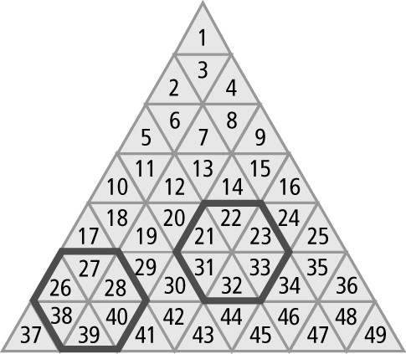

17. 5, 8, 11 18. 188, 176, 164, 152

10.2 Variables and Expressions,
pages 361–364
4. a) | Base | 1 | 2 | 3 | 4 | 5 | 6
 | Perimeter | 4 | 8 | 12 | 16 | 20 | 24
b) Answers may vary. For example, the perimeter is 4 times the number of toothpicks in the base. c) 4b d) 40
5. a) Answers may vary. In each figure, the number of dots is 5 times the figure number. The number of black dots is
4 times the number of red dots. The number of line segments is 4 times the figure number. The number of red dots is equal to the figure number. The number of black dots is 4 times the figure number. b) 100

c) | Figure Number | 1 | 2 | 3 | 4 | 5 | 6 | 7
 | Number of Black Dots | 4 | 8 | 12 | 16 | 20 | 24 | 28
d) 4f e) 204
6. a) n represents the number of students trying out. n − 7 b) f represents the number of people in Alice’s family.
f − 5 c) m represents the number of family members. 2m
7. a) 3w b) v − 8 c) A + 15 d) e) 2l − 2
8. a) 1.79p b) 1.35c c) 1.79p + 1.35
9. Answers may vary. For example,
a) Each magazine costs $4.
b) the number of magazines

10. Answers may vary. a)
b) b represents the figure number.
11. a) 30 − x b) n − 11 c) p − x
12. a) w + 3; variable: w; constant: 3; coefficient: 1
b) 2p; variable: p; coefficient: 2
c) or 0.5t; variable: t; coefficient:
or 0.5
13. a) h. The number of hours Salma babysat.
b) bonus of $3 c) $38
14. a) the sum of the number of loaves of white and brown bread
b) the number of loaves of white bread ordered over a number of days
15. a) 25x b) 10y c) 25x + 10y
16. a) variable: a; coefficient: 7; constant: 8
b) variable: h; coefficient: 3; constant: 100
c) variable: q; coefficient: 8
d) variable: n; coefficient: ; constant: 5
17. a) Answers may vary. The numbers increase by 10 down the H.
b) 168
c) Multiply the middle number by 7.
d) Answers may vary. 7 × 26 = 182
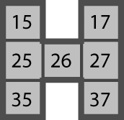 | e) 7m
18. a) 5t b) B
19. a) Patterns A and B: 602 units
b), c) Pattern A: 4h + 2;
Pattern B: 4(h − 1) + 6

10.3 Evaluate Expressions, pages
368–371
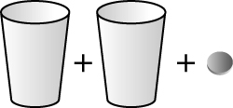
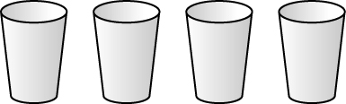
5. a) b)
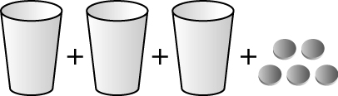
c)
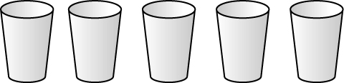
6. a)
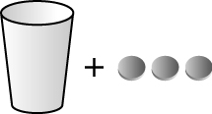
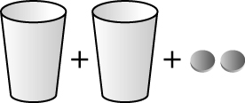
b) c)
7. a) c + 4 b) 3c + 2
8. a) 2c + 4 b) 3c + 1 c) 3c
9. a) 8 b) 3 c) 17
10. a) 11 b) 3 c) 17
11. a) | Figure Number | Perimeter | b) 60
 | 1 | 5
 | 2 | 10
 | 3 | 15
 | 4 | 20
 | 5 | 25
 | 6 | 30

12. a) | Bookcase | Number of Shelves | b) 4b  c) bookcase  number
 | 1 | 4 | b) 4b  c) bookcase  number
 | 2 | 8 | b) 4b  c) bookcase  number
 | 3 | 12 | b) 4b  c) bookcase  number
 | 4 | 16 | b) 4b  c) bookcase  number
 | 5 | 20 | b) 4b  c) bookcase  number

13. | x | 3x + 4
 | 0 | 4
 | 1 | 7
 | 2 | 10
 | 3 | 13
 | 4 | 16

14. a) | Figure Number | Number of Toothpicks | b) 46  c) 501
 | 1 | 6 | b) 46  c) 501
 | 2 | 11 | b) 46  c) 501
 | 3 | 16
 | 4 | 21
 | 5 | 26
 | 6 | 31
 | 7 | 36
^{15. a) 14 cm2 b) 56 cm}2
16. a) 200 mL b) | Pour | Volume (mL) | c) 100p  d) number  of pours  e) 1500 mL
 | 1 | 100 | c) 100p  d) number  of pours  e) 1500 mL
 | 2 | 200 | c) 100p  d) number  of pours  e) 1500 mL
 | 3 | 300 | c) 100p  d) number  of pours  e) 1500 mL
 | 4 | 400 | c) 100p  d) number  of pours  e) 1500 mL
 | 5 | 500 | c) 100p  d) number  of pours  e) 1500 mL
 | 6 | 600
 | 7 | 700
17. a) 17 b) 7 c) 22 d) 20
18. a) | Figure  Number | Number of Red Squares | Number of Black Squares
 | 1 | 2 | 2
 | 2 | 3 | 4
 | 3 | 4 | 6
 | 4 | 5 | 8
 | 5 | 6 | 10
 | 6 | 7 | 12
b) 2f where f is the figure number
19. a) | Triangle Number | 3t + 6 | t + t + t + 6
 | 1 | 9 | 9
 | 2 | 12 | 12
 | 3 | 15 | 15
 | 4 | 18 | 18
 | 5 | 21 | 21
b) They are both correct because
3t + 6 = t + t + t + 6.

20. a) 14 cm b)
21. a) |  | Figure 5 | Figure 6
 | Black | 20 | 24
 | White | 25 | 30
b) 4f where f is the figure number
c) Answers may vary.
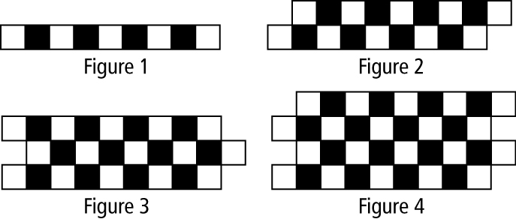
d) Answers may vary.

10.4 Graph Linear Relations, pages
378–381
3. a) | Number of  Red Tiles, x | Number of White Tiles, y
 | 1 | 2
 | 2 | 4
 | 3 | 6
 | 4 | 8
 | 5 | 10
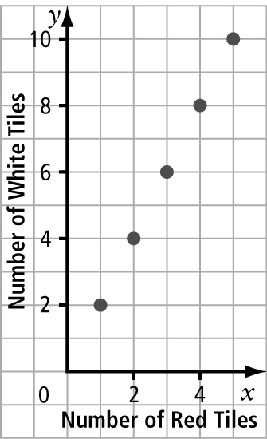
b)
c) Words: The pattern of points forms a straight line, starting at (1, 2). The
y-coordinate is 2 times the x-coordinate.
Horizontal and Vertical Distances: The points increase by 1 unit right, then
2 units up, starting at (1, 2).
Relationship: The number of red tiles
is x. The number of white tiles is y. The coordinates of the points are (x, y). The relationship between x and y is linear. It can be written as (x, 2x) or y = 2x.
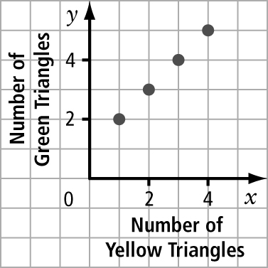
4. a)
b) Words: The pattern of points forms a straight line, starting at (1, 2). The
y-coordinate is one more than the
x-coordinate.
Horizontal and Vertical Distances: The points increase by 1 unit right, then 1 unit up, starting at (1, 2).
Relationship: The number of yellow triangles is x. The number of green triangles is y. The coordinates of the points are (x, y). The relationship between x and y is linear. It can be written as (x, x + 1) or y = x + 1.
5. a) | Day, d | Number of Visitors, v
 | 1 | 4
 | 2 | 5
 | 3 | 6
 | 4 | 7
 | 5 | 8
 | 6 | 9
 | 7 | 10
b) Words: The pattern of points forms a straight line, starting at (1, 4). The
y-coordinate is 3 more than the
x-coordinate.
Horizontal and Vertical Distances: The points increase by 1 unit right, then 1 unit up, starting at (1, 4).
Relationship: The number of
days is d. The number of visitors
is v. The coordinates of the points are (d, v). The relationship between d and v is linear. It can be written
as (d, d + 3) or v = d + 3. c) 15
6. a) | Number of Lifeguards, x | Number of Swimmers, y
 | 1 | 20
 | 2 | 40
 | 3 | 60
 | 4 | 80
 | 5 | 100
 | 6 | 120
b) Words: The pattern of points forms
a straight line, starting at (1, 20).
The y-coordinate is 20 times the
x-coordinate.
Horizontal and Vertical Distances: The points increase by 1 unit right, then
20 units up, starting at (1, 20).
Relationship: The number of lifeguards is x. The number of swimmers is y. The coordinates of the points are (x, y).
The relationship between x and y is linear. It can be written as (x, 20x) or
y = 20x. c) 240
7. Answers may vary. a) expression: 7x; linear relation: y = 7x b) expression:
x − 2; linear relation: y = x − 2
8. a) The number of pucks is p. The total cost is C. The relationship between p and C is linear. It can be written as (p, 2p) or C = 2p. b) $18 c) C = 2p + 30
9. Yes, Faheen is correct. When you substitute the values of x when x = 1, 2, 3, 4, the
y values for Graph A match y = 8 − 2x and the y values for Graph B match y = 8 − x.
10. a) | n | f | 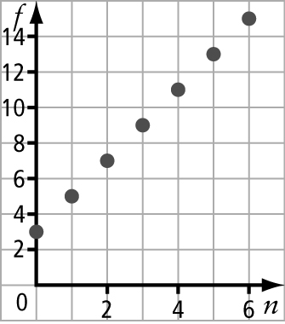  b) | c) 27
 | 0 | 3
 | 1 | 5
 | 2 | 7
 | 3 | 9
 | 4 | 11
 | 5 | 13
 | 6 | 15
11. a) Graph 2 b) Graph 1
12. a) | Number of Sales (1000s) | Monthly Earnings ($)
 | 1 | 1250
 | 2 | 1300
 | 3 | 1350
 | 4 | 1400
 | 5 | 1450
b) Extend the line made by the points on the graph to x = 8. Then determine that the y value at that point is 1600.
c) 10 000 widgets

13. a) | Sightings After 1606 | Year
 | 1 | 1682
 | 2 | 1758
 | 3 | 1834
 | 4 | 1910
 | 5 | 1986
b) 5 times
c) 2062
d) 76n + 1606; n stands for the sighting number of the comet since 1606.
e) 76n + 1606 = 76(15) + 1606 = 2746
14. a) | Row, r | Number of Seats, s | 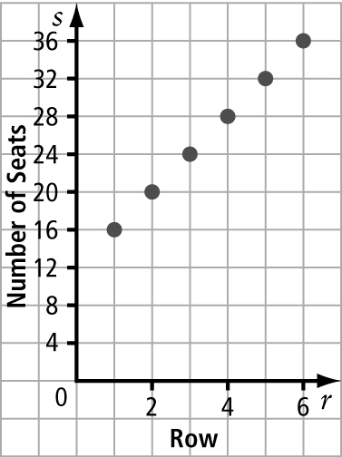  b)
 | 1 | 16
 | 2 | 20
 | 3 | 24
 | 4 | 28
 | 5 | 32
 | 6 | 36
c) The row number is r. The number of seats is s. The relationship between
r and s is linear. It can be written as
(r, 4r + 12) or s = 4r +12.
d) Method 1: 4r + 12 = 4(15) + 12 = 72
Method 2: As the row number increases by 1, the number of seats increases
by 4. From row 6 to row 15, there are
9 rows. By the 9th row, the number of seats increases by 9 × 4 = 36 seats. There are 36 seats in the sixth row. The number of seats in the fifteenth row is 36 + 36 = 72.
 | 15. a) 7 b) |  | Number of Triangles, t | Number of Sticks, s
 |  |  | 1 | 3
 |  |  | 2 | 5
 |  |  | 3 | 7
 |  |  | 4 | 9
 |  |  | 5 | 11
 |  |  | 6 | 13
 |  |  | 7 | 15
 |  |  | 8 | 17
c) |  | 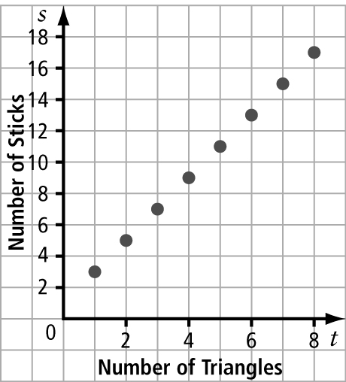
d) The number of triangles is t. The number of sticks is s. The relationship between
t and s is (t, 2t + 1) or s = 2t + 1.
e) 4015 sticks

Chapter 10 Review, pages 382–383
1. variable 2. expression 3. constant
4. numerical coefficient 5. linear relation
6. a) Start with a row of 7 cubes, then put
5 cubes on top, then put 3 cubes on top of that, and then 1 cube on top of that.
b) 25
7. a) , b) c)
8. a) 0.3888… or . Determine the pattern of adding to the previous decimal number in the pattern:
. b)
9. a) 4 b) down c) Up. In all figures with odd numbers the last triangle is pointing up, and 35 is an odd number.
10. a) b − 5, where b is the number of birds sitting in the tree before 5 birds fly away b) 8C, where C is the cost of a can of soup c) r + 3, where r is the length of rope Peter has d) , where d is the number of dogs
11. a) the total number of wheels
b) the length of one car
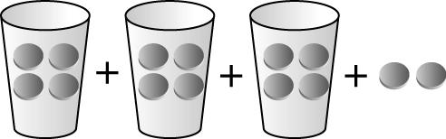
12. ; 14

13. a) | Number of Samosas Sold | Total  Cost ($)
 | 1 | 2.50
 | 2 | 5.00
 | 3 | 7.50
 | 4 | 10.00
 | 5 | 12.50
 | 6 | 15.00
b) 2.5s where s represents the number of samosas sold c) $22.50
14. a) 13 b) 18.1 cm² c) 32 mm
15. a) | Number of Days, d | Total Cost ($), C
 | 3 | 1
 | 4 | 2
 | 5 | 3
 | 6 | 4
 | 7 | 5
b) Words: The pattern of points forms a straight line, starting at (3, 1). The
C-coordinate is 2 fewer than the
x-coordinate.
Horizontal and Vertical Distances: The points increase by 1 unit right, then
1 unit up, starting at (3, 1).
Relationship: The number of days is d. The total cost is C. The coordinates of the points are (d, C). The relationship between d and C is linear. It can be written as (d, d − 2) or C = d − 2.
c) 0. It does not make sense because that means it is free to play the game for two days.
d) $46. Substitute d = 48 into the expression d − 2.
16. a) Graph 1 b) Graph 2

Chapter 10 Practice Test, pages 384–385
1. D 2. C 3. C 4. A
5. a) 3 cats leave the schoolyard
b) half of the cats in the schoolyard
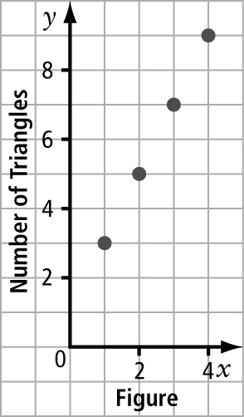
6. a) 9 b)
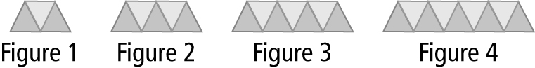
c)

7. a) 2t + 10 where t is the number of toppings
b) | Number of Toppings, t | Total Cost ($), C | 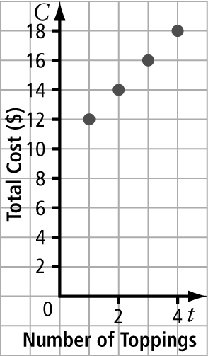  d)
 | 1 | 12
 | 2 | 14
 | 3 | 16
 | 4 | 18
c) The number of toppings is t and the cost is C. The relationship is
C = 2t + 10.

8. a) 12
b) | Number of Small Tables, x | Number of Guests, y
 | 1 | 4
 | 3 | 8
 | 5 | 12
 | 7 | 16
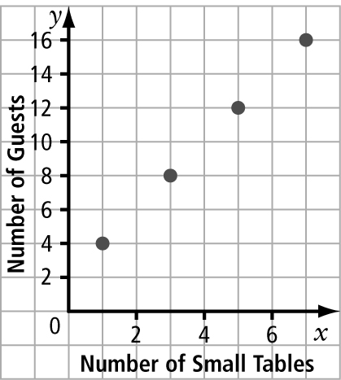
c) | d) The number of small tables is x. The number of guests is y. The relationship  is y = 2x + 2.

